Case 1 A 50 year-old violin teacher presented with tripped and fell with left shoulder contusion. Xray was taken (Fig.1)

A. What is the radiological diagnosis?
B. Which type is this patient’s injury under the Rockwood grading system?
C. Name the two ligaments which would be torn in the type of injury indicated in question (B).
D. How would you manage this patient?

Case 2 Based on the USG finding shown in Figure 2,

- What is the diagnosis
- What are the 3 types of cause of this condition?
- What are the salient features on history?
- Describe the management of such condition.

Case 3 A 58 years old patient presented to AED because of progressive drowsiness over the last one hour. He had history of DM and Parkinson’s disease. His BP was 124/70mmHg, pulse 130/min. His wife suspected that the patient had overdose himself and she presented to you some empty medication packages, which included Metformin, Dothiepin, Paracetamol. His H’stix was 10.0mmol/L. ECG was done. (Fig.3)

- List 3 ECG abnormalities.
- Which medication is the most likely culprit in this case?
- What is the pharmacological mechanism that account for the cardiotoxic effect?
- What is the antidote?

Case 4 A 50 years old woman tripped and fell at stairs. She fell on her left out-stretched forearm. Figure 4 is the xray exam of her painful left wrist.

- Describe the xray exam finding.
- What is the eponymous name of this fracture?
- What is the treatment?

Case 5 A 58 years old male, with history of DM and hypertension, presented with dizziness and epigastric pain. Physical examination showed epigastric tenderness, gross perineal and scrotal swelling. PR examination revealed fresh blood. Figure 5 shows the patient’s abdominal X-ray.

- What is the diagnosis?
- Name three risk factors for the condition in question (A).
- What are the definitive treatment for this condition?

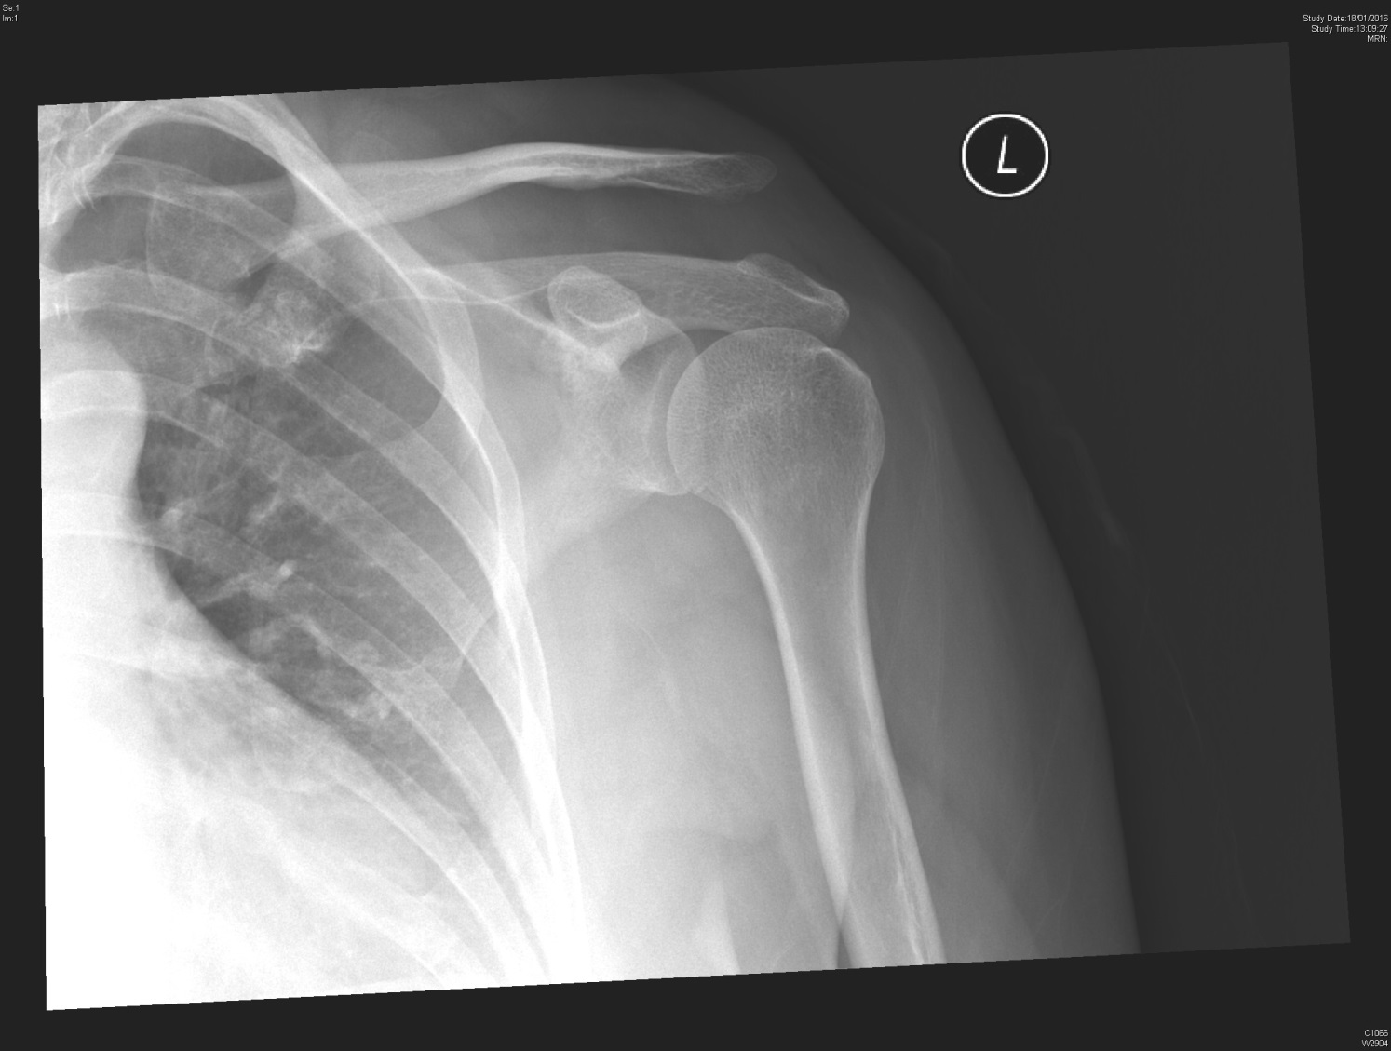
Figure 1
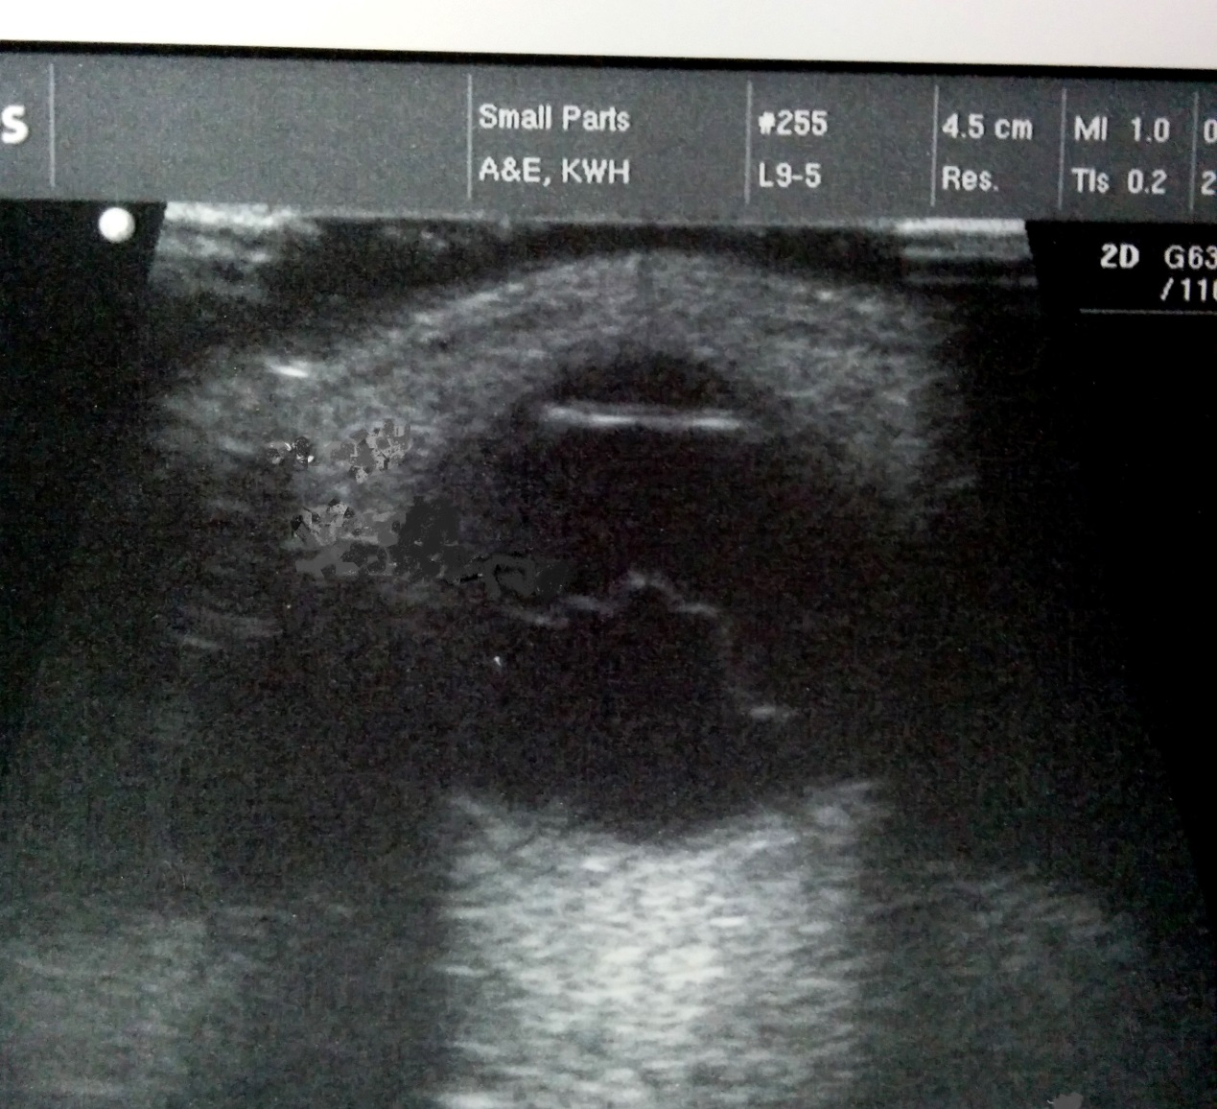
Figure 2
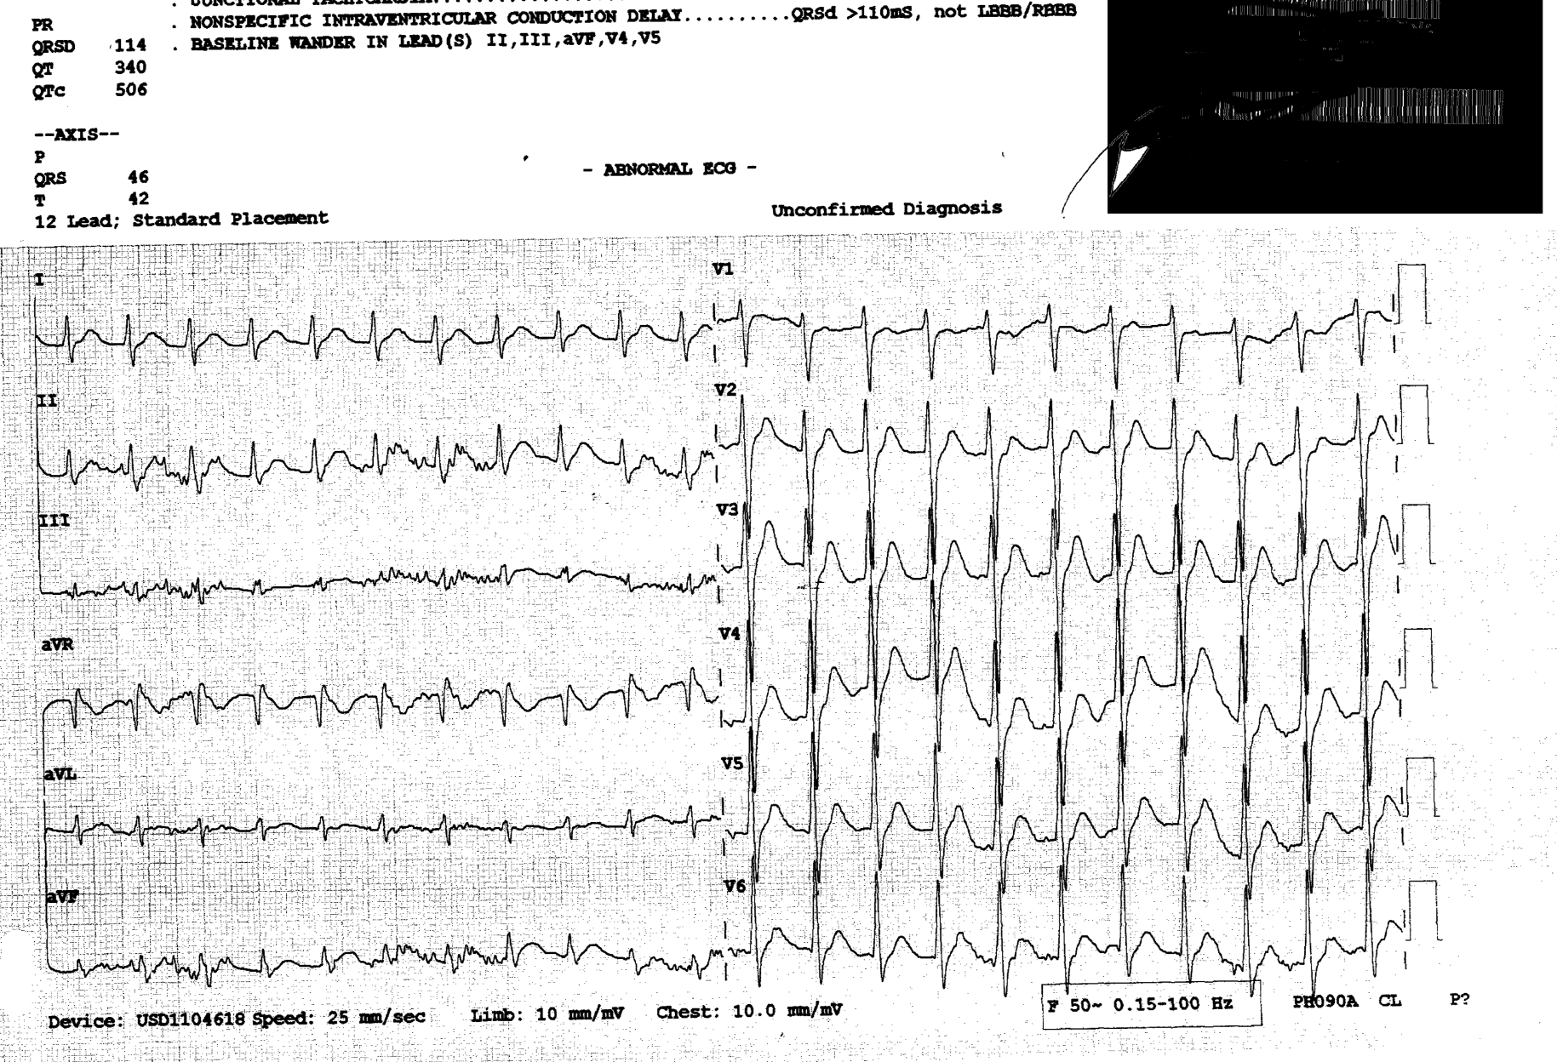Figure 3
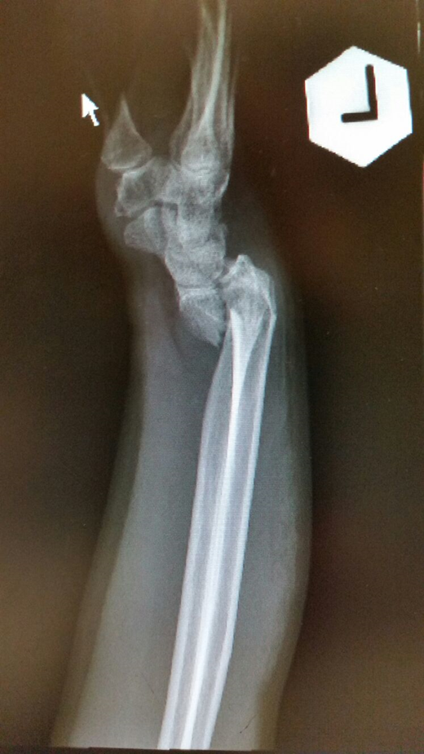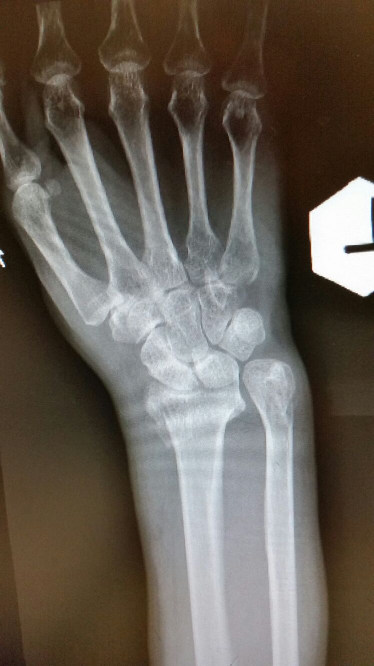 Figure 4
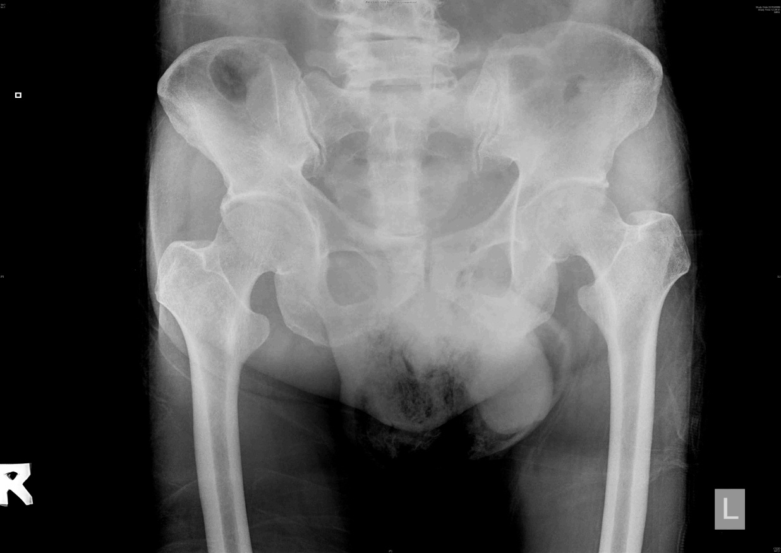
Figure 5

