OSCE 8/2016 by TKOH

Q1. M/60, chronic smoker
complained of on and off Right side headache for 3-4 months
also diplopia, worst on right lateral gaze
no fever / injury / vomiting / dizziness
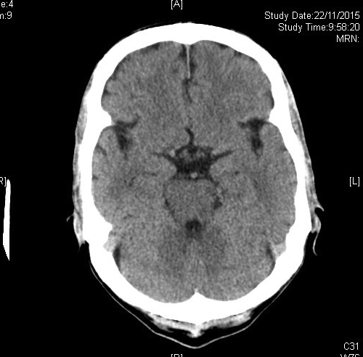
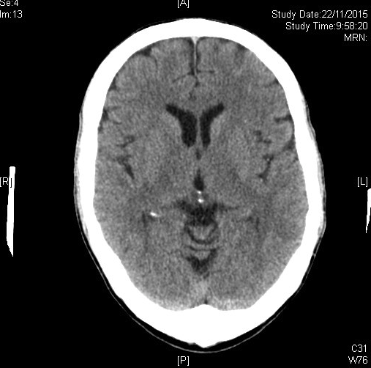
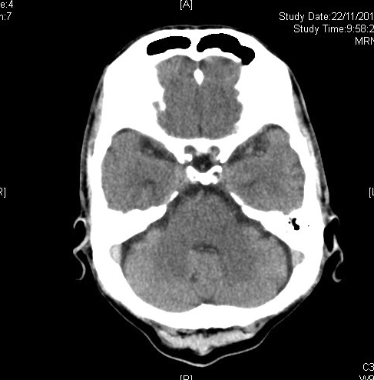

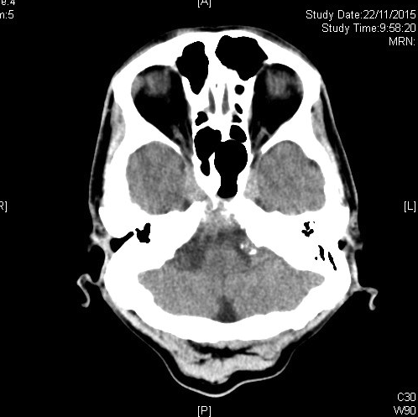
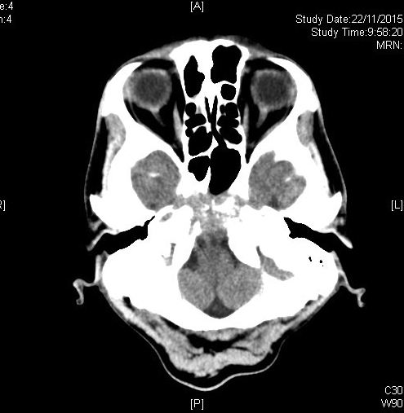

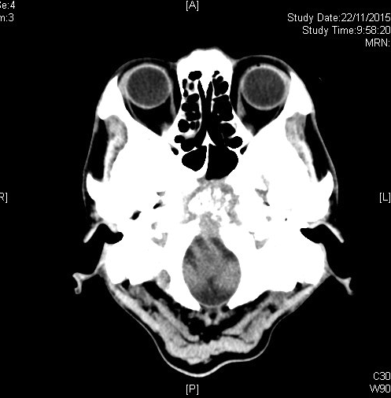

1. What are the abnormalities in the CT Brain?

2. What is the most likely diagnosis?

3. What are other differential diagnosis?

4. After assessment by neurologist and ophthalmologist, there was right lateral gaze palsy.
a) What is the total number of extra-ocular muscles for right eye?
b) Which extra-ocular muscle was responsible for the right lateral gaze? Which nerve was involved?
c) What are the possible causes for the nerve palsy?

a)
b)
c)
Q2. F/70, known HT, ↑lipid, ESRF on HD
complained of sudden onset central chest pain for 1 hr, radiate to left shoulder, which non-exertional, no fever
BP: 105/55, SaO2, 95% on 2LO2, ECG: sinus tachycardia 110/min

CXR in this admission
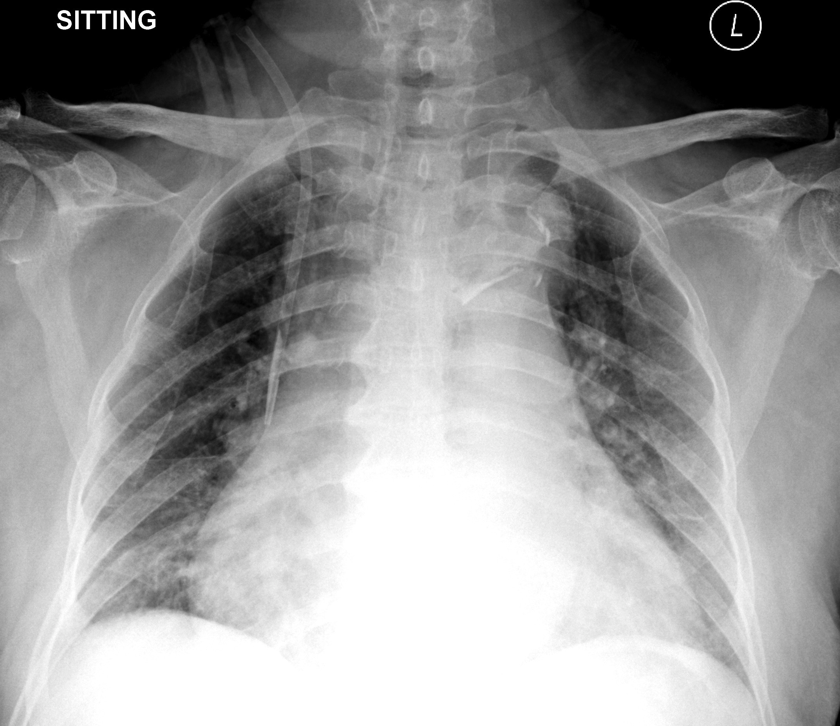
This is the CXR taken 1 month ago:
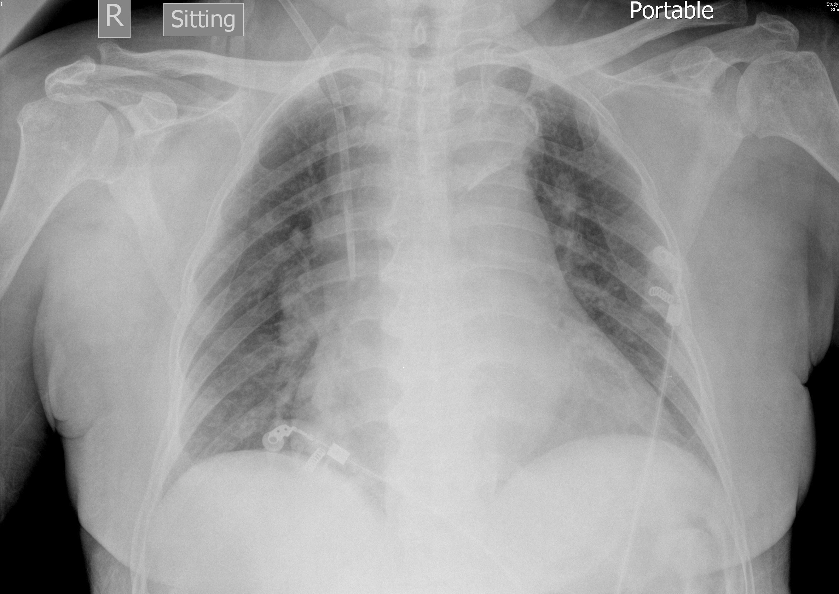

- What are the abnormalities in the CXR in this admission?

- What is the diagnosis?

- What are the other x-ray signs for this condition? Name 3.

- What further investigation should be done?

- Name a classification system for the condition.

Q3. F/60, known bilateral renal stones FU Urology.
Left lower pole renal stone with extracorporeal shockwave lithotripsy (ESWL) was done 1 week ago, complained of persistent left loin pain since ESWL, no fever
KUB was done:
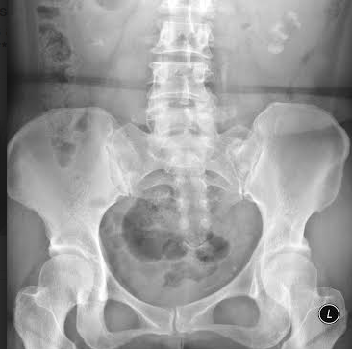
- Please describe the x-ray.

2. What is the term for the finding over left ureter?

3. What are the treatment options for this condition?

4. What are the possible complications?

Q4. M/50, smoker drinker, known DM / HT
attended AED for headache, dizziness and blur vision
no weakness / injury/ fever, no vomiting, no eye pain/ redness

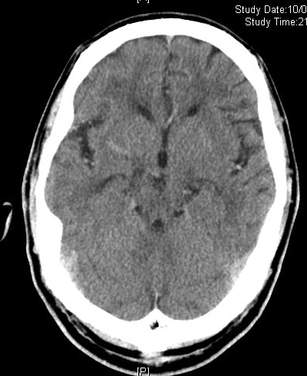
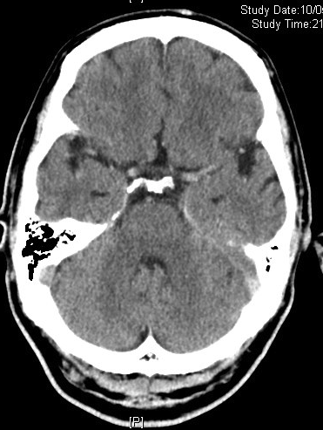
CT brain was done:
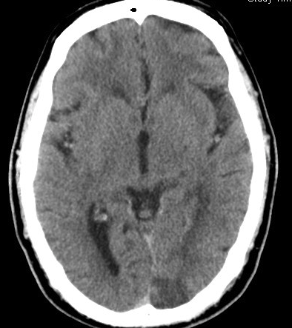

1. Please describe the CT brain abnormalities.

CBC was shown:
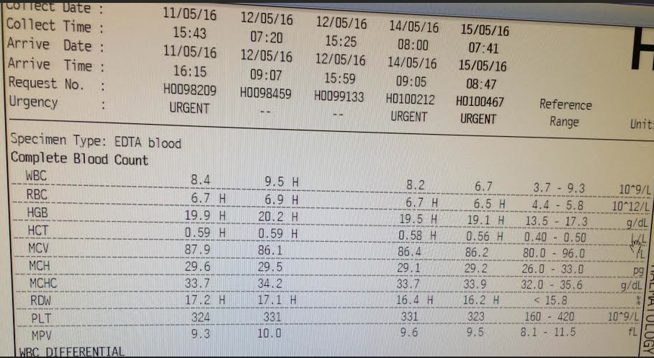

2. What is the term for the abnormality in blood picture?

3. Together with headache, blur vision, what syndrome shall we think of?

4. What are the causes for the syndrome? Name 3.

5. What treatment shall be initiated in AED?

- What other treatment for the blood picture abnormality?

Q5. M/37, smoker
Attended for epigastric pain, which is related to meal intake and is non-exertional
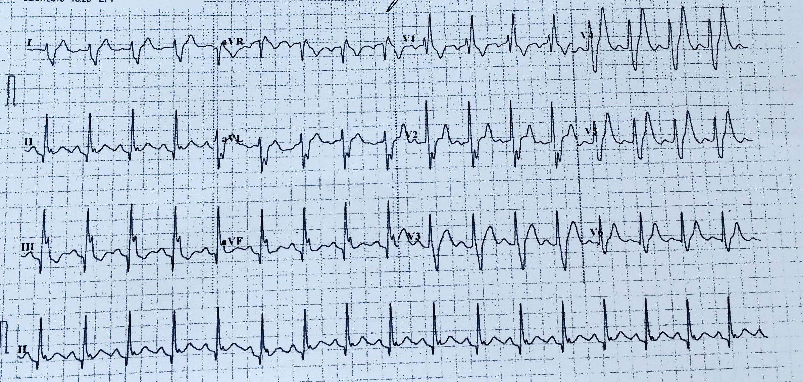
ECG was done at triage station:
1. Please describe the ECG.

On further examination of the patient, we found
frontal baldness, temporalis wasting and muscle of mastication wasting bilaterally, no obvious ptosis but weakness when closing eye with resistance.

Upper limbs:
Bilateral muscle wasting especially over distal forearm and hand
Tone ↑↑ bilaterally
Power 5/5 proximally , 4/4 distally
Reflex ↓ over bicep reflex and supinator reflex
Sensation and propioception preserved

Lower limbs:
Bilateral distal muscle wasting
No fasciculation
Power 5/5 over proximal and distal muscle
Reflex normal over knee and ankle
Gait normal
TnI normal x 2 sets, CK 378 → 365→ 746

2. What is the likely diagnosis?

3. How many types of the disease are present?

4. What is the form of genetic inheritance for this disease?

