OSCE JCM 2 2016
YCH AED

Q1 .

A 20 years old man presented with syncope today. Also fever, running nose and cough for 2 days

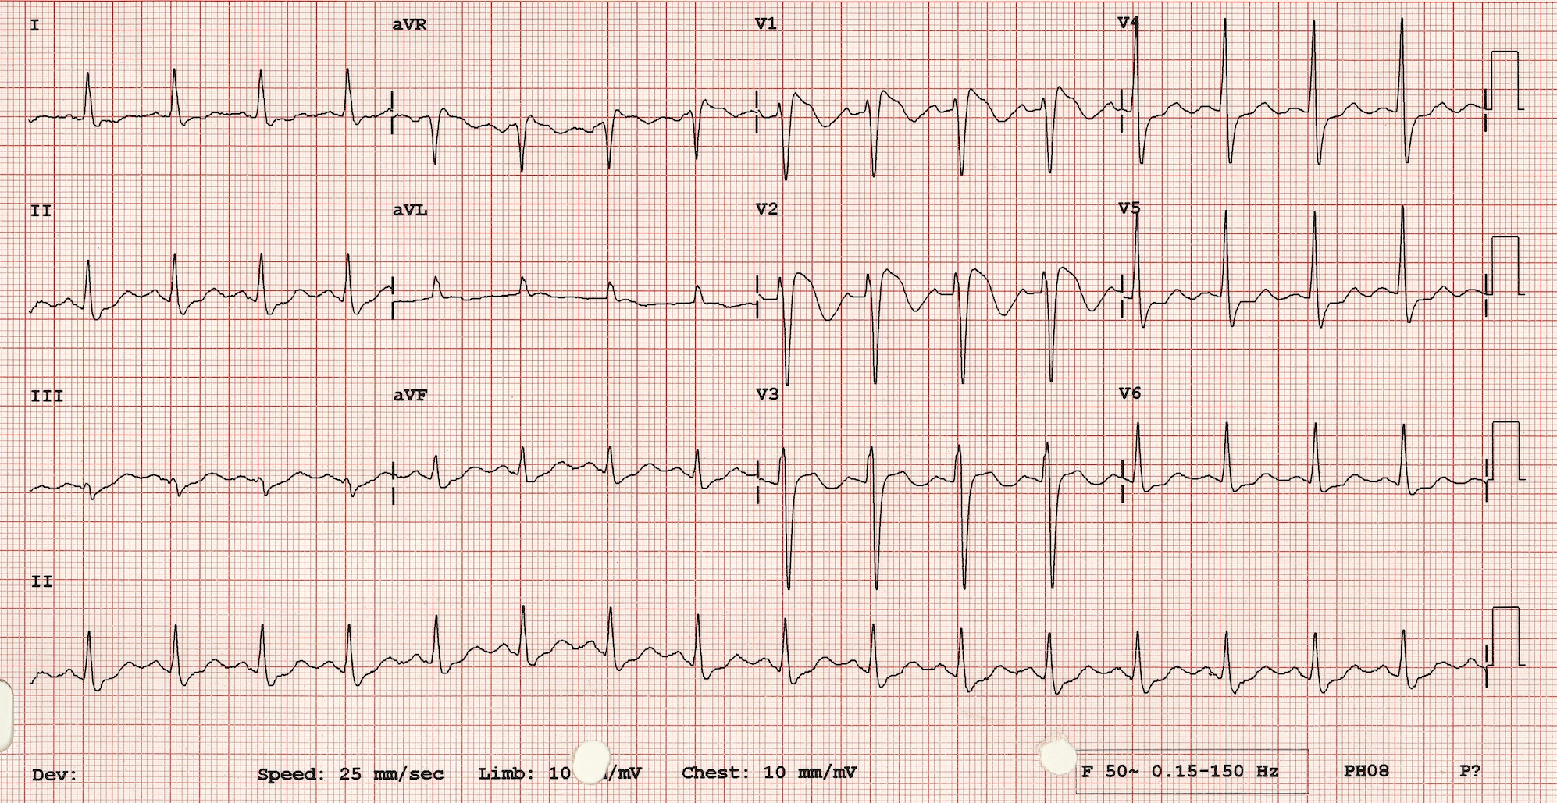

- What are the ECG findings?
- What is the diagnosis?
- What are the other clinical criteria to make the diagnosis?
- What is the definitive treatment?
- The ECG record (few weeks ago) has no abnormality detected, why ?

Q2

A 51 man presented with retrosternal chest pain for 2 hours
BP 176/115 P 130

- What are the ECG findings?
- What is the diagnosis?
- Where is the lesion?
- What is the preferred treatment?
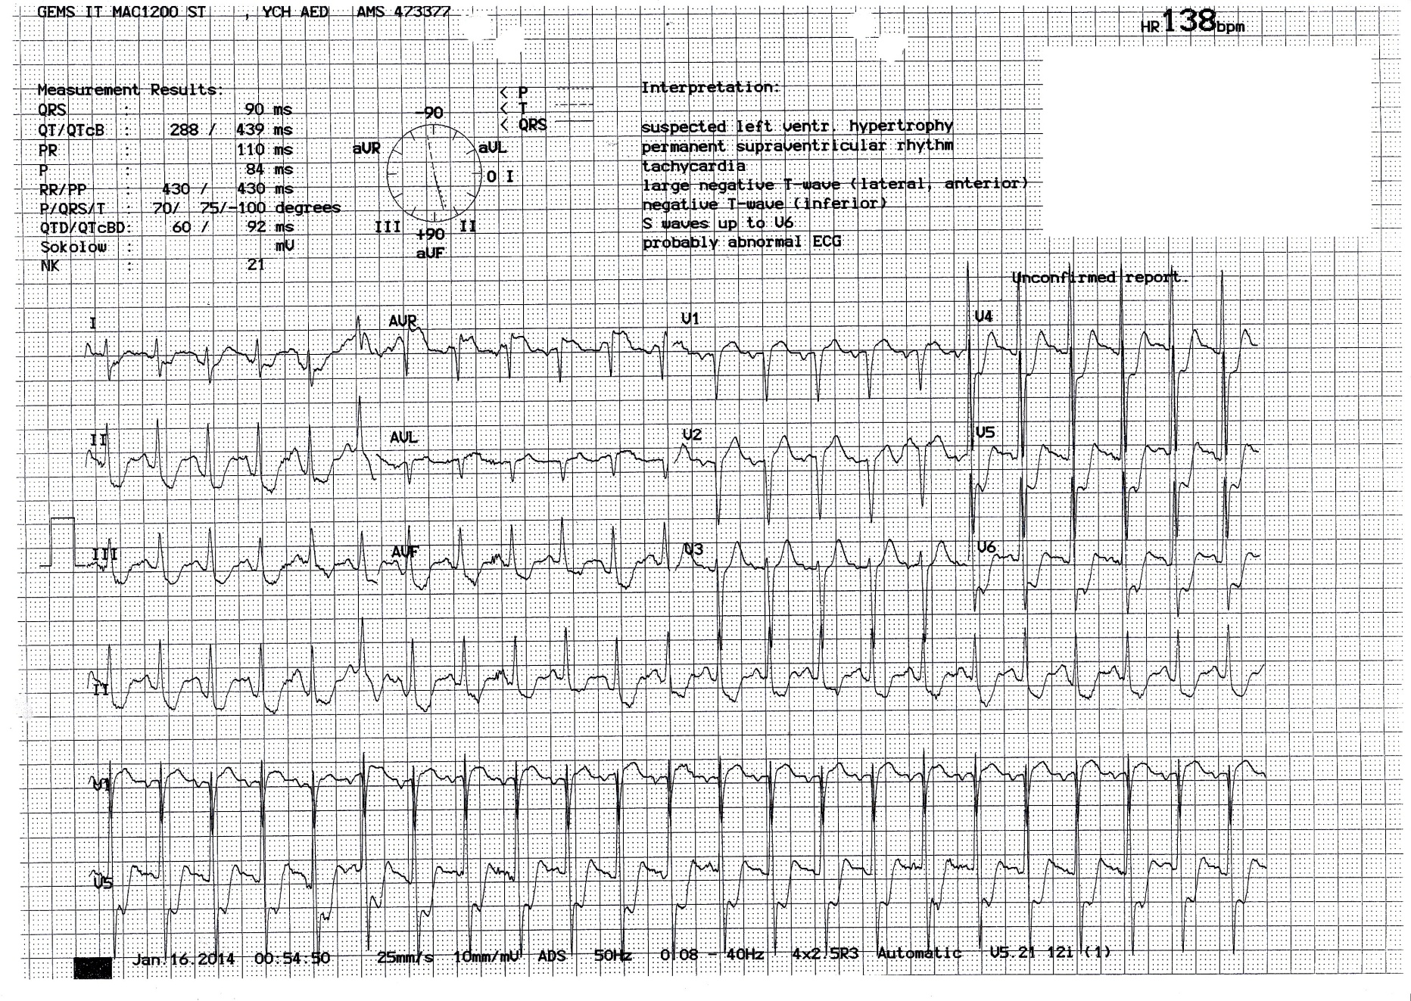

Q3
A 30 years old man fall on level ground

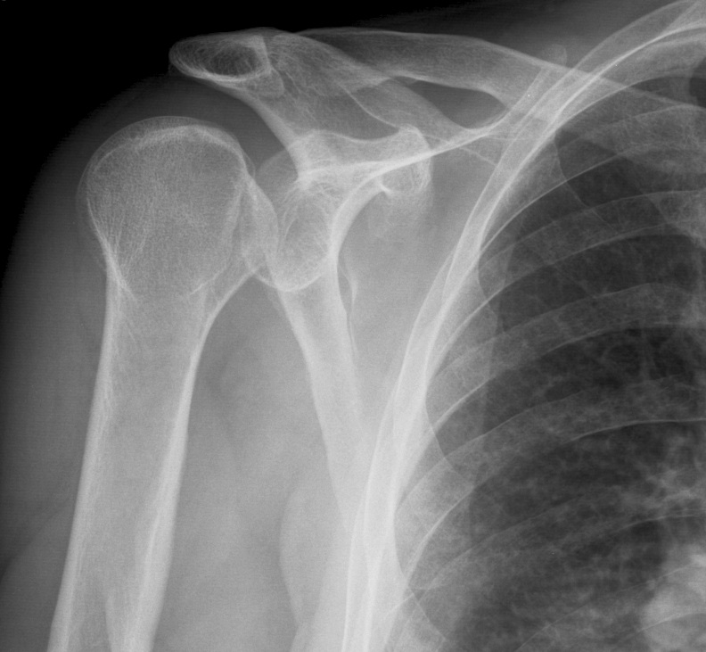

- What are the x ray findings and diagnosis?
- What other images would you order to confirm your diagnosis?
- What past medical history the patient may has?
- What is the treatment?

Q4
A 30 years old woman presented with heel pain and lumps over eyes for few months
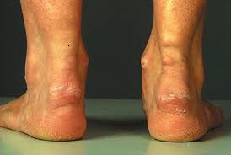
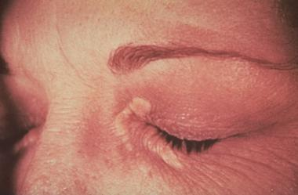

- What are the clinical findings?
- What is the diagnosis?
- What other investigation(s) would you order to confirm your diagnosis?

Q5

A 13 years old Pakistan girl with history of coeliac disease and default follow up.
She presented with both knee pain for few months
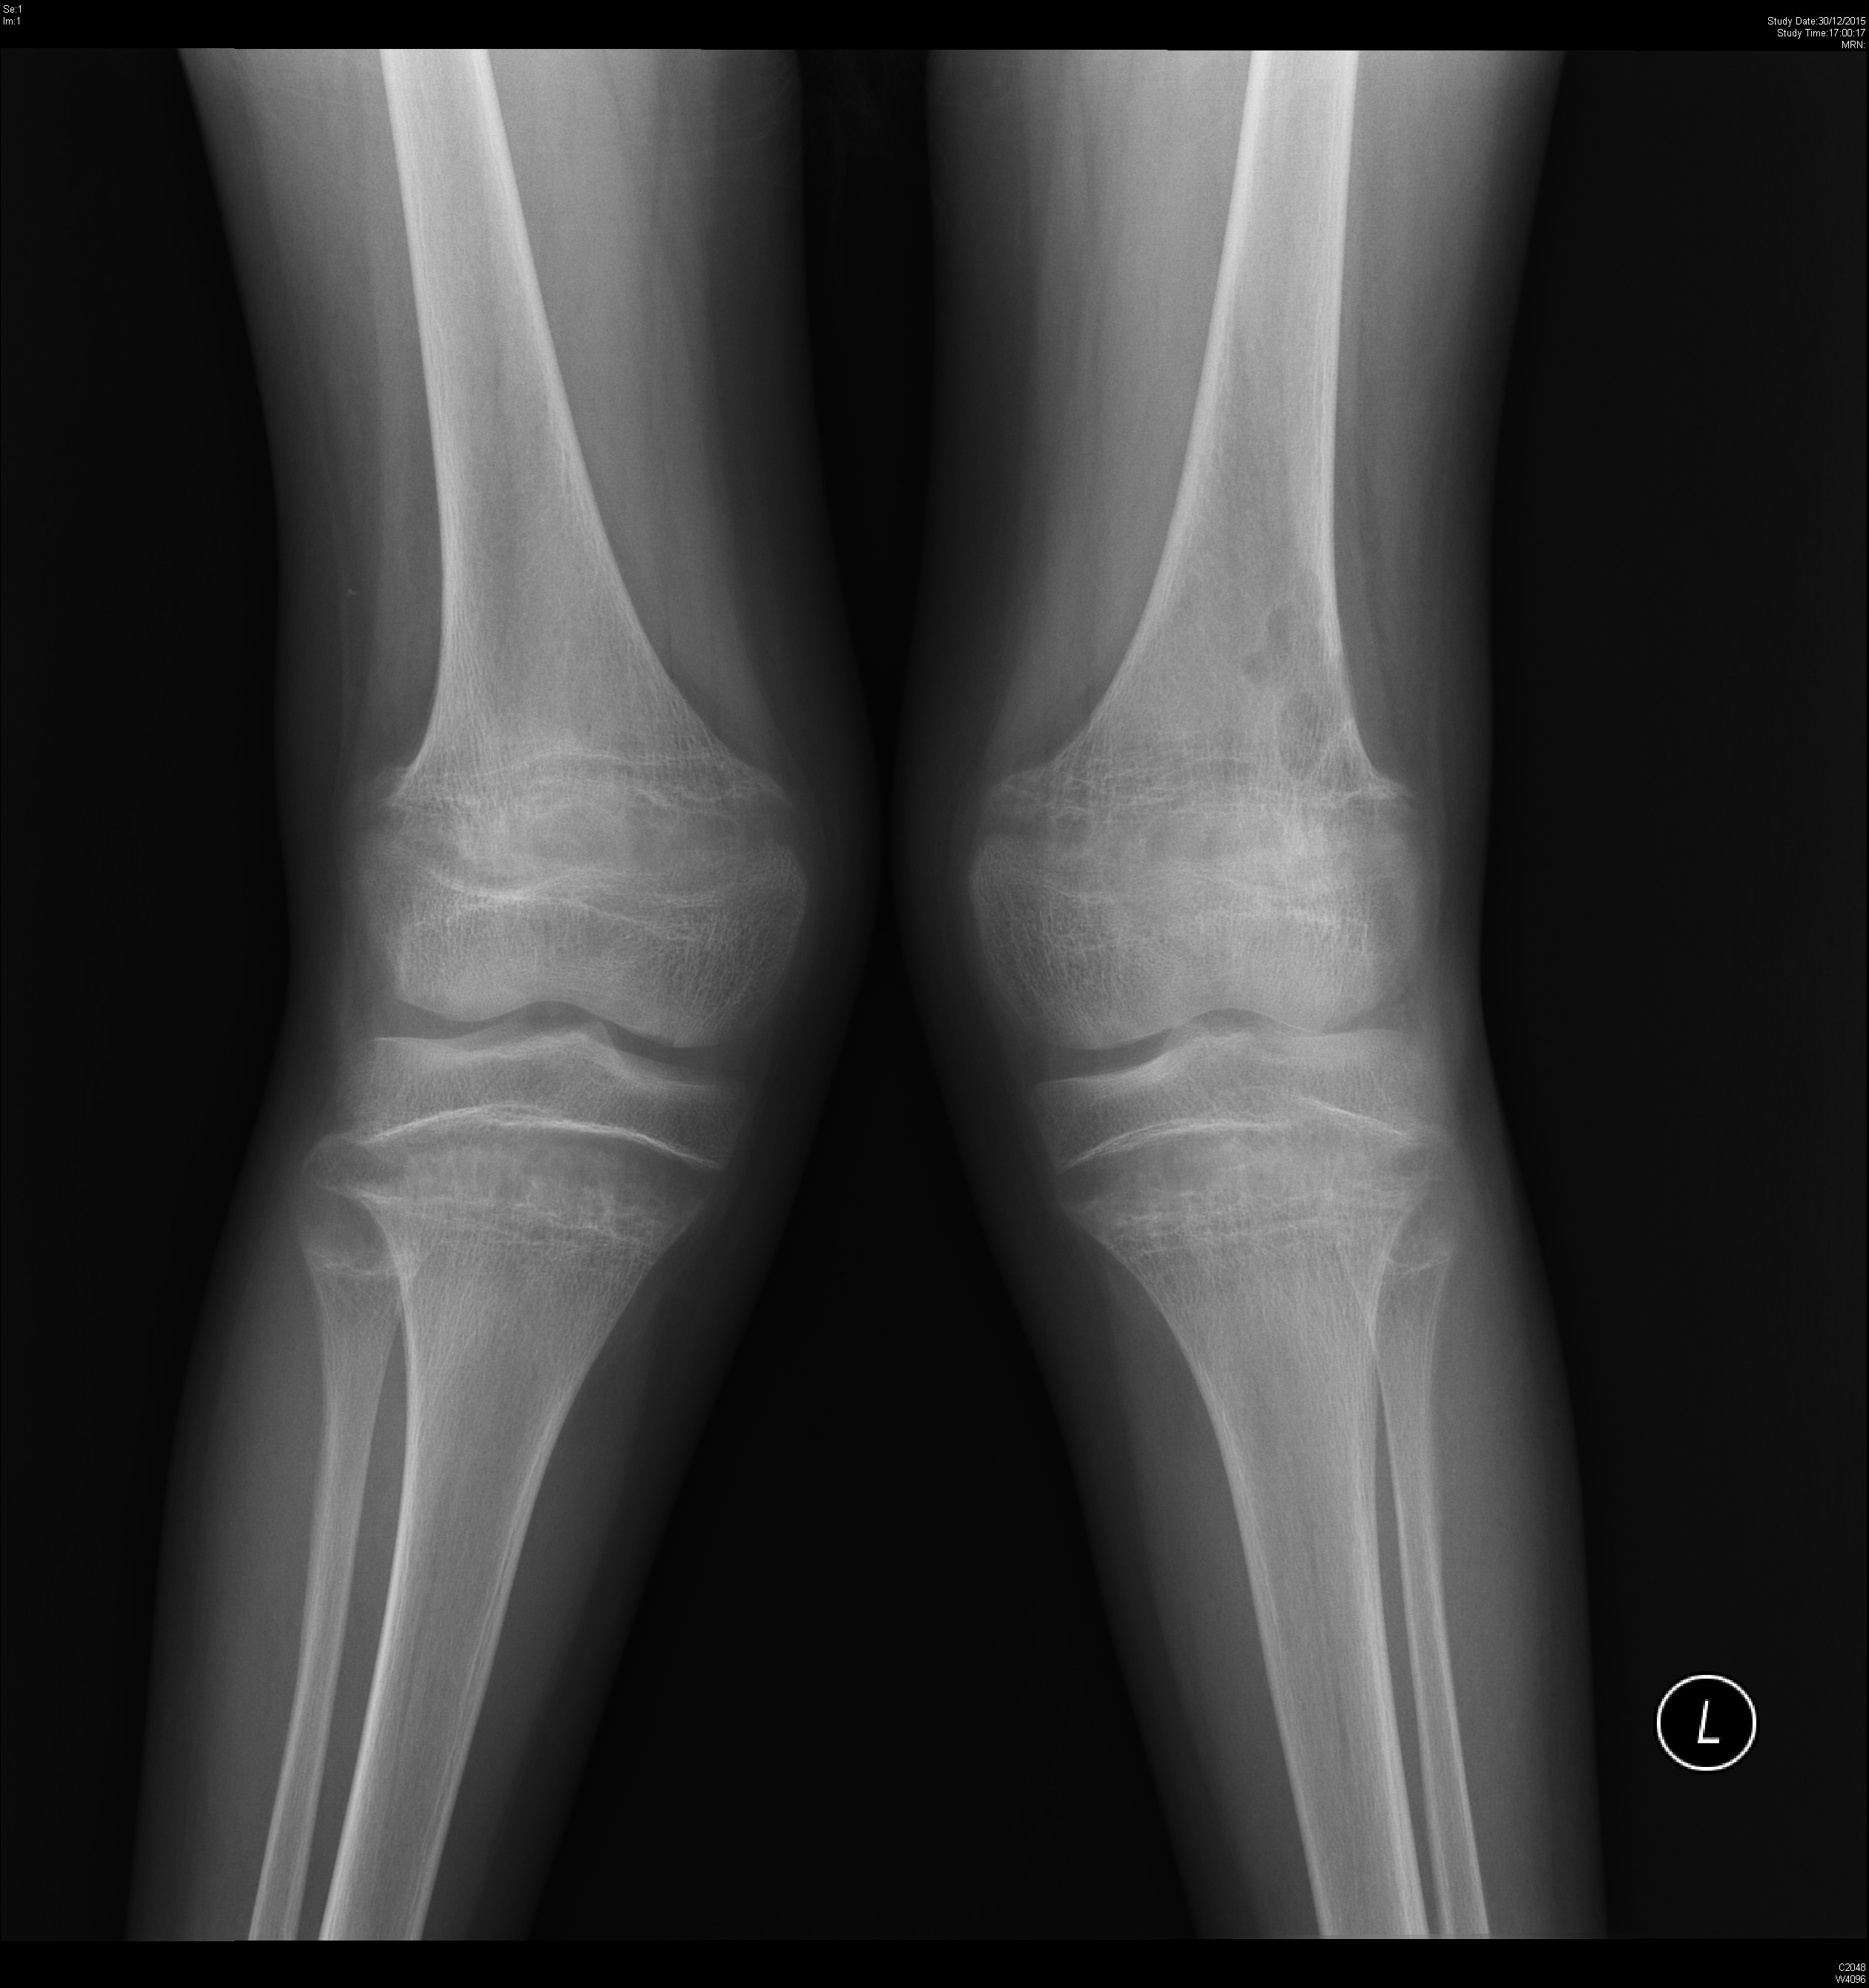
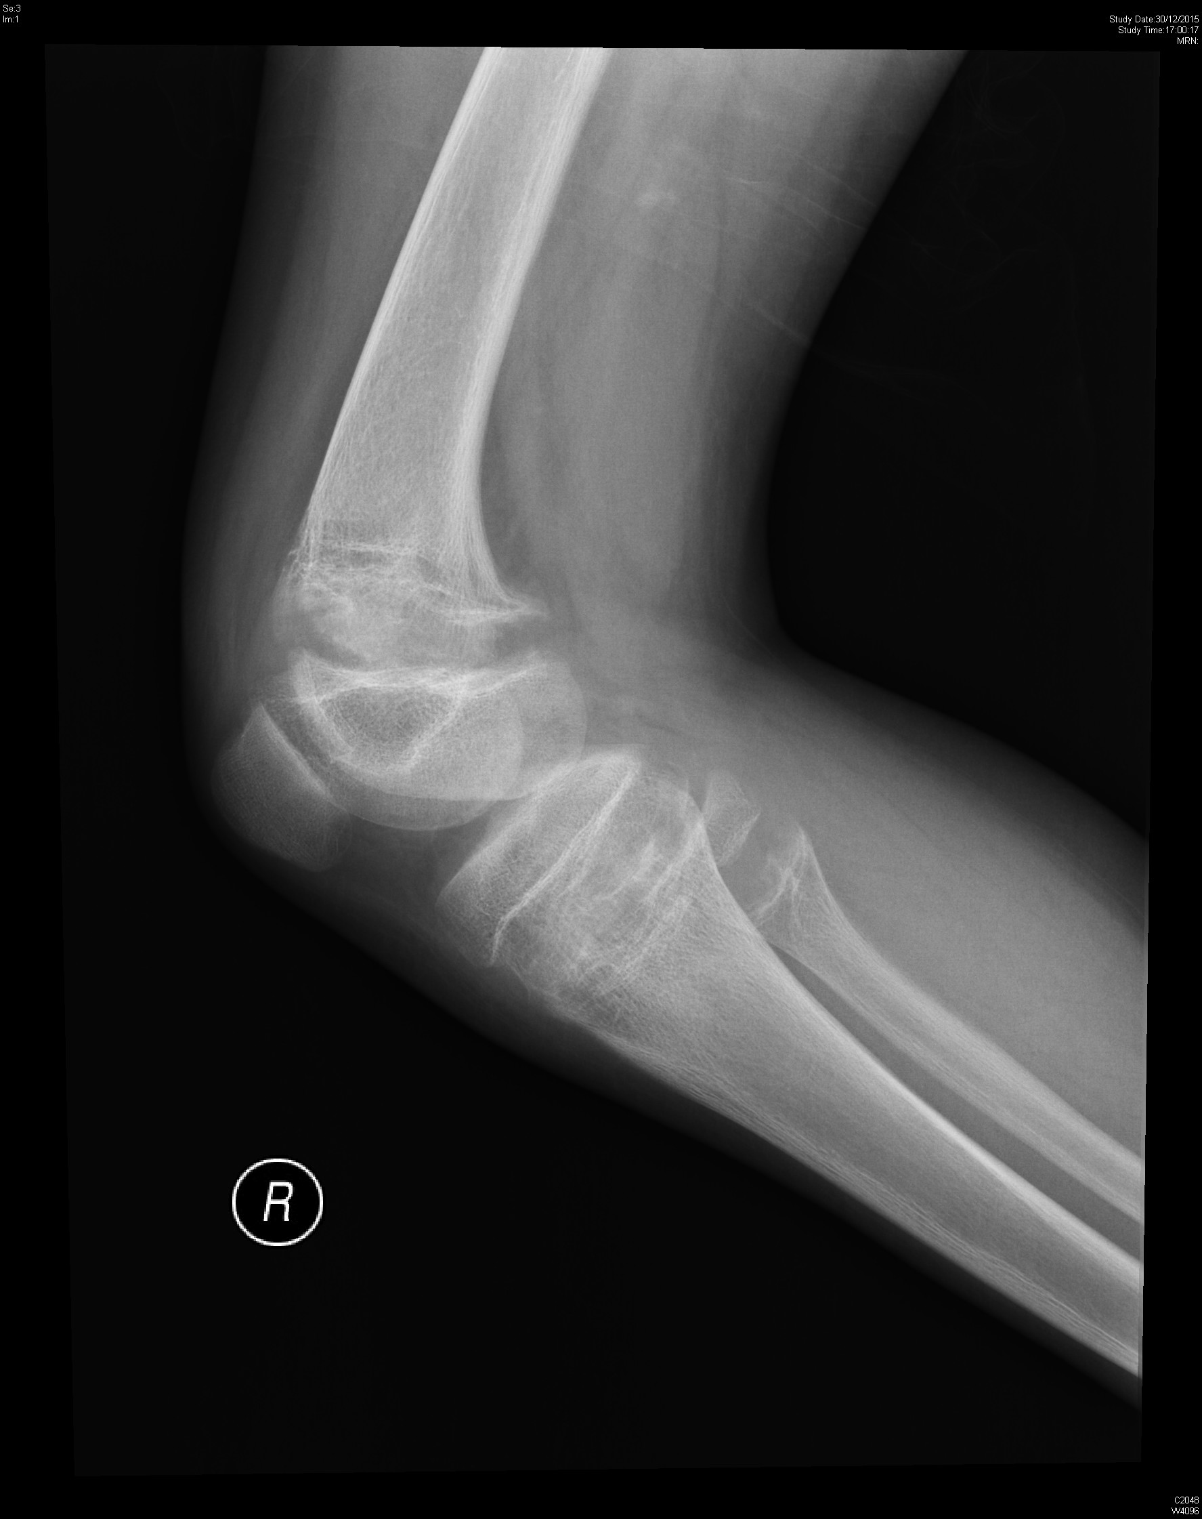

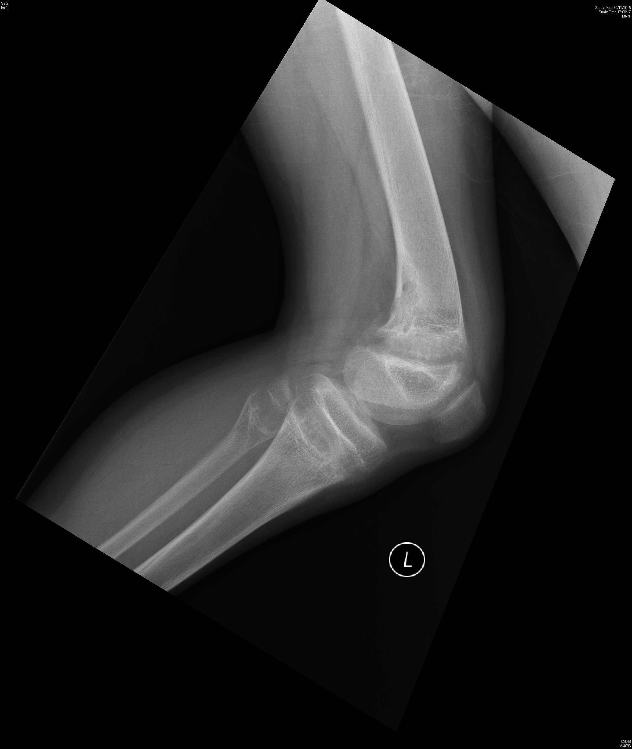

Blood test :

- What are the x ray findings?
- What is the diagnosis?
- What other investigation(s) would you order to confirm your diagnosis?
- What is the cause of the disease in this patient?

