OSCE July 2014 PMH

Question 1
A 16-months-old girl with good past health presented with sudden onset of vigorous cough and vomiting during food ingestion, associated with transient difficulty in breathing and cyanosis.
In ED, she was playful with RR 30/ min, SpO2 97% on room air.

CXR was performed.

- Please described the XR findings (Please include important negative findings)

- Hyperinflated Rt lung as evidenced by
  - Increase intercostal space on Rt side
  - Hyperlucency over Rt lung field
  - Depressed Rt hemi disphragm
  - ? Apparent Mediastinum shift to Lt side (can be due to rotated film)
- No pneumothorax / pneumomediastinum
- No subcutanoeus emphysema
- No consolidation

- What is the most likely diagnosis?

- Food Aspiration/ choking
- With food bolus / foreign body in Rt respiratory tract (bronchus/ bronchioles)

- What are the physical findings to look for during initial assessment?

- Appearance
  - Alertness
  - Smile/ consolable cry/ inconsolable
  - Effective cough/ cry
- Breathing
  - cyanosis
  - Tachypnea
  - SpO2
  - Nasal flaring
  - Intercostal retraction
  - Decrease Air entry on pathological side
  - Stridor
- Circulation
  - BP/P
  - Cap refill
- Categorize if any Respiratory distress/failure

- What are the possible complications?

- Bronchospasm
- Aspiration Pneumonia
- Pneumothorax / pneumomediastinum
- Long term complication if repeated episode or residual foreign body
  - Bronchiectesis
  - Atelectesis
  - Lung abscess

- What is the definitive treatment?

- Bronchoscopy (rigid/flexible) + removal of foreign body

Question 2
A 50-year-old man complained of neck pain after fall injury. He failed to recall the landing mechanism.

XR C-spine was performed.

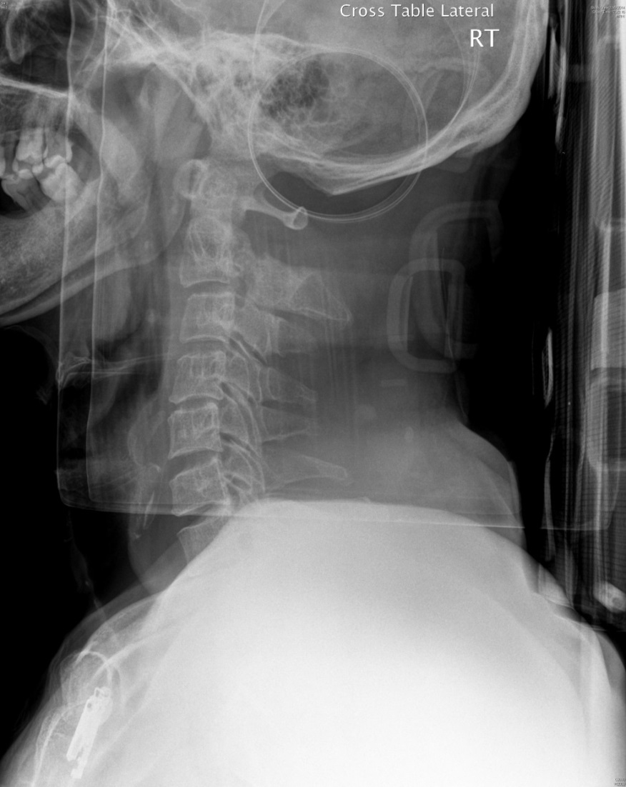

- Describe the x-ray abnormalities.

- Spondylolisthesis of C2/3
- Radiolucency and irregularities at pars intercularis suspicious of fracture

Non-contrast CT C-spine was performed.

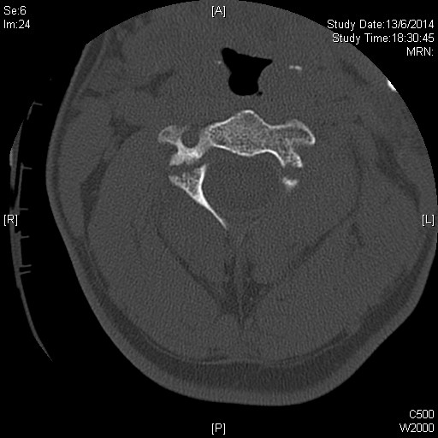

- What is the CT abnormality?

- Fracture of bilateral lamina of C2

- What is the diagnosis?

- Hangman’s fracture

- What is the common mechanism of injury for the above diagnosis?

- Hyperextension with or without axial loading
- Flexion with distraction
- Flexion with compression

- What are the potential complications?

- Tetraplegia
- Diaphragmatic breathing
- Neurogenic shock
- Air way compromise – soft tissue swelling
- Fracture – malunion / non union

- What is the classification of this disease?

- Levine and Edwards Classification
  - Type 1 – stable # with less than 3 mm displacement , no angulation
  - Type 2 – displacement more than 3mm , angulation > 10 deg, C2/3 disc and PSL are disrupted
  - Type 2A – minimal displacement, significant angulation > 10 deg
  - Type 3 – characteristics of type 2 + bilateral interfacetal dislocation

Question 3

A 50-year-old man, with IHD and AF on warfarin (dosage of warfarin reduced in last follow-up), complained of chest discomfort, right upper limb numbness and weakness. There was no headache, vomiting, SOB, sweating or radiation of pain.
On physical exam,
- GCS 15/15, BP/P 210/100, pulse 90/min, Temp 36 C, Hstix 6.5
- Chest/CVS/abdomen unremarkable
- Upper Limb power right =4/5, left 5/5

- Name 3 differential diagnoses?

- CVA
- Thromboembolism/acute ischemic limb ischemia
- Dissecting thoracic aneurysm with subclavian artery involvement

ECG was performed, showing AF without ischemic changes
CXR showed clear chest without widened mediastinum
CT brain showed no focal lesion

- What additional sign and symptoms will you look for?
- Complete neurological exam e.g. limb tone, reflex, anal tone
- Pain, Pallor, Pulseness, Parathesia, Paralysis, Persisted cold
- BP Rt and Lt arm, radiofemoral delay

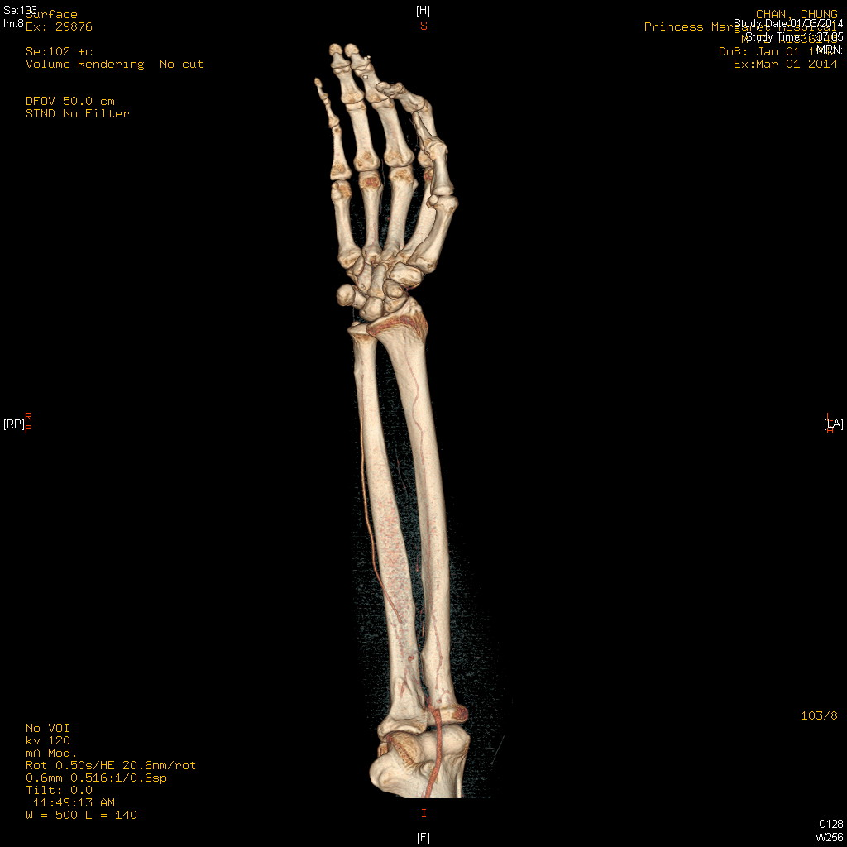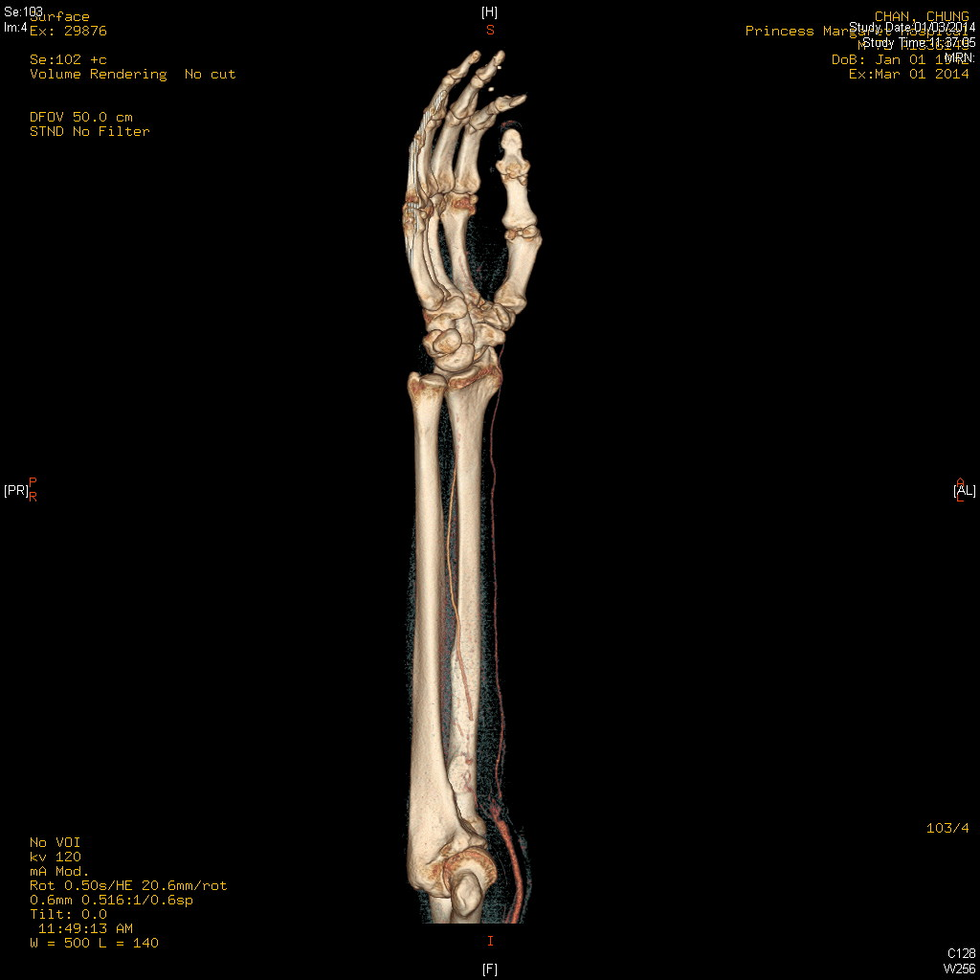

- What is the name of the above investigation? What and where is the lesion ?

- CT angiogram
- Thrombosis over proximal ulnar artery

- What is the definite treatment?

- Urgent thrombolectomy +/- on table angiogram

- After the treatment, what intravenous medication you can give to patient?

- Heparin

- What is the common dosage and how do you monitor the therapeutic effect and target of such therapy?

- 80 units/kg iv bolus follow by 18 units/kg/hour
- APTT Q6H, aiming at 1.5 to 2.5 times of reference value

Question 4

A 57-year-old man with good past health, and is a never smoker and never drinker.
He attended AED complaining of ACUTE onset of dizziness with “difficulty in swallowing saliva”. There was no definite limb weakness/ numbness

Physical exam showed
- BP 144/93 P61 T 36.3 GCS 15/15
- Chest clear, HS dual no murmur
- Neurological exam:
  - Horizontal nystagmus +ve
  - Lt side past-pointing +ve, dysdiadochokinesia +ve
  - Decrease in pharyngeal-palatal elevation ?Loss of gag reflex
  - Other CN exam and sensory not commented in ED
  - Power of 4 limbs full

- What is the working clinical diagnosis?

- Cerebral vascular attack

- Which blood vessel is likely involved in this case?

- Brach of vertebral artery / posterior inferior cerebellar artery

In addition to the above clinical findings, there was loss of pain and temp sensation on the contralateral side of body and ipsilateral side of the face.

- What is the specific name of this syndrome?

- Lateral medullary syndrome / Wallenberg syndrome

CT brain on admission:
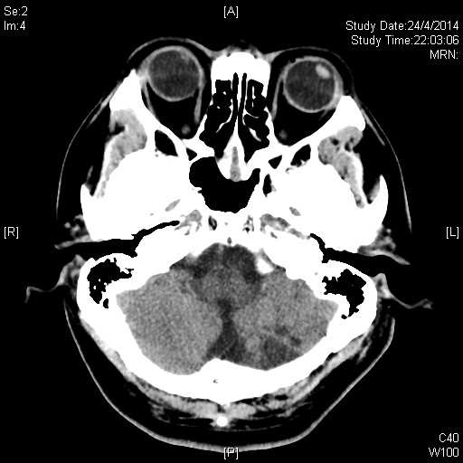

CT brain 5 days later:
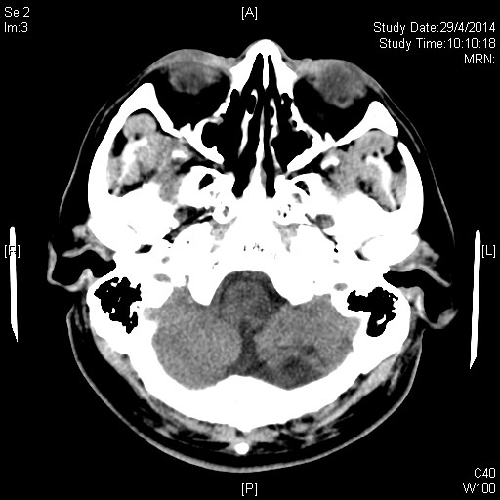

- Please describe the abnormalities of CT brain

- CT brain on admission: hypodense lesion over Lt cerebellar hemisphere, likely old infarct
- CT brain 5 days later: a new hypodense lesion over Lt medulla

- What further investigation should be performed?

- MRI of brain with contrast + angiogram

Question 5

A 44-year-old woman came to AED as a road-traffic-accident victim. She was a passenger of a 7-seat van, sitting on back row of seat without wearing seat belt. She was thrown to front row of seat when the car crashed onto hill. She mainly complained of severe low back pain

XR LS spine was performed.
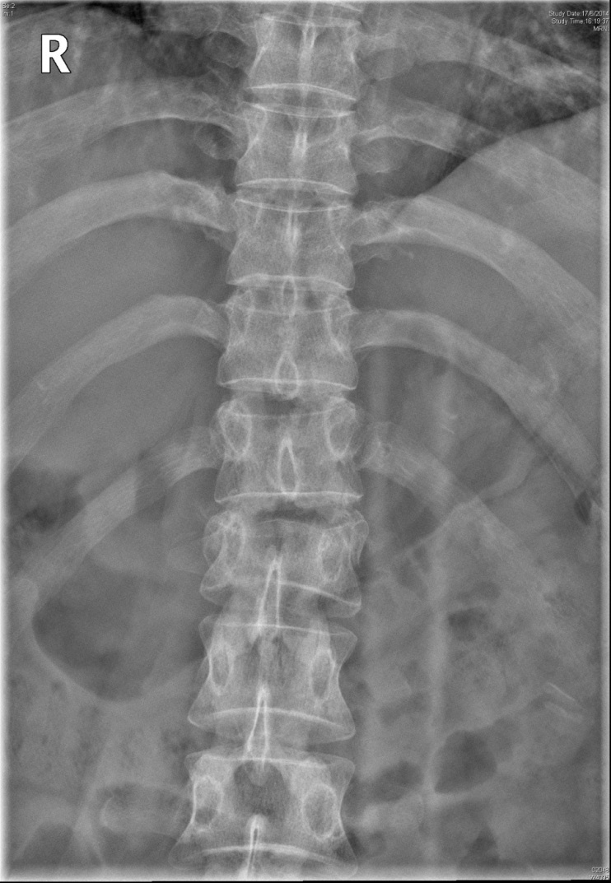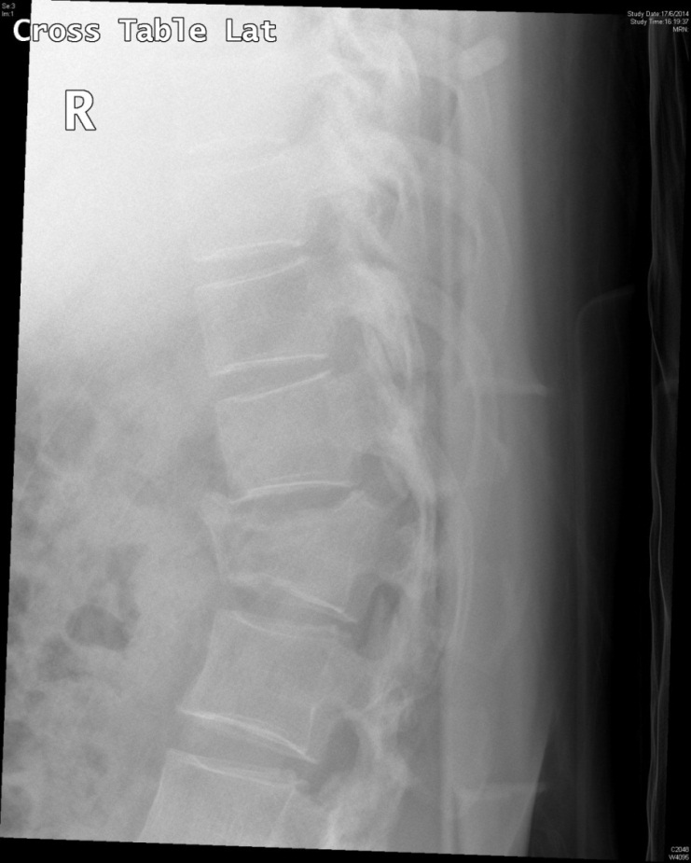

- Describe the X-ray finding

- Compressive fracture of L1
  - Decrease vertebral body height of L1 with anterior wedging
  - Disrupted superior and inferior end plate of L1
  - Minimal horizontal translation

Subsequently CT TL spine was performed.
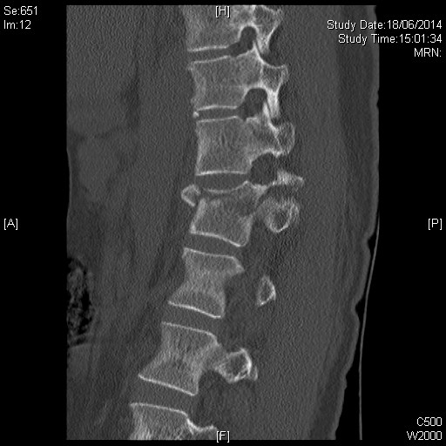

- Please describe the CT findings

- # vertebral body, Lt lamina, and Lt transverse process of L1

- What is the name of this fracture?

- Chance fracture of L1

- What is the mechanism of injury for this fracture?

- Flexion- distraction
  - Back seat passenger restrained by seatbelt
  - (special point in this case, patient did not worn seat belt)
- Fall from height

- What is a common associated injury with this fracture?

- Retroperitoneal and abdominal visceral injuries

