Question 1:
It is now 9 am.
A 72 year old man, with history of hypertension, presented to AED with left sided weakness and slurring of speech at 8 am after woke up.
BP 190/115mmHg, P 68 bpm, SaO₂ 96 RA, T=36.5°C
- What is the most important information from your history that will affect your subsequent management? (1 mark)
- Named a screening tool for acute stroke (1 mark)
- For this potential stroke patient, what should be done within the first hour after AED arrival? (4 marks)

A plain CT brain scan was obtained:
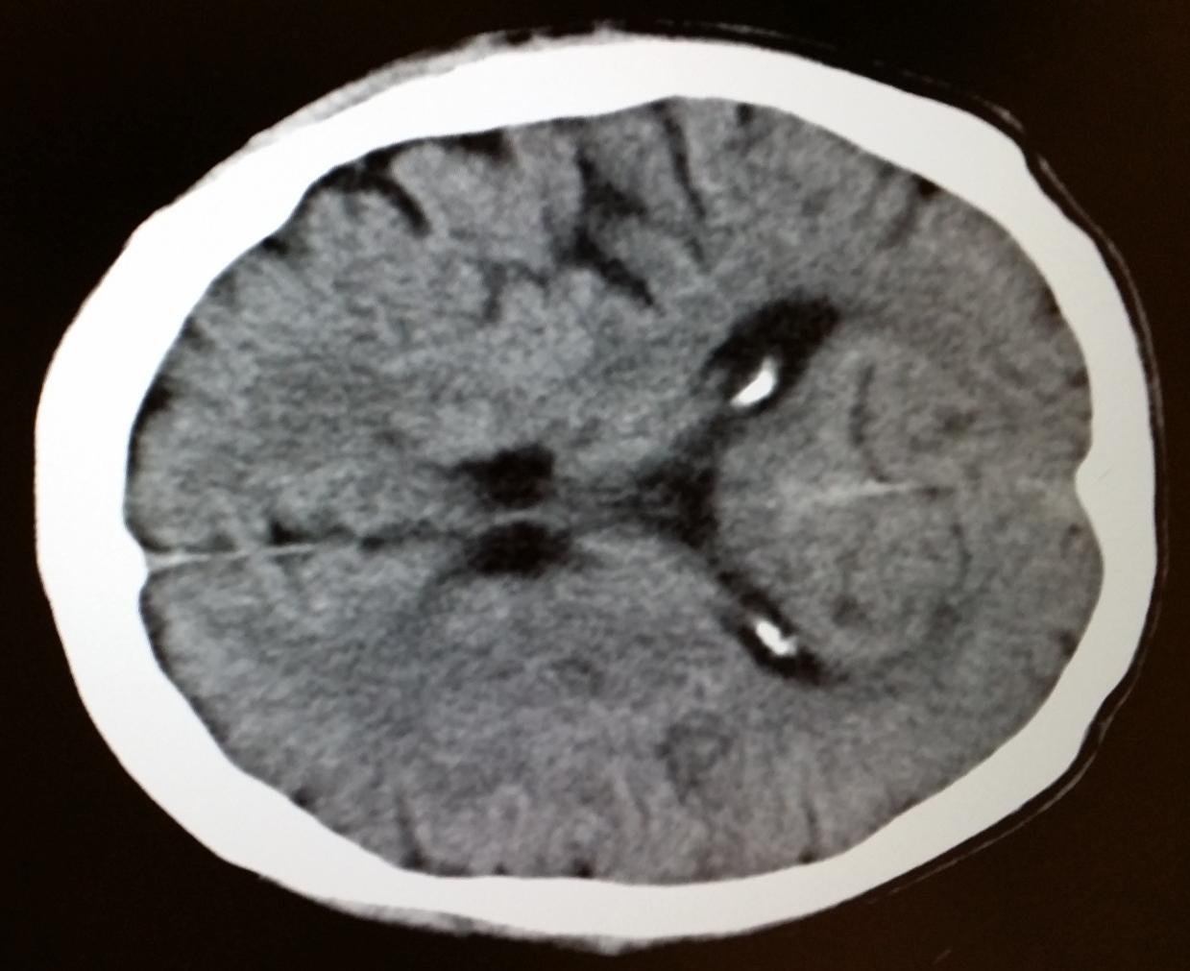
- What are the CT features suggestive of hyperacute ischaemic stroke? (4 marks)

Answers:
- What is the most important information from your history that will affect your subsequent management? (1 mark)
- Answer: Time of last seen well / as usual

- Named a screening tool for acute stroke (1 mark)
Answer: (any of below two scores)
“ROSIER score”
Recognition of Stroke in Emergency Room: an assessment tool for medical staff to differentiate patients with stroke and stroke mimics
LOC –1, seizuire –1, Unilateral Arm weakness +1, unilateral leg weakness +1, facial asymmetry +1, slurring of speech +1, visual field defect +1 (-2 to +5)
Score positive (1-5) => stroke likely
Or “Cincinnati Prehospital Stroke Scale”
Facial droop, Arm drift, Abnormal speech
1 of 3 signs abnormal gives probability of stroke 72%, all 3 findings present gives probability >85%

- For this potential stroke patient, what should be done within the first hour after AED arrival? (4 marks)
Answer:
  - Immediate general assessment and stabilization
  - Activation of stroke team with immediate neurological assessment
  - Obtain plain CT brain scan with interpretation
  - Decision for administration of fibrinolytic therapy

- What are the CT features suggestive of hyperacute ischaemic stroke? (4 marks)
Answer (any 4 of below, 1mark each)
Dense MCA sign
Hypo-attenuation of basal ganglia
insular ribbon sign
obscuration of Sylvian fissure
effacement of cortical sulci

Question 2:
A 26 year-old female complained of palpitation with chest discomfort for 2 hours. There was no dizziness and shortness of breath. Blood pressure was 123/70 mmHg and pulse was 150 per minute.

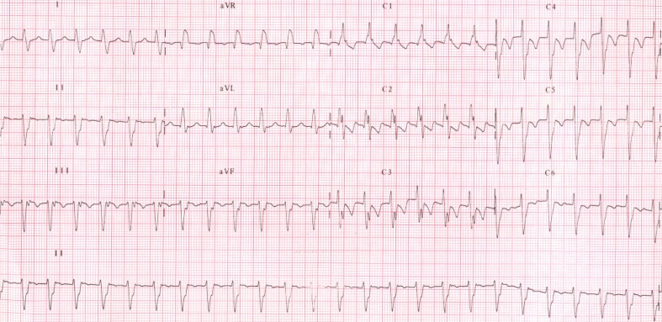
- What are the ECG findings? (3 marks)
- What is the diagnosis? (2 marks)
- What age group and which gender is this arrhythmia more commonly seen? (2 marks)
- Where is the common site of cardiac origin for this arrhythmia? (1 mark)
- How to manage this patient in AED? (1 mark)
- What is the long term treatment for patients with severe symptoms? (1 mark)

Answers:
- What are the ECG findings? (3 marks)
Regular wide-complex tachycardia (1 mark)
RBBB (1 mark)
Left axis deviation (1 mark)
- What is the diagnosis? (2 mark)
Fascicular ventricular tachycardia (1 mark for VT; 1 mark for fascicular)
- What age group and which gender is this arrhythmia more commonly seen? (2 mark)
Young age (15-40 year old) (1 mark)
More frequent in men (1 mark)
- Where is the common site of cardiac origin for this arrhythmia? (1 mark)
Left posterior fascicle (1 mark)
- How to manage this patient in AED? (1 mark)
Intravenous verapamil (1 mark)
- What is the long term treatment for patients with severe symptoms? (1 mark)
Radiofrequency catheter ablation (1 mark)

Question 3:
A 75-year-old man lived alone with no relatives in Hong Kong. He had good past health. He presented now to an A&E Department for new onset of chest pain for 2 hours.
Chest X-ray was done.
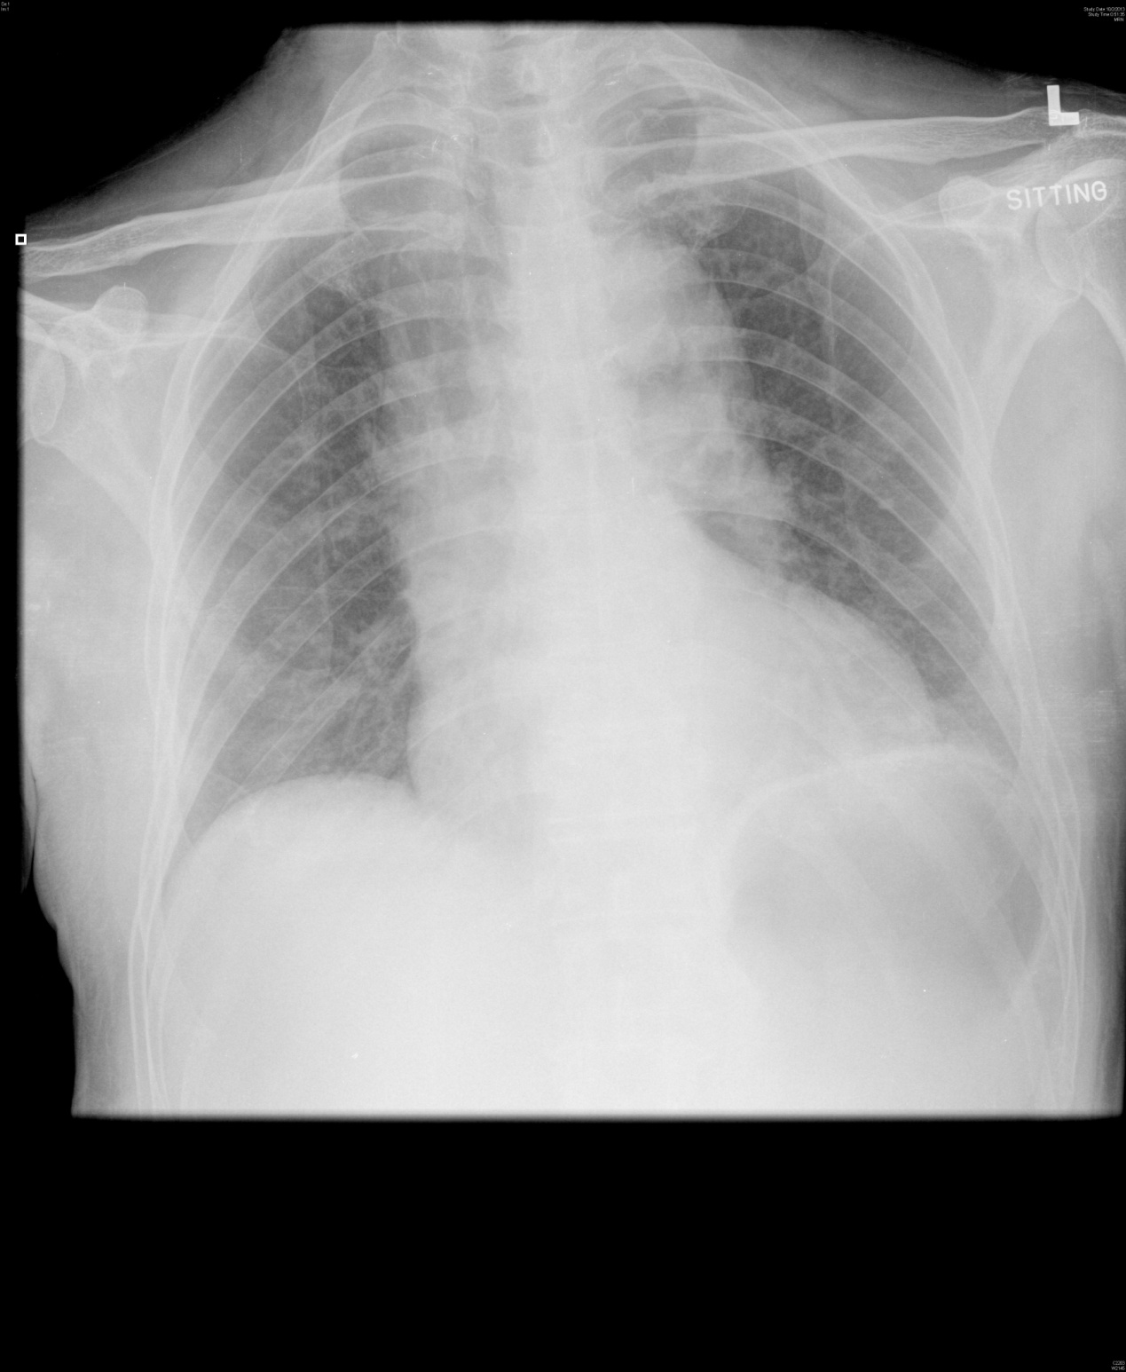
- Is this chest X-ray normal? What differential diagnosis of his chest pain may possibly be excluded ? (2 marks)
- If this patient’s BP was 200/130 mmHg, what is the drug of choice to lower his BP in A&E Department? (1 mark)

An imaging investigation was done soon after. One of the films was shown here.

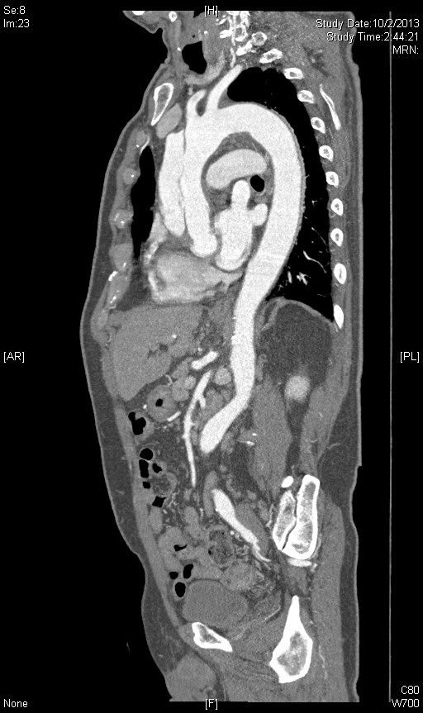

- What is the cause for this gentleman’s chest pain. (2 marks)
- What is the treatment of choice for this patient ? (1 mark)

This patient requested DAMA and insisted despite explanation by your senior.

- What does DAMA stand for ? (1 mark)
- What is estimated risk of death for his disease in the first month if his problem is left untreated? (1 mark)
- Would you allow him DAMA ? Please explain? (2 marks)

Answers:
- Abnormal with widening of mediastinum (be cautious as it is a sitting film). (0.5 mark each) Pneumothorax, pneumomediastinum, pneumonia, pleural effusion are likely to be excluded. (0.5 mark each, up to one mark; other reasonable diagnosis will also be acceptable but not dissecting thoracic aortic aneurysm, AMI, ulcer pain.)
- Labetalol (or esmolol if available in A&E) – rapidly acting, titratable parenteral beta-blockers. (1 mark) (half mark for nitroprusside as it will cause reflex tachycardia if used alone)
- Stanford type A (1 mark) dissecting thoracic aortic aneurysm (1 mark)
- For Stanford type A dissection, surgical treatment is superior to medical management.(1 mark)
- Discharge with acknowledgement of medical advice (1 mark); no marks for discharge against medical advice.
- 90% mortality at one month for untreated dissecting thoracic aortic aneurysm. (1 mark)
- Yes, after full explanation of the risk and treatment options. He has no relatives in HK as given. (2 marks)

Question 4:
A 77-year-old female presented to A&E Department with painful swelling below left angle of jaw for 3 days with increasing sore throat and difficulty in swallowing. Her temperature was 37.5⁰C. Her BP was 159/70 mmHg, pulse 94/min and SpO₂ 100% whilst on room air.
Physical examination found swollen and tender left submental and submandibular regions.

- Name one life-threatening condition you need to consider in this lady? (1 mark) Why is this condition life-threatening? (1 mark)
- What is the sign you need to look for during physical examination? (1 mark)
- What other examination will you do to find out the cause of this condition? (1 mark)

An X-ray was done:
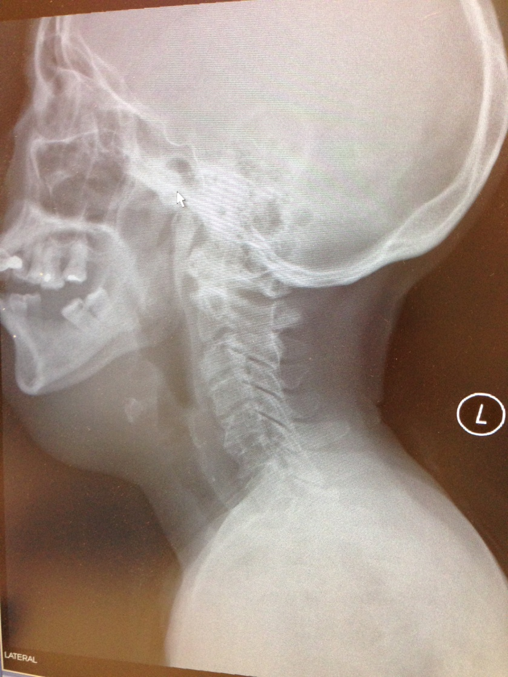
- What is the abnormality of this X-ray? (1 mark)
- Name two groups of bacteria that may cause this condition? (1 mark)
- If the patient’s condition deteriorated, name two airway management of choice for this patient. (1 mark)
- Name two major interventions to treat this condition after airway management. (2 marks)
- What is the mortality rate for this condition despite treatment? (1 mark)

Answers:
- Ludwig’s angina; it may be complicated by airway obstruction. (2 marks)
- Stridor (1 mark); (give cyanosis half mark)
- Dental examination because 80% of the cases are from dental infection. (1 mark)
- Soft tissue swelling at submental and submandibular regions. (1 mark)
- Alpha-hemolytic streptococci, staphylococci, bacteroides, Fusobacterium nucleatum (any two, 0.5mark each)
- Surgical airway or awake nasal intubation (0.5 mark each)
- Iv broad spectrum antibiotics (1 mark) and surgical drainage (1 mark)
- 5-8% (1 mark)

Question 5:
A fifty-eight years old lady slipped and fell in the slope during hiking. She complained of right hip pain after the injury. She was brought to AED and the initial vital signs were as follows: BP/P 155/96 Pulse 101/min SpO2 100% on RA Respiratory rate 24/min GCS 15/15. After initial stabilization and primary survey, an AP pelvis X ray was taken.
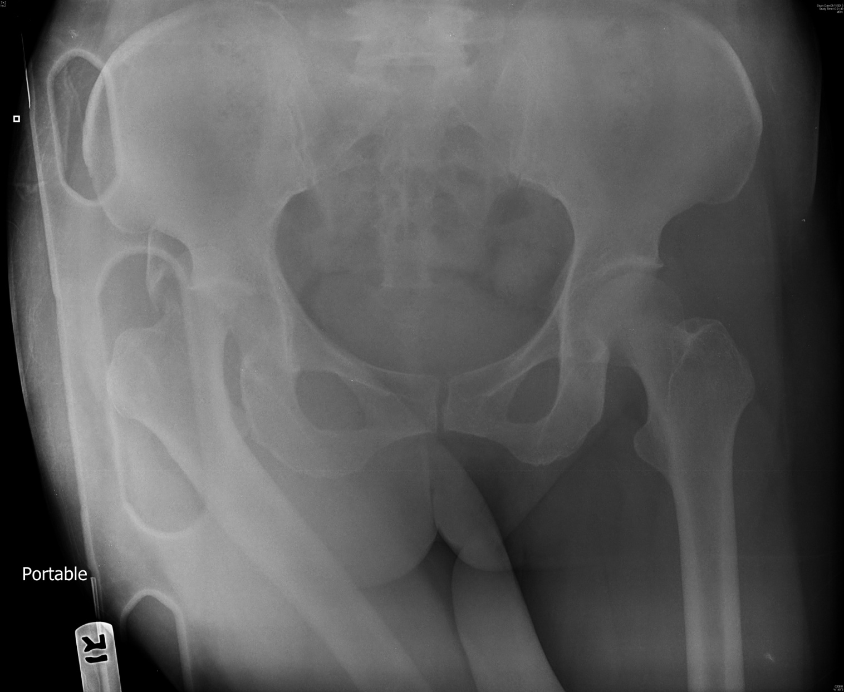
a. What are the diagnoses? (2 marks)
b. What will be the position of her right lower limb on physical examination? (1 mark)
c. Name two complications of this condition. (2 marks)
d. How would you manage this patient? (2 marks)
e. Name two techniques involved in your management of such condition. (1 mark)
f. How would you manage this condition if the above-mentioned techniques are failed? (1mark) Give two possible causes for the failure. (1 mark)
Answers:
a. What are the diagnoses? (2 marks) (one mark for each, up to 2)
Posterior hip dislocation (1)
Femoral head fracture (1)
Acetabulum fracture (suspected) (1)
b. What will be the position of her right lower limb on physical examination? (1mark)
shortened (0.5) and internally rotated (0.5)
c. Name two complications of this condition. (2marks) (one mark for each, up to 2)
a) Sciatic nerve injury (1)
b) Femoral head avascular necrosis (1)
c) Osteoarthritis (1)
d) thromboembolism (1)
d. How would you manage this patient? (2marks)
a) Manage according to ATLS. Treat life-threatening injuries first. (1)
b) Attempt closed reduction under procedural sedation or general anaesthesia as earlier as possible. (1)
e. Name two techniques involved in your management of such condition. (1 mark)
a) Allis manoeuvre (0.5)
b). Stimson maneuver (0.5)
b). Bigelow manoeuvre (0.5)
c) East Baltimore lift technique (0.5)
f. How would you manage this condition if the above-mentioned techniques are failed? (1 mark) Give two possible causes for the failure. (1 mark)
Open reduction (1)
a) button holing of the femoral head through the capsule (0.5)
b) entrapment of the labrum, gluteus maximus (0.5),
c) psoas and pisiformis tendon entrapment (0.5)
d) bony fragment entrapment from acetabular or femoral head fracture (0.5)

