Q1)
- Fluid level in the Lt frontal sinus.
- Water’s view (also called occipitomental view)
- The maxillary sinuses are clear. There is fluid level in the Lt frontal sinus.
- 1) Lt frontal headache; 2) stuffy Lt nostril; 3) Nasal discharge from Lt nostril; 4) Low-grade fever; 5) Post-nasal dribbling; 6) loss of smell

Q2)
- Bilateral subdural hemorrhage. The 2 sides are of different ages. The right is relatively hyperdense and is of more recent onset. Compression of the anterior and posterior horns of lateral ventricles and third ventricle on the Lt side suggesting a rise in ICP +/- acute-on-chronic hemorrhage.

- Confusion / Decreased level of consciousness
- Headache
- Fall / Difficulty with gait or balance
- Poor memory / Cognitive dysfunction or memory loss
- Personality change
- Weakness / Motor deficit (eg, hemiparesis)
- Speech difficulty / Dysphasia
- Vomiting
- Thrombocytopenia, thrombocytopathy, diminished fibrinolysis
- Mannitol 1g/kg rapidly by iv push

Q3)
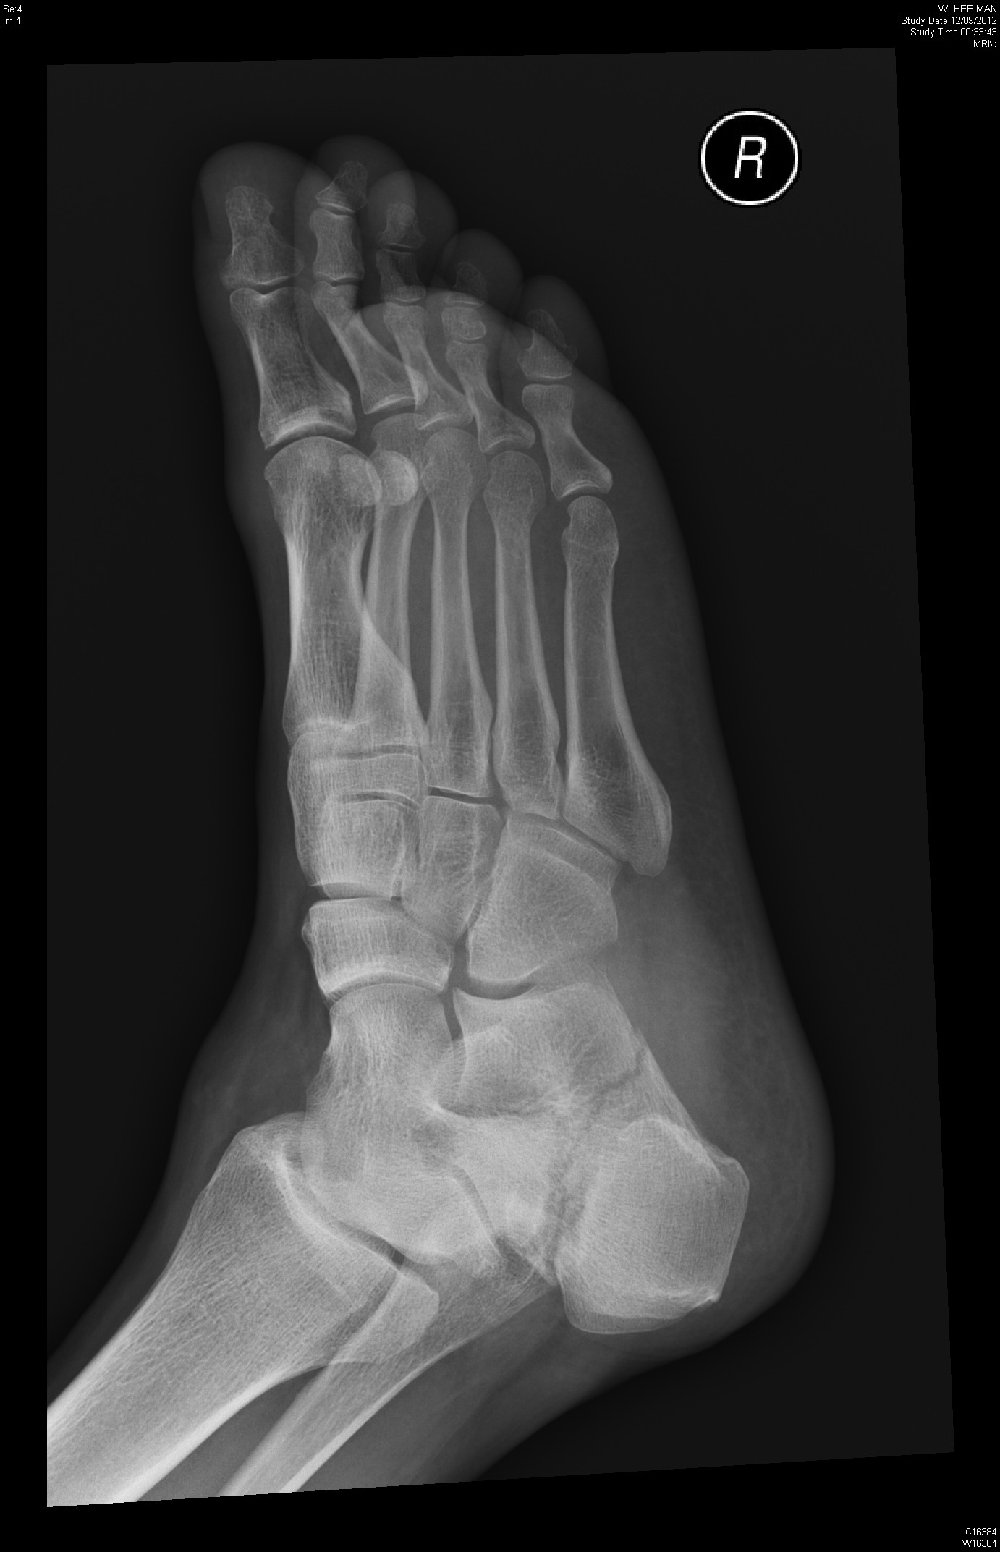
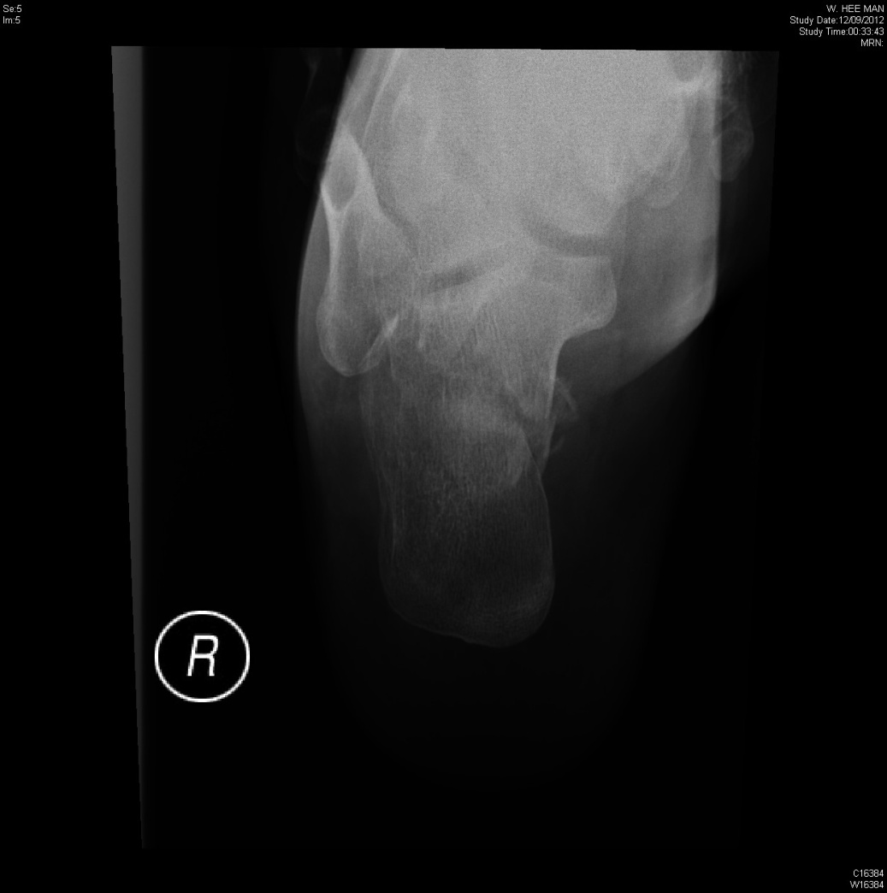
- This is the lateral view of the Rt ankle. It shows a diminished Bholer’s angle.
- Possibly # of the right calcaneum.
- Order an x-ray of the Rt calcaneum. CT scan Rt calcaneum if available.
- Fact: # of Rt calcaneum into 2 or 3 pieces with involvement of subtalar joint. X-ray is not a good tool for classification. A CT scan is currently the imaging study of choice for evaluating calcaneal injury.

Q4)
- Multiple pustules on the medial surface of the left calf and one or two pustules on the medial surface of the right calf. Each pustule can be traced back to a hair and a hair follicle.
- Acute folliculitis (no point for herpes zoster!)
- Staph aureus OR Pseudomonas spp.
- Systemic Cloxacillin/Flucloxacillin (either oral or iv)

Q5)
- Back of the patient: Neurofibromata; café-au-lait spots; surgical scar (thoracotomy) on the right
- Neurofibromatosis type I (or von Recklinghausen disease)
- Thoracic scoliosis (convex to Rt); lateral meningocele Rt hilar region
- 50% chance of being normal. NF-I is autosomal dominant, the chance of receiving and expressing a particular gene is 50% regardless of the sex of parent or child.

