Q1. A 35 year-old construction worker c/o facial pain. He was diagnosed trigeminal neuralgia by a GP. X-ray of the face was ordered by a junior doctor.

- What is shown in the x-ray below?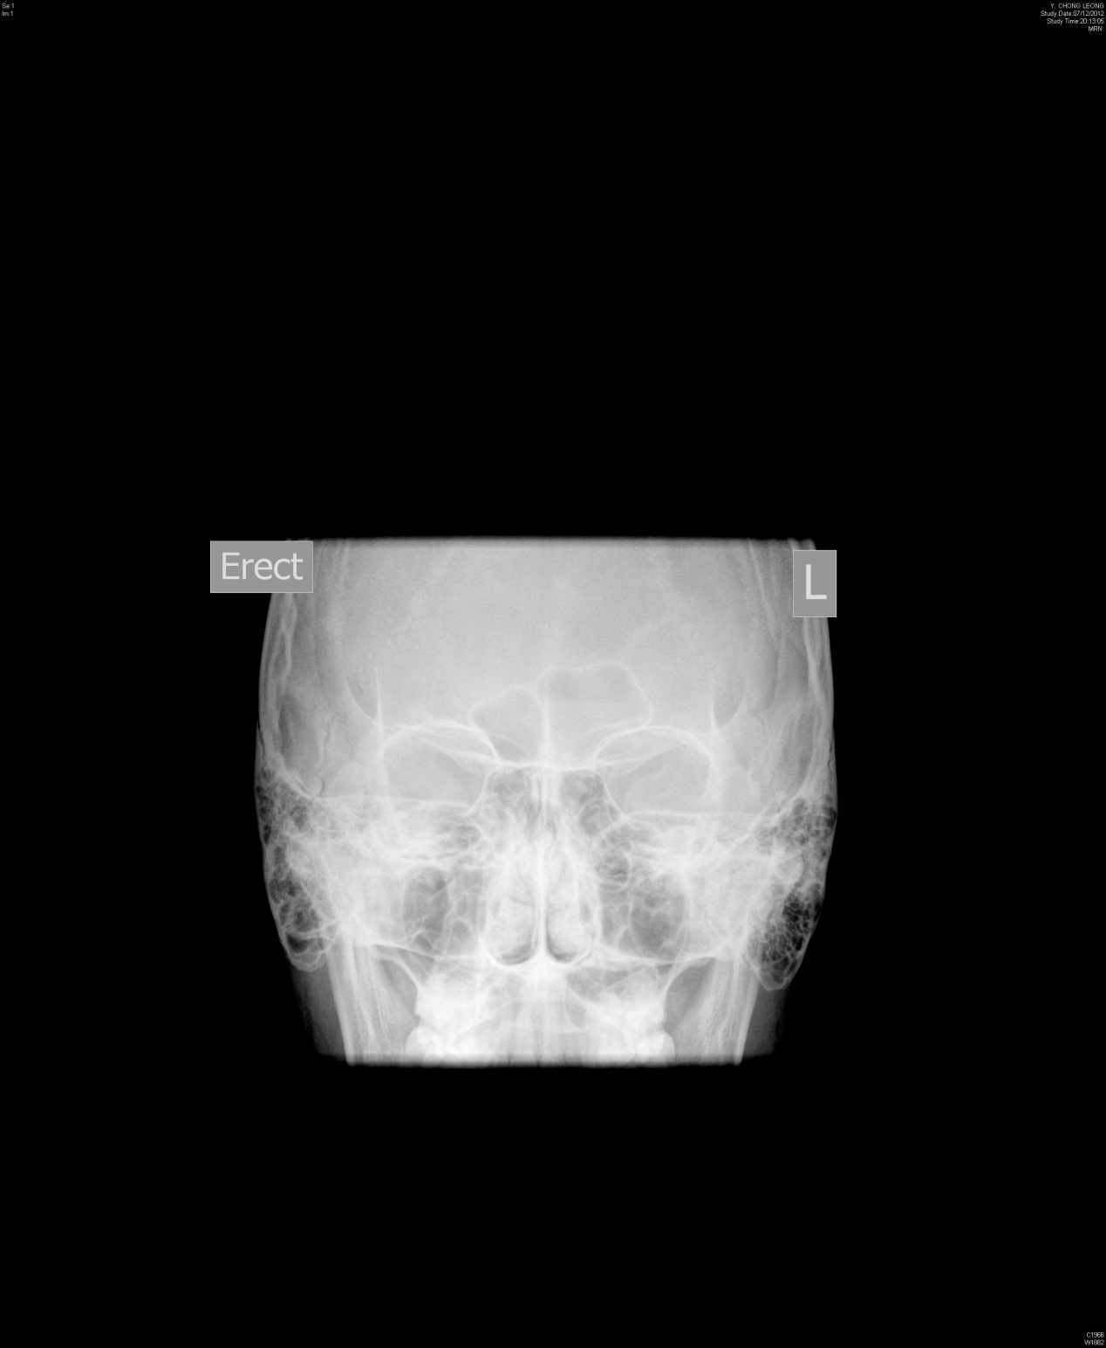
- A senior doctor was not satisfied with the x-ray, he wanted to visualize the maxillary sinuses. What view should he order?
- This is the x-ray of the new set. Please comment on the x-ray.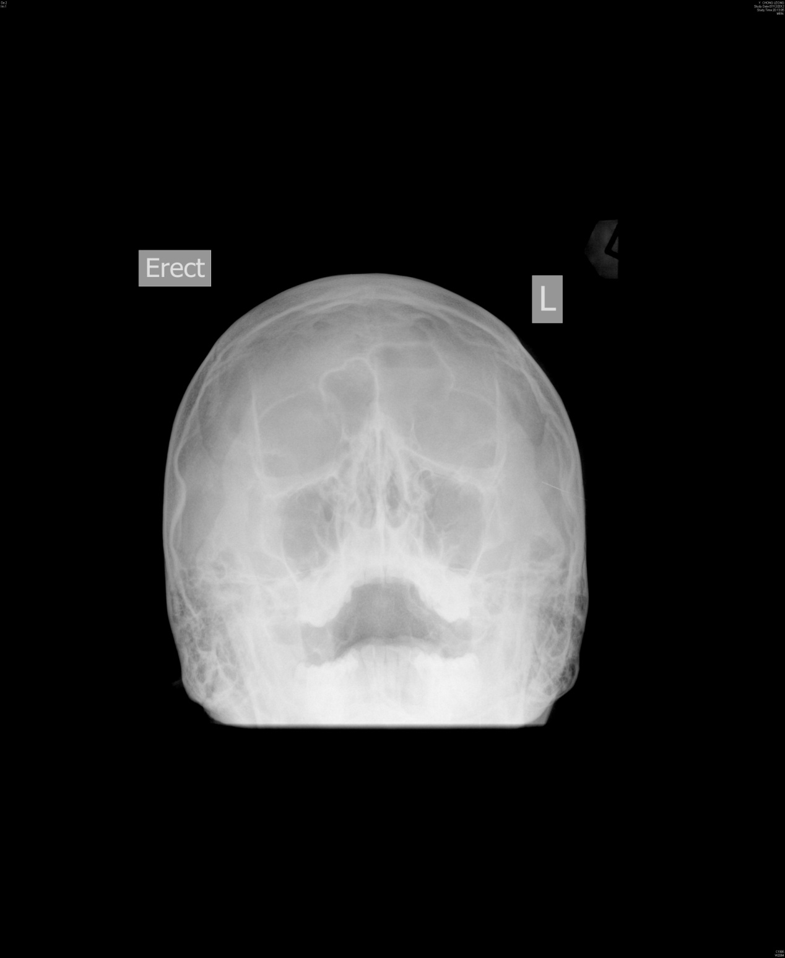
d) What clinic features would you expect from this patient. Name four.

Q2) A 50 year-old man with history of alcoholism presented with drunkenness to A&E. While pending recovery in the reassessment area he vomited 3 times. Your nursing staff suggested a “brain scan”. You reluctantly ordered a plain CT-scan brain.

- What are the abnormalities shown in the brain scan (Im 15 & 17)?
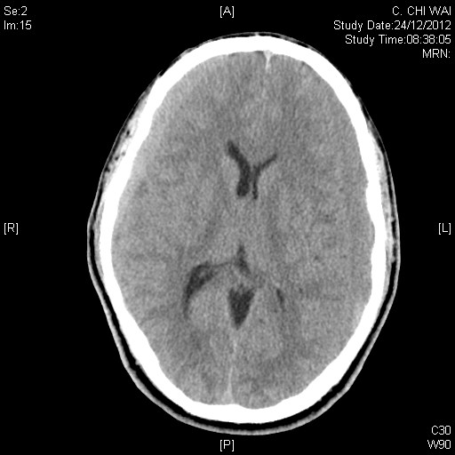
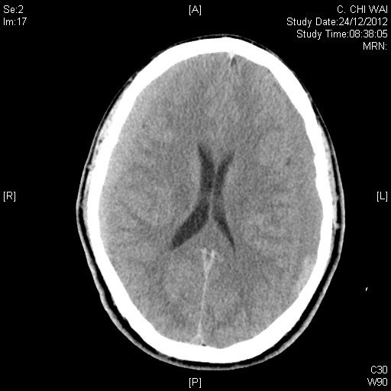
- On repeated physical examination, you found no external wound on this patient. His wife volunteered a mild head injury after a fall 4 days ago and he had another fall last night (just about 12 hours ago). Please name 5 symptoms the patient might have in this admission.
- What disorders of blood-clotting system would an alcoholic have?
- In the resuscitation room, what medication can you give to lower the ICP of this patient? Please specify the dosage and route of administration.

Q3) A 25-year old robber was brought to the A&E after being caught in a chase. The robber claimed to have sprained his right ankle and could not walk. o/e: the right ankle/foot was swollen, tender and bruised.

- Describe the x-ray.
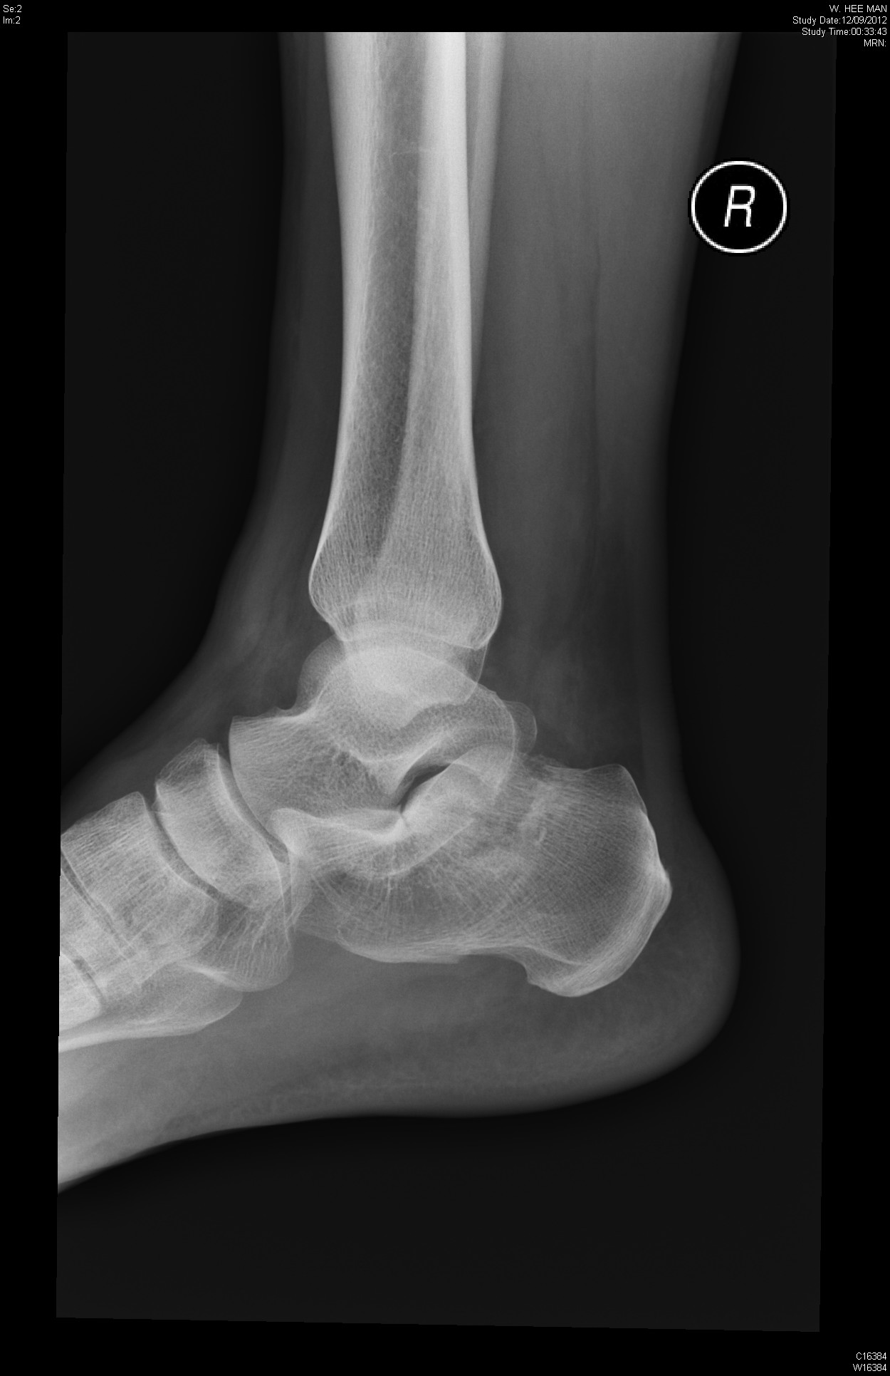
- What is the abnormality of the x-ray?
- How could you confirm your clinical suspicion?
- One of your seniors said x-ray is insufficient to classify the calcaneal fracture. Do you agree? What is the current mode of investigation for calcaneal injury?

Q4. A 38-year man went to Thailand for a holiday vacation. On returning to Hong Kong, he found both his feet were itchy. On the second day, he noticed a few red dots in the left leg medial aspect. He admitted massage during the trip.

- Describe the picture.
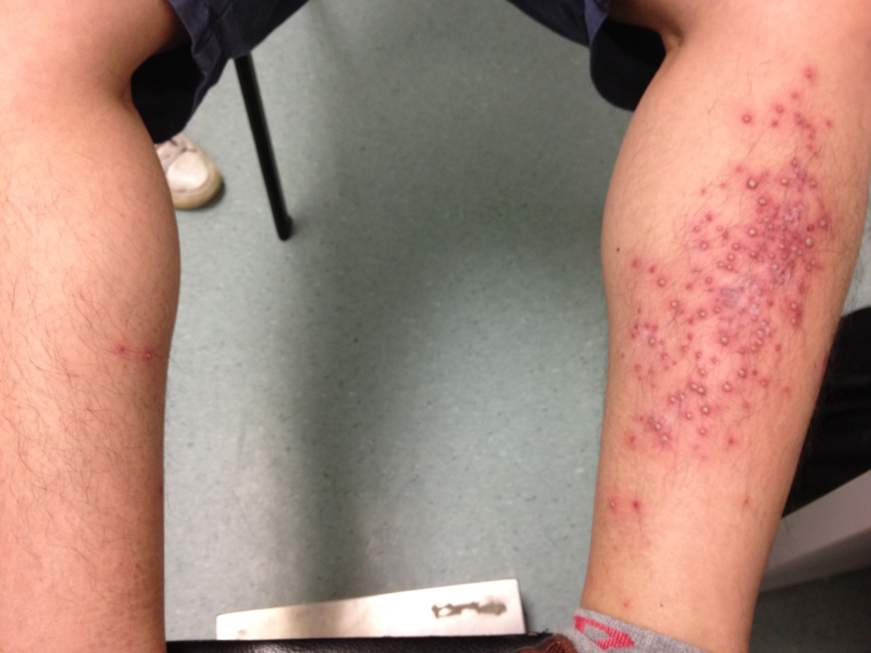

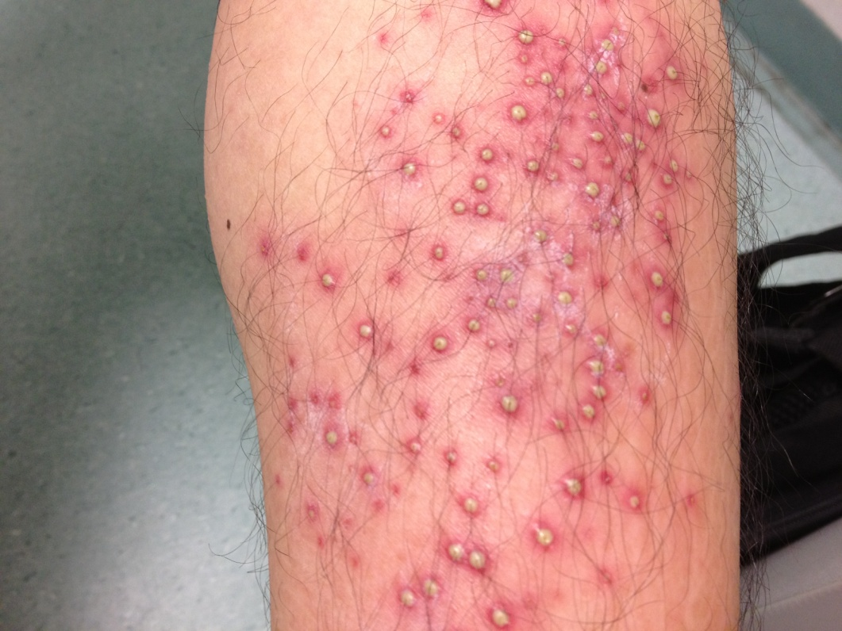
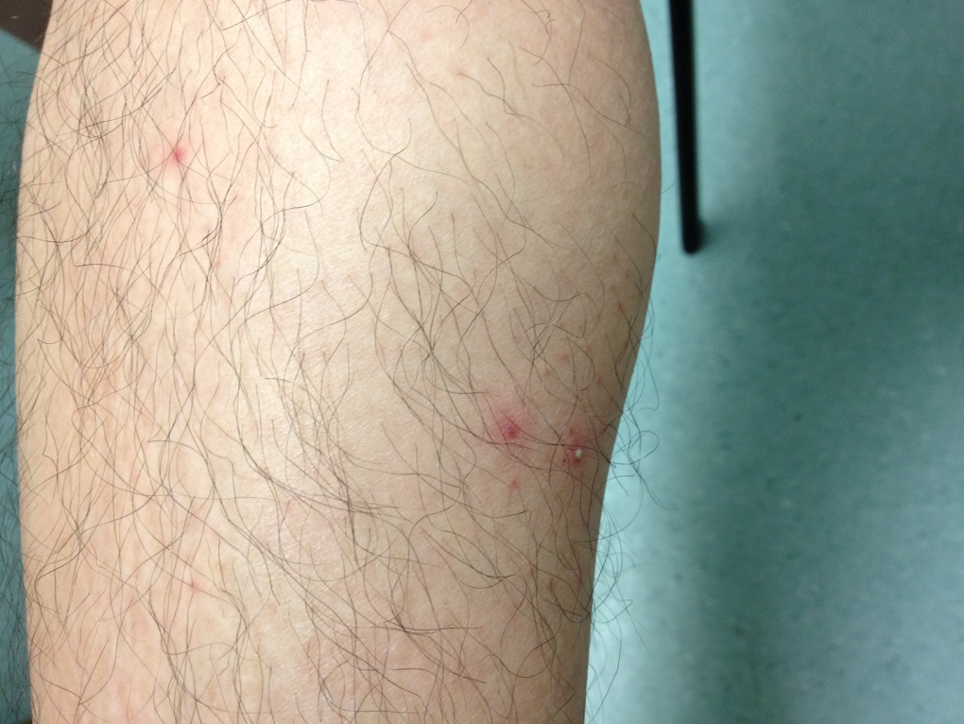
- What is the diagnosis?
- What is the causative agent of this condition?
- What specific treatment is available?

Q5. A 30-year old new immigrant from China presented with shortness of breath.
- Please describe the picture.
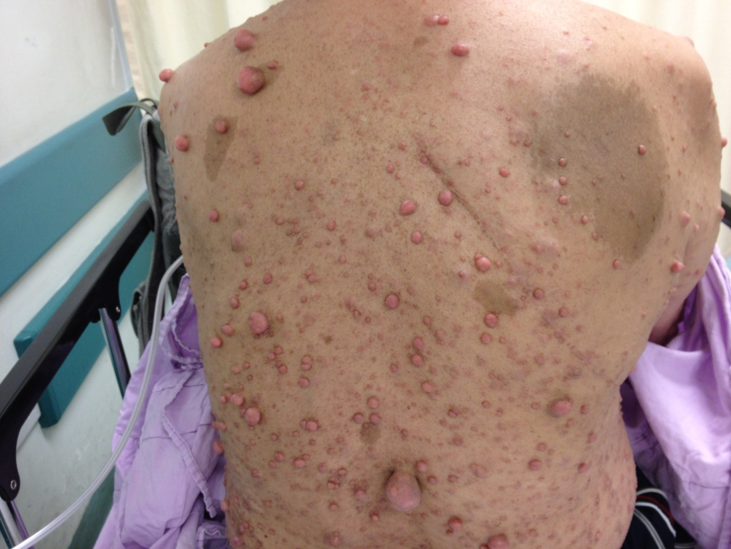
- What is the diagnosis?
- A CXR was taken. Describe what you see.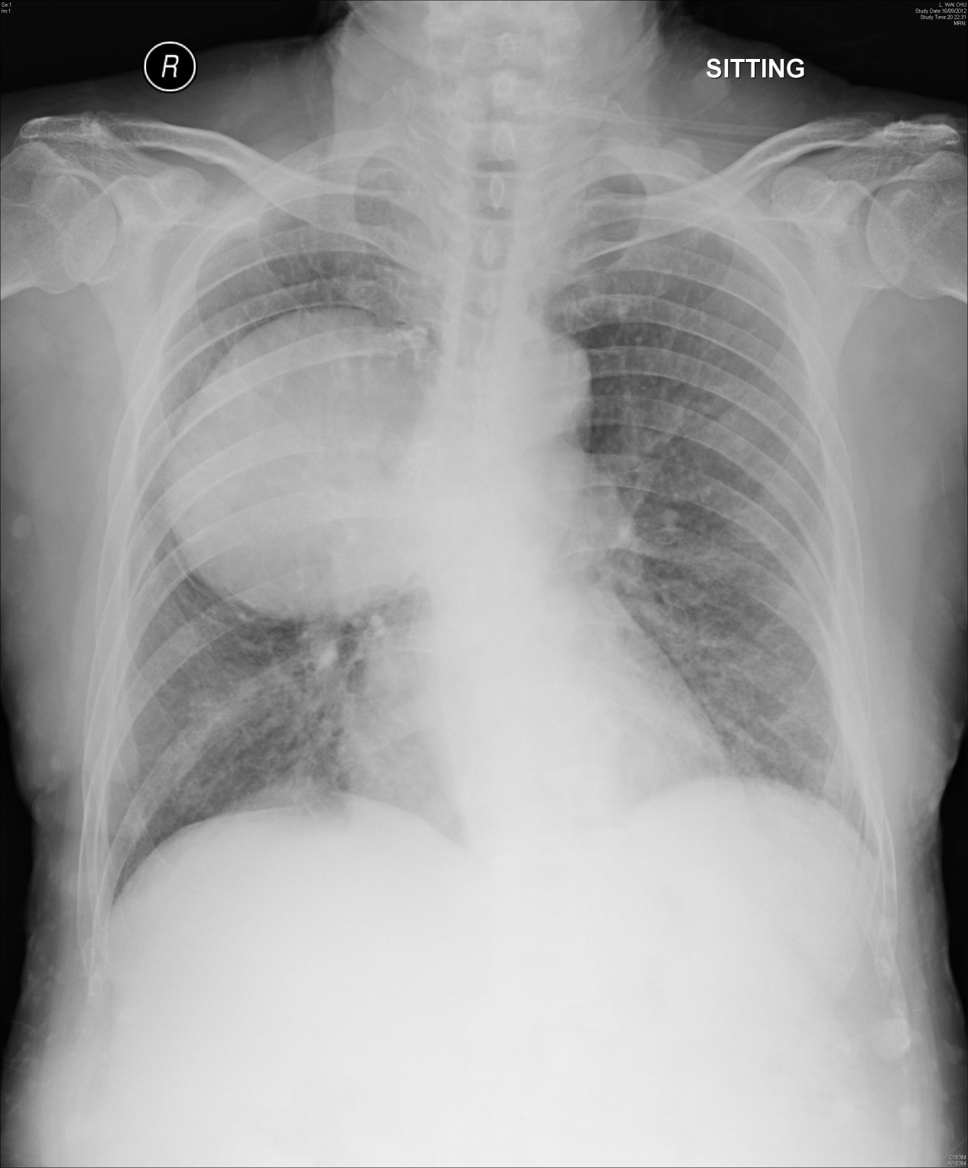
- His wife is pregnant. What is the probability of giving birth to a normal baby without this condition?

