Q.1
A 39 years old gentleman presented to AED due to pleuritic chest pain and SOB for 4 days. He enjoyed good past health. The vital signs were stable. ECG was performed.

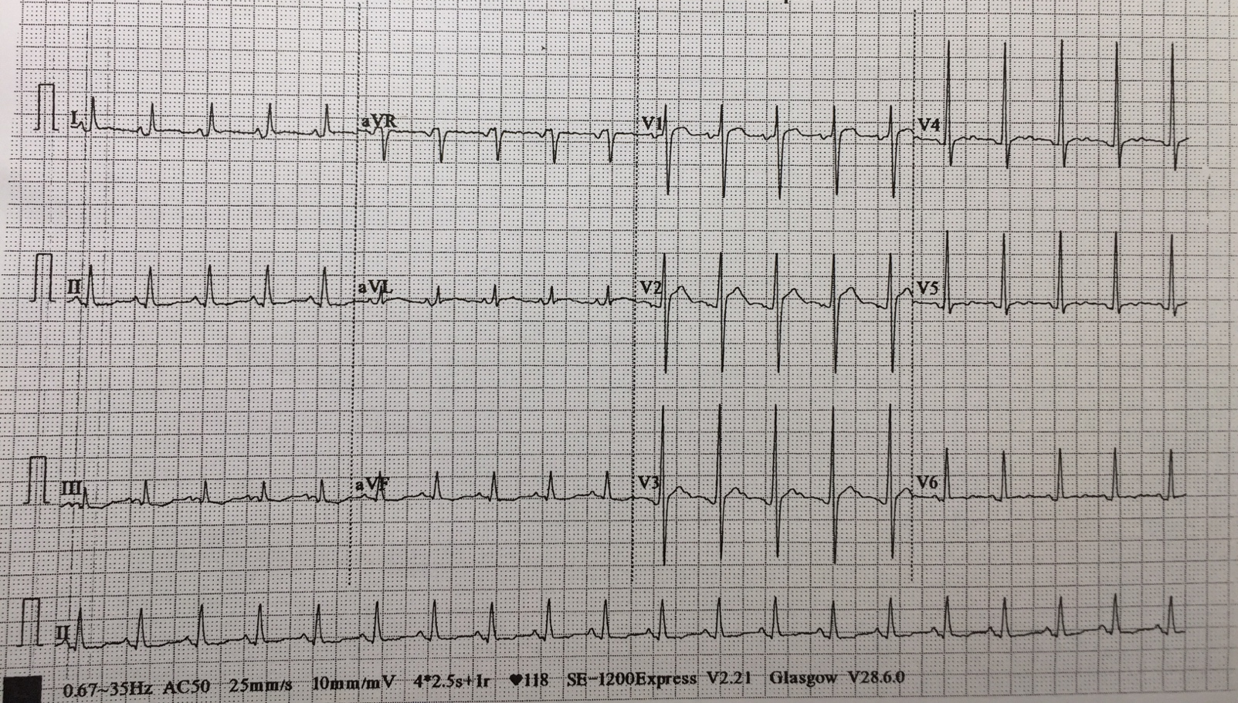

- Please describe the ECG abnormalities. Give 3.
- What is the most likely diagnosis?
- What specific sign you will look for to support your diagnosis?
- How to differentiate the above diagnosis and acute myocardial infraction in ECG? Give 4.
- What is the pharmacological treatment? Give 2.

Q.2
A 55 years old gentleman presented to AED due to fall with out stretched left hand. He complained left wrist pain and decreased range of movement over the left wrist. Physical examination showed tenderness along the ulnar border of the left wrist. X-ray of the left wrist was taken.

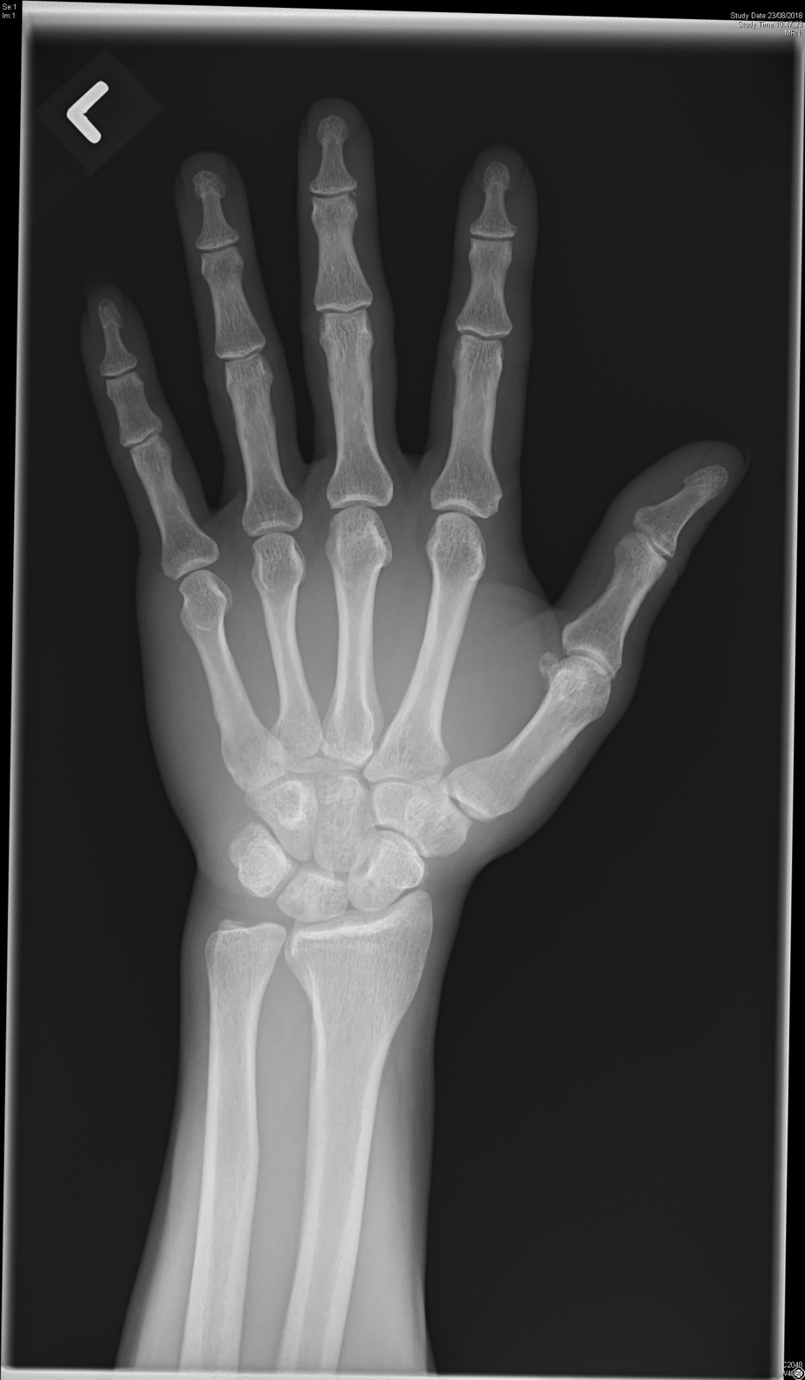

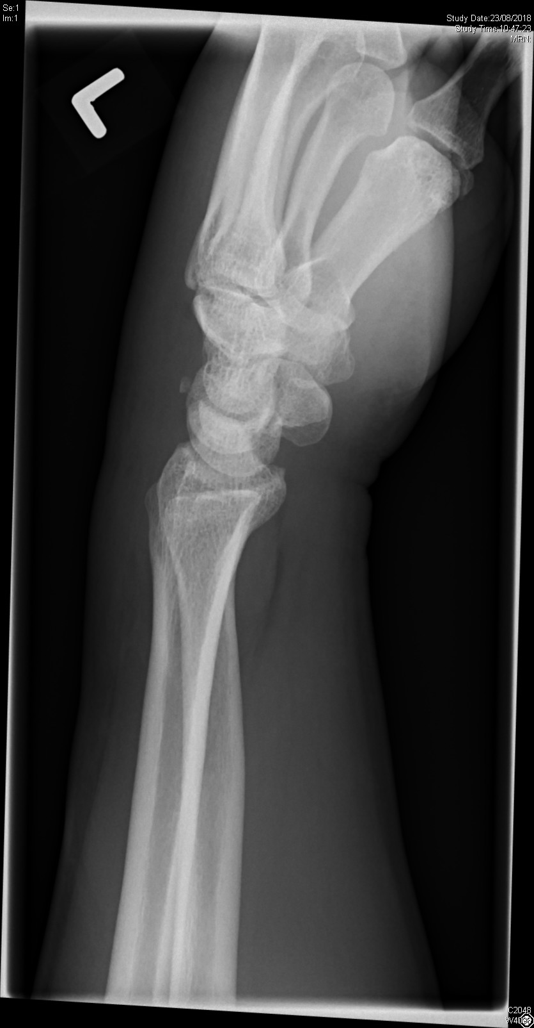

- What is the x-ray finding? And what is the diagnosis?
- What is the mechanism of injury?
- What is the indication for surgical intervention? Give 4.
- What is the non-surgical management?
Q 3
75 years old gentleman with history of hypertension and DM, presented to AED for dizziness and syncope. ECG was performed.
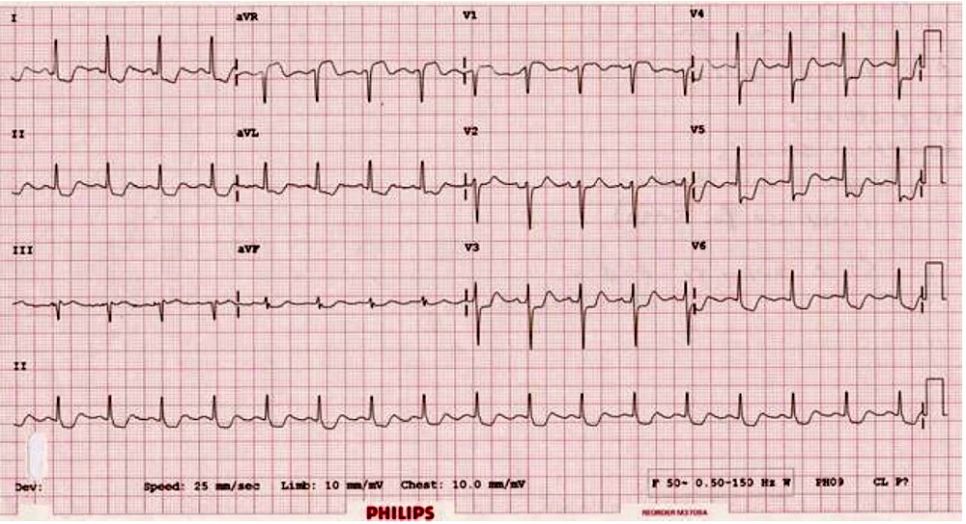
- Please describe the ECG findings.
- What is the differential diagnosis?
- What is the ED management?

Another patient presented to AED with central chest dull discomfort for 1 hour.
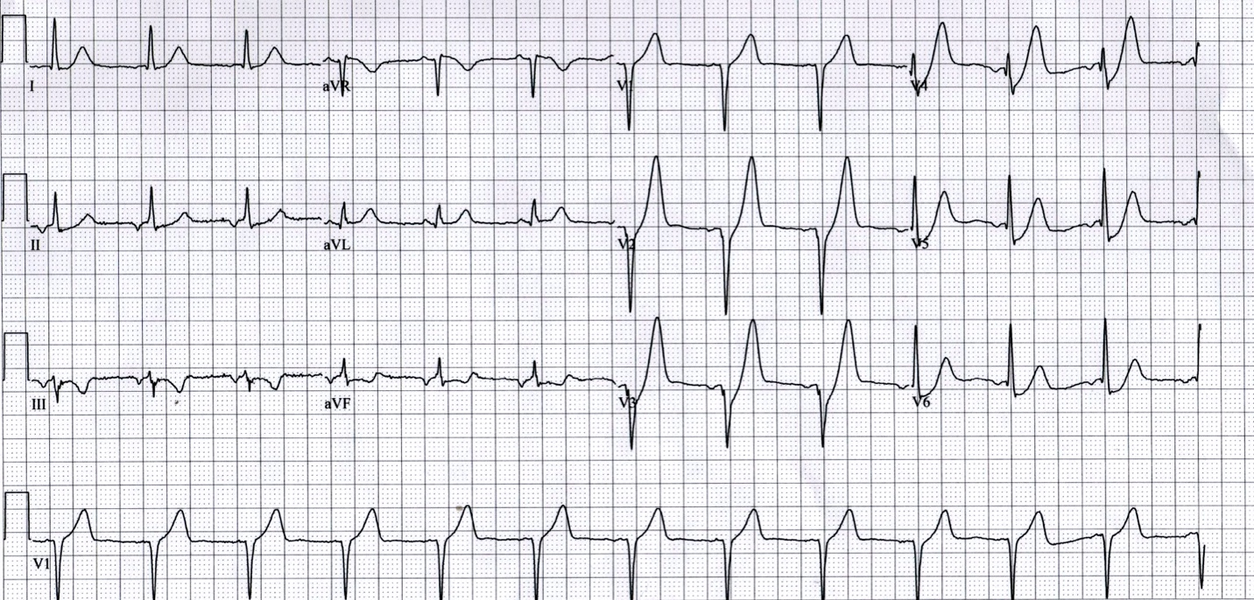
- Please describe the ECG findings.
- What is the diagnosis?
Another poor patient with chest pain.
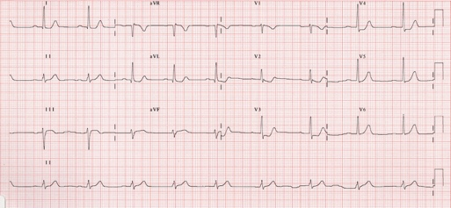
- Please describe the ECG findings.
- What is the diagnosis and how to confirm?

Q 4
70 years old lady with history of DM, presented to AED with fever, malaise and abdominal pain.
BP 80/40mmHg, P 120 bpm, Temp 39C. AXR was performed.
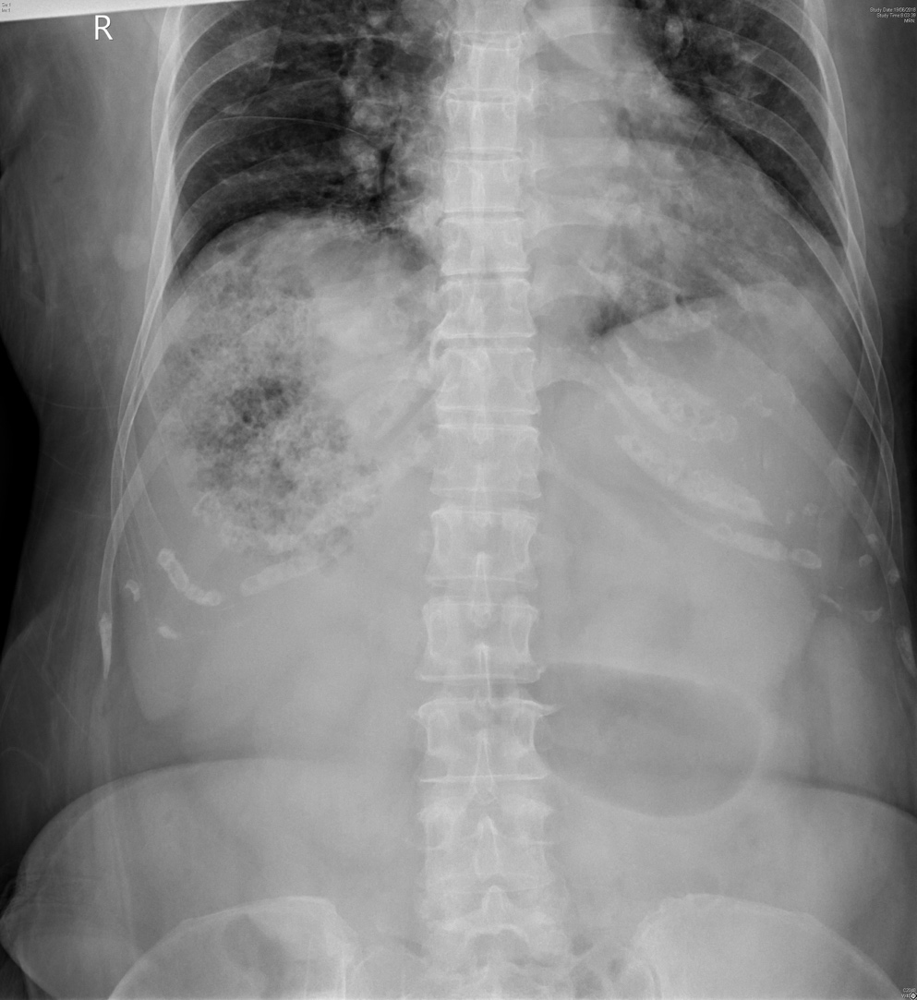

- Please describe the AXR findings.
- What is the diagnosis?
- What is the most likely pathogen causing the condition?
- What is the complications?
- What is the ED management?

