JCM OSCE 5/6/2019
- M/36, metal factory worker, found lying on ground in a park. GCS E4V1M1. BP 123/81 mmHg, P 118/min. RR 16/min. SPO2 98% RA. Temp 36.5C. Pupils equal and reactive 4mm.
- List 5 differential diagnosis.
- POCT was done. What is the anion gap?
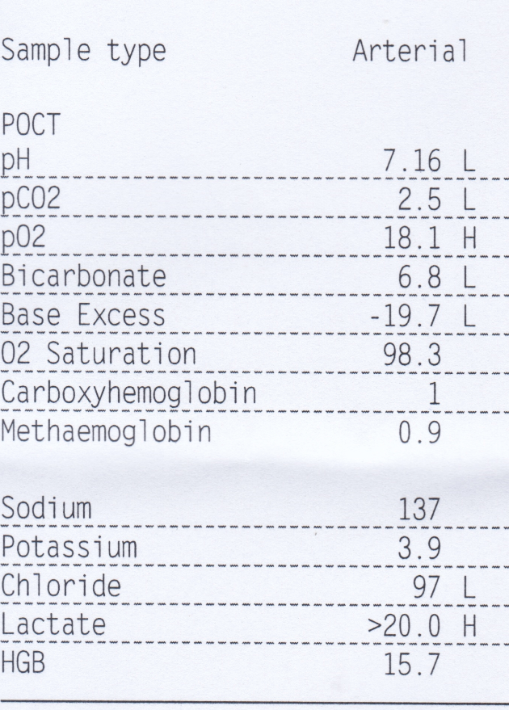
- What is the diagnosis based on the POCT result?
- List 4 further investigations to find out the underlying cause.
Patient subsequently regained consciousness and volunteered ingestion of cyanide for suicide attempt.
- What are the sources for cyanide in general?
- What are the specific antidotes for cyanide poisoning?

- M/55. Good past health. Attended for retrosternal compressive chest pain for 30 minutes. Vital signs stable. ECG was done.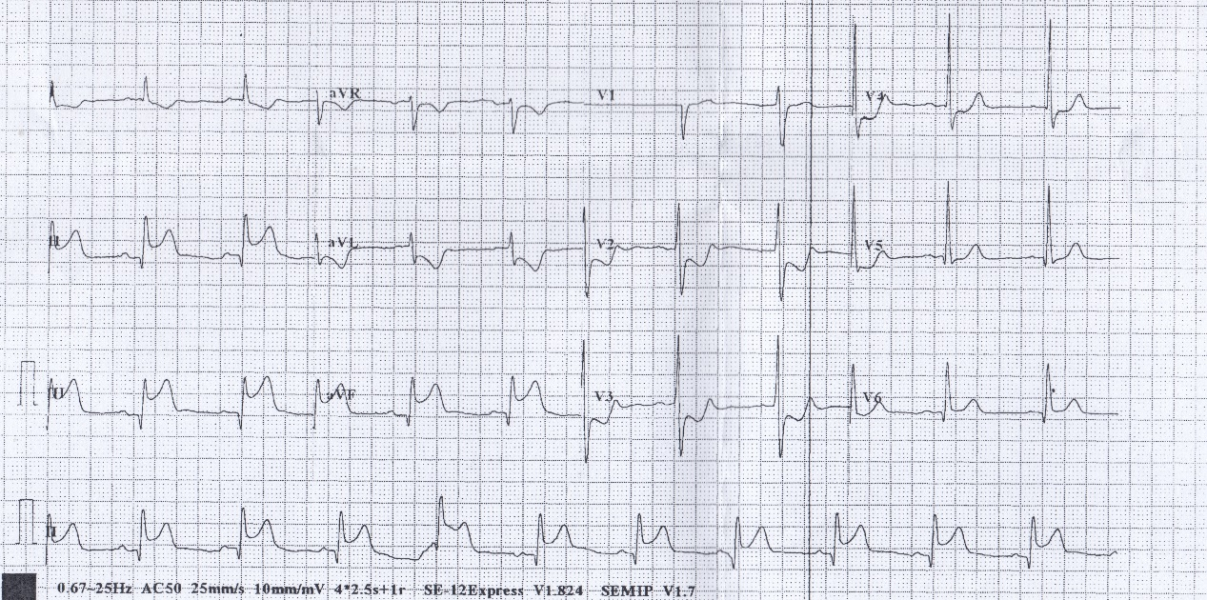
- List 2 ECG findings
- What further investigations are to be done in AED?
- Special ECGs were done.
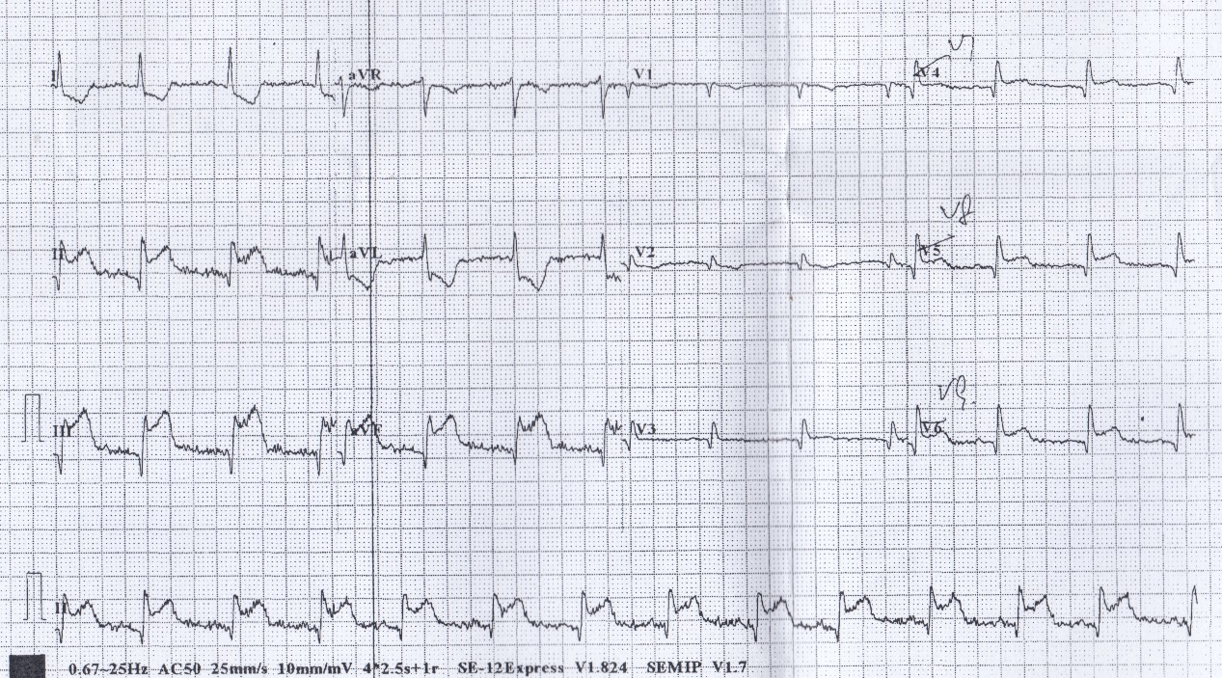
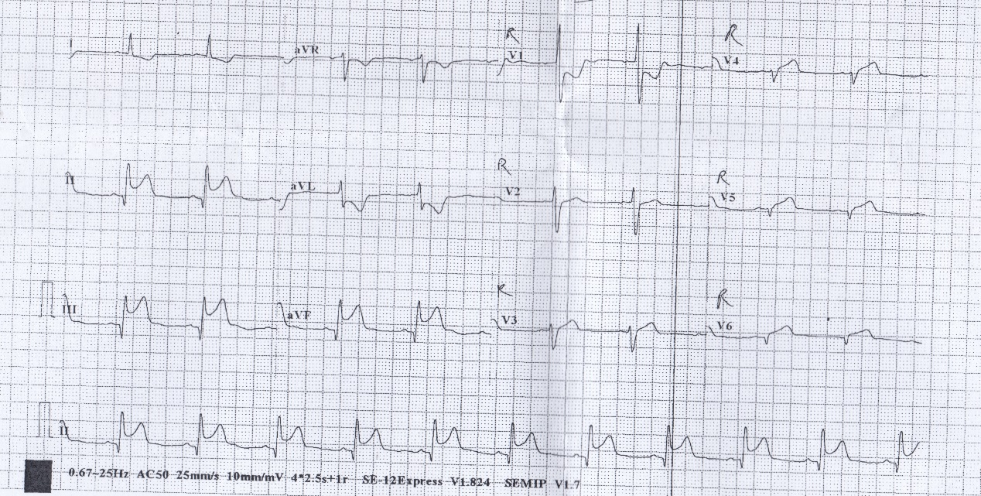What is the diagnosis now?
- What are the treatments to be done in AED?
- What treatment is contraindicated if the disease involved the right ventricle?

- F/40. good past health. attended AED for URI symptoms. CXR was taken.
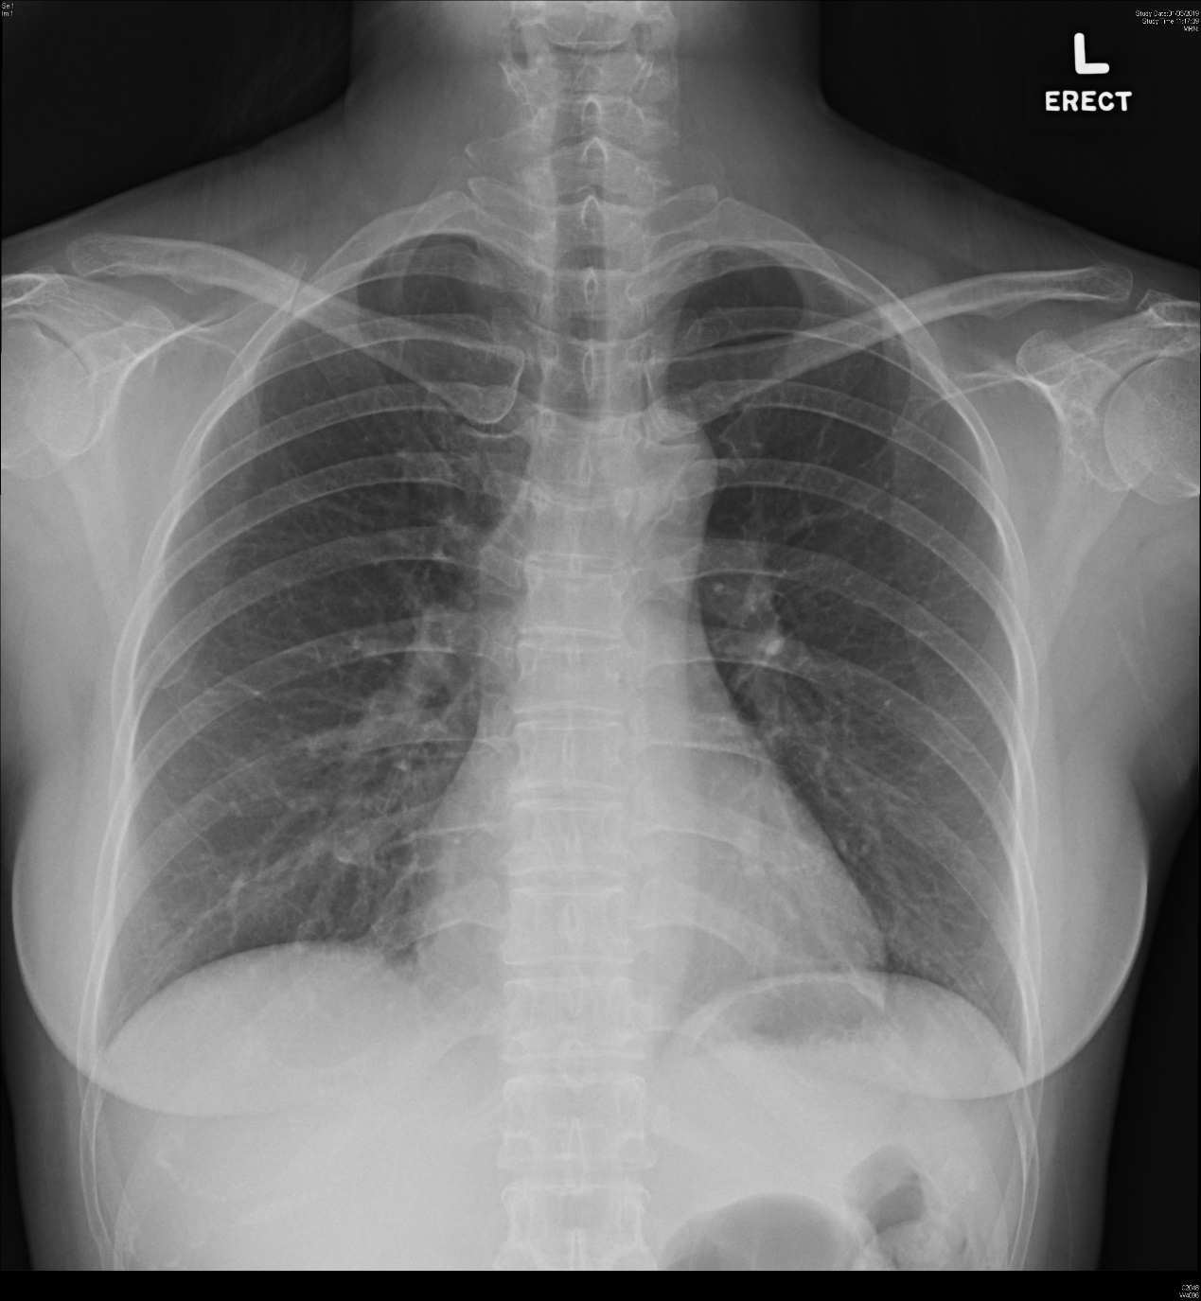
- What is the radiological diagnosis?
- What are the usual clinical presentations?
- What is the treatment option for symptomatic patients?

- M/52. Good past health. He complained of fever, dysphagia and sore throat for 3 days. A neck XR was taken.
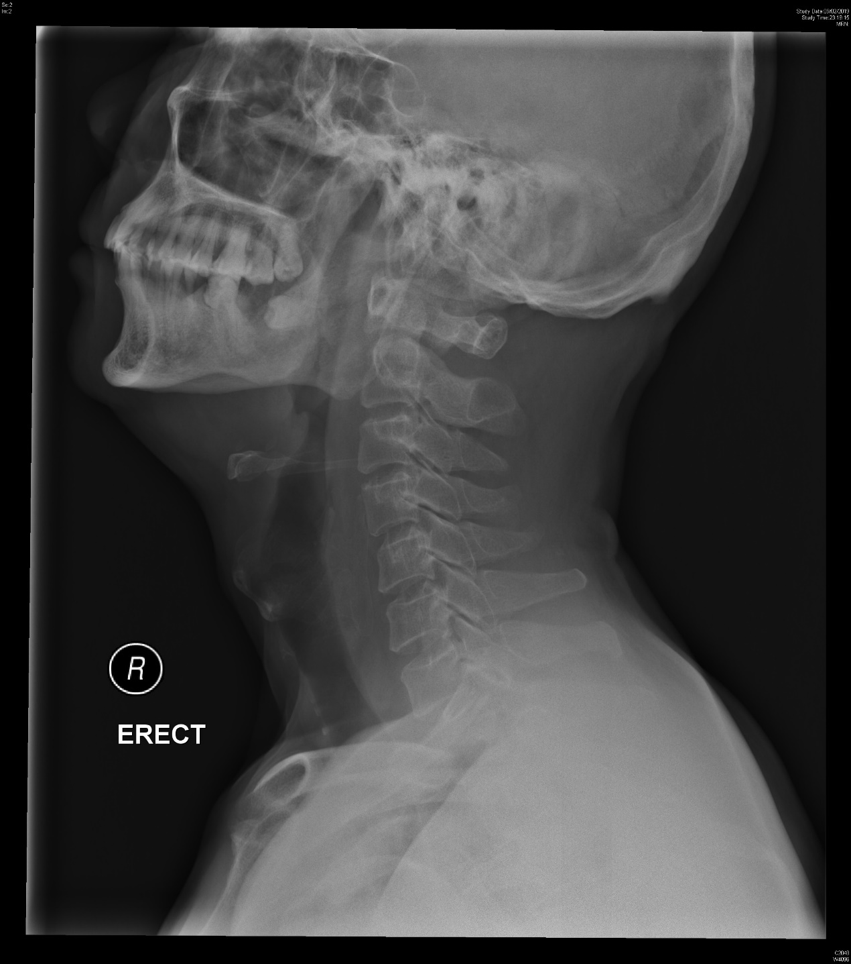
- What is the radiological finding?
- List 3 differential diagnoses.
- List 2 subsequent investigations.
- A contrast CT neck was done. 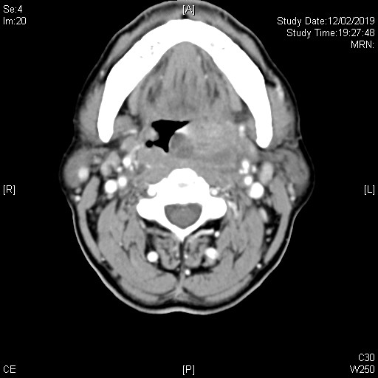
What is the diagnosis now?
- What are the underlying causes for this disease?
- What is the definitive treatment?

- F/72. Attended for minor head injury by falling over occiput. GCS full. Plain CT brain was done.
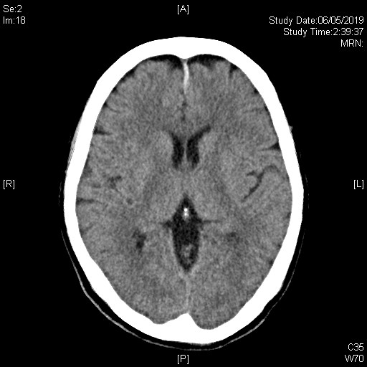
- What is the radiological diagnosis?
- What is the mechanism of this injury?
- What are the common risk factors for this condition?
- List 4 management for this patient.
- List 3 potential complications.

- M/50. He slipped and fell and injured his left leg, complaining of left knee pain. XR left knee was done.
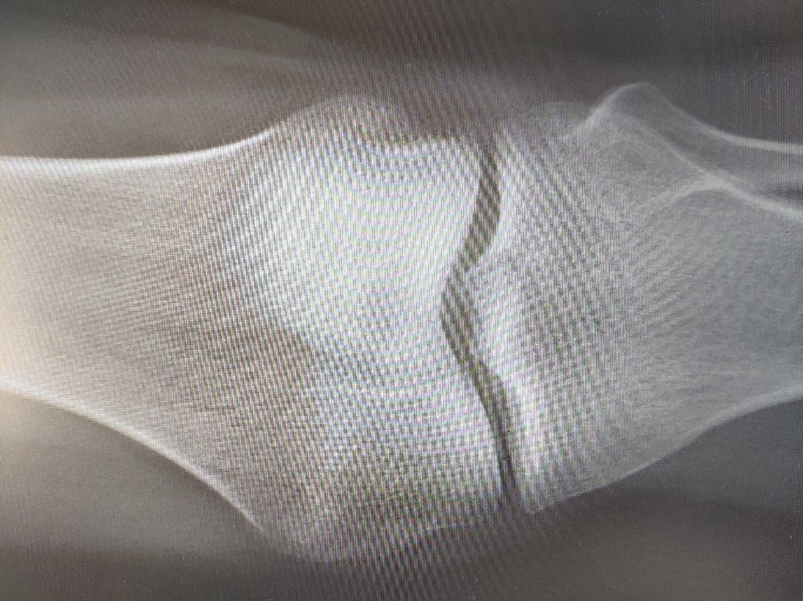
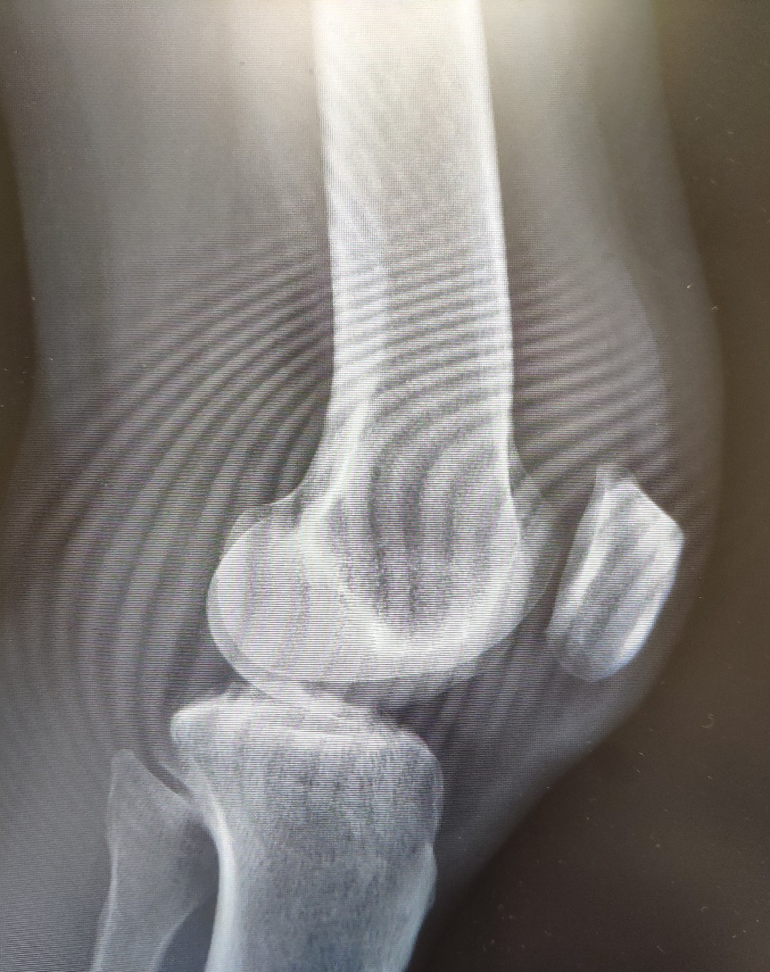
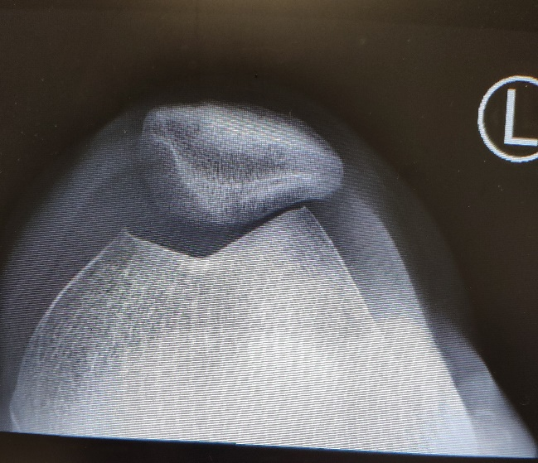
- What is the radiological diagnosis?
- What is the most common age group for this injury?
- Name the classification system for this kind of injury.
- How to treat this injury non-operatively?
- What are the complications of this injury?

