Question 1

A 72-year old man complaint of sudden onset left side weakness 30 minutes ago. His wife found that he was sitting on floor and vomited undigested food.

He had the following past medical history:
- Hypertension
- Diabetes Mellitus
- Hyperlipidemia

Vital signs:
BP 42 / 28 mmHg, Pulse rate 90/min
Body Temp.36.4 C SpO2 100% on Room Air

Physical examination:
PEARL 3mm, R side sluggish
No facial asymmetry
Limb power:
5|0
5|4-
Plantar reflex: Left side upgoing; Right side downgoing

- You worry the patient had acute stroke. What is the definition of stroke?

_________________________________________________________________________________

_________________________________________________________________________________

- Can you give five diagnoses of stroke mimics?

_________________________________________________________________________________

_________________________________________________________________________________

Non-contrast Computed Tomography of Brain (CTB) was performed and showed no intra-cerebral hemorrhage and evidence of space-occupying lesion e.g. edema

- What are the early sign of cerebral ischemia in non-contrast CTB? Please give 4.

_________________________________________________________________________________

_________________________________________________________________________________

_________________________________________________________________________________

_________________________________________________________________________________

At the resuscitation room, the blood pressure on right arm was 42/28 mmHg. Then the nurse took blood pressure over left arm and was 54/37. After that the nurse took blood pressure over left thigh and was 104/55.

A CXR also performed
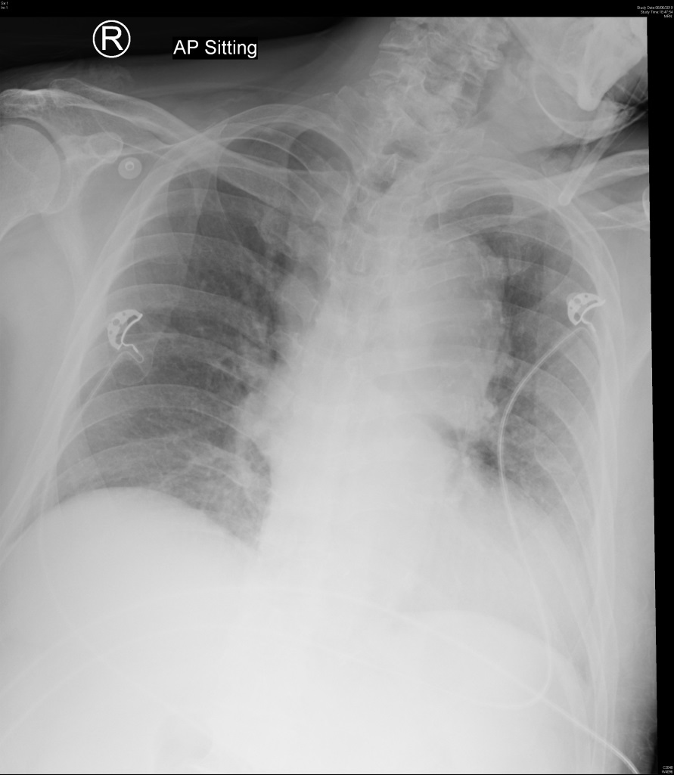

d) Please comment the CXR and what do you worry with this CXR together with the above-findings and why?
Can you write down four other ‘typical’ findings in CXR for this condition?
What is the imaging of choice to diagnose this condition?

______________________________________________________________________________

______________________________________________________________________________

______________________________________________________________________________

______________________________________________________________________________

______________________________________________________________________________

______________________________________________________________________________

______________________________________________________________________________

Here is the CT you finally request.
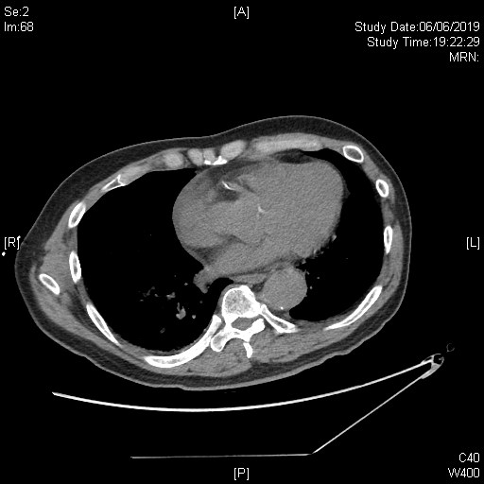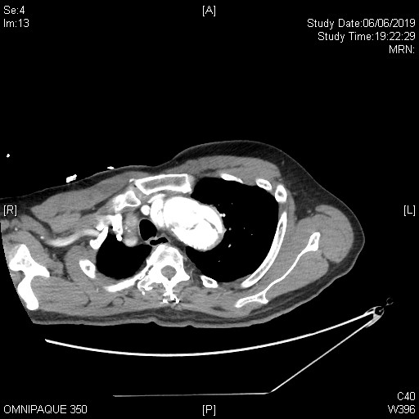
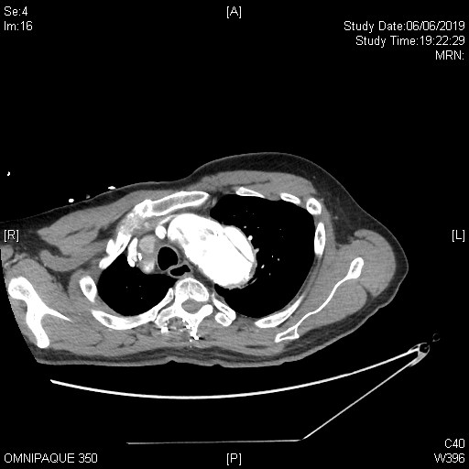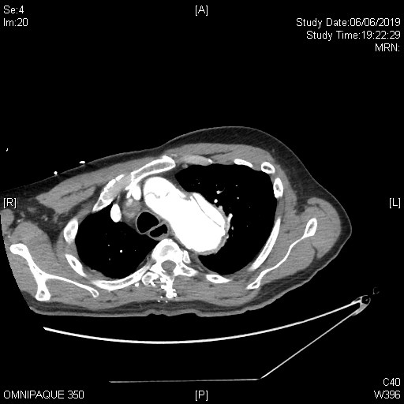

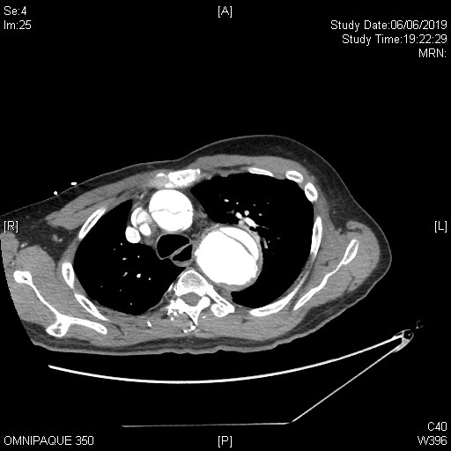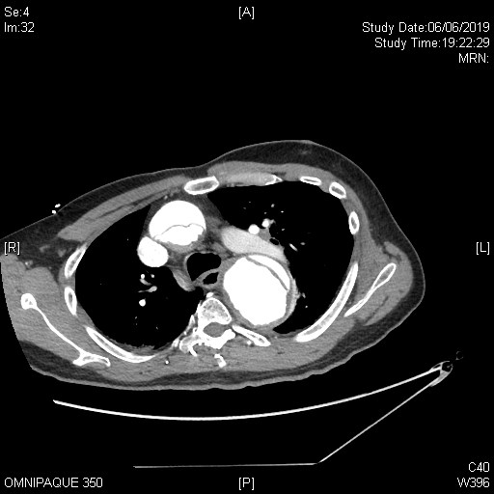

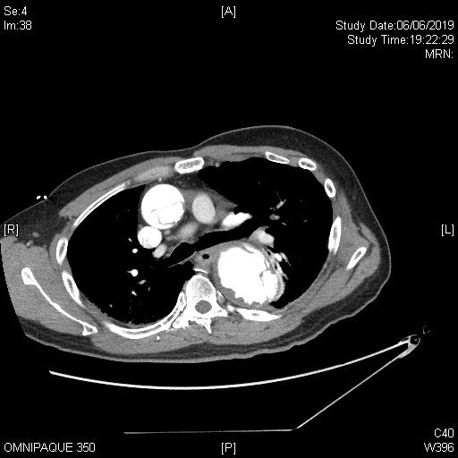

e) What is the diagnosis? What branch(es) are involved (from the CT findings and the clinically findings)

_____________________________________________________________________________

_____________________________________________________________________________

Question 2

Several junior doctors are not familiar with the management of animals bite and indication of rabies vaccination and ask you for help.

- A lady was bitten today by her own dog which has received full vaccination.

- A man with unremarkable past health was bitten by a dog in Malaysia two days ago and did not seek medical help

- A man was bitten by a dog in mainland China three days ago and went to Hospital in China and received vaccination on the same day.

He gave you the details of the vaccination: Human Diploid Cell Vaccine (HDCV)

- A man with good past health was bitten by a dog in mainland China three days ago and went to Hospital in China and received vaccination on the same day. He threw away the vaccination record and cannot give you the details of the vaccination.

- A woman with SLE on steroid for a long time was bitten by a bat/ bats over her left hand and right leg when she went to a cave today.

- A man with good past health noticed there was a bat in his room. He was awake and conscious all along. There was no obvious wound over his body.

- A man is receiving a course of Verorab. But he forgot to come back to AED 2 days ago for Day 7 dose.

- A man has been received full course of Verorab 3 years ago was bitten by a dog in Hong Kong today but he felt that the dog could not be caught as he forgot how the dog looks like.

Question 3

A 40-year-old man with good past health complained of increased occipital headache for 1 day, vomiting and blurred bilateral vision.

BP: 207/157

PE: GCS full, no focal neurology, neck soft

RFT: Cr 23

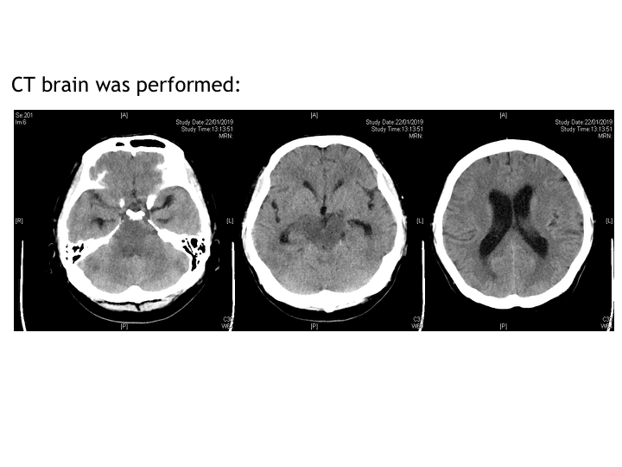
- What is the clinical diagnosis?

B) Describe the CT brain. What is the most likely diagnosis based on the radiological findings combined with the clinical picture？

_________________________________________________________________________________

_________________________________________________________________________________

C) Apart from hypertension, what are the other possible risk factors for this condition?

_________________________________________________________________________________

_________________________________________________________________________________

D) What are the possible clinical manifestations?

_________________________________________________________________________________

_________________________________________________________________________________

_________________________________________________________________________________

_________________________________________________________________________________

E) What further Ix should be done?

_________________________________________________________________________________

_________________________________________________________________________________

_________________________________________________________________________________

F) How do you treat the condition?

______________________________________________________________________________

______________________________________________________________________________

______________________________________________________________________________

______________________________________________________________________________

Question 4

A 69-year-old man was found to have acute confusion 2 hours ago by family. He has recently DAMA from medical ward with the same condition.

He was on multiple PCMs.

BP: 186/116 P: 132/min temp: 37.8C

GCS E2V2M5

Pupils: 4mm bilaterally

Dry and red skin

- What is the toxidrome of this patient?

_________________________________________________________________________________

B) Give 2 examples of herbal medicine that would give rise to this toxidrome.

_________________________________________________________________________________

C) What antidote can be given? How should it be given?

_________________________________________________________________________________

_________________________________________________________________________________

_________________________________________________________________________________

_________________________________________________________________________________

_________________________________________________________________________________

D) What caution should be taken when administering the antidote?

_________________________________________________________________________________

_________________________________________________________________________________

_________________________________________________________________________________

_________________________________________________________________________________

Question 5

A 73-year-old man complained of low back pain for a few months; He has increased pain for 2 days and could not get up from floor.

Noted low grade fever

PE: lumbar spine tenderness, no LL neurology

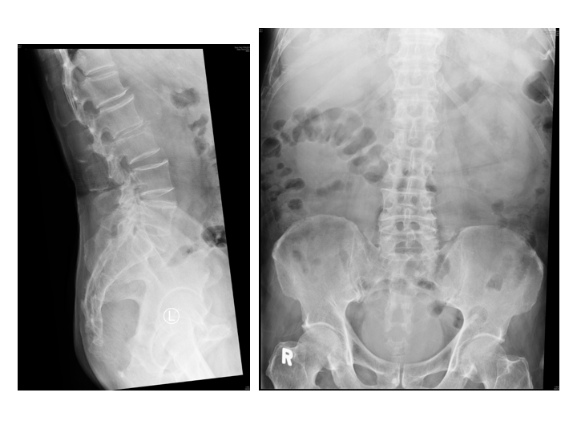
L-spine X-ray findings of ‘degenerative changes’ documented in A&E notes
- Describe the radiological findings.

_________________________________________________________________________________

_________________________________________________________________________________

_________________________________________________________________________________

_________________________________________________________________________________

B) What is the likely diagnosis?

_________________________________________________________________________________

C) What are the next steps of investigation?

_________________________________________________________________________________

_________________________________________________________________________________

_________________________________________________________________________________

_________________________________________________________________________________

_________________________________________________________________________________

D) What are the criteria/ indications for choosing surgical rather than medical treatment for this condition?

_________________________________________________________________________________

_________________________________________________________________________________

_________________________________________________________________________________

_________________________________________________________________________________

_________________________________________________________________________________

E) If blood culture showed gram-positive organisms, and cannot be explained by an obvious source, what concurrent condition should be evaluated?

_________________________________________________________________________________

F) What are the red flags of non-traumatic back pain?

_________________________________________________________________________________

_________________________________________________________________________________

_________________________________________________________________________________

_________________________________________________________________________________

_________________________________________________________________________________

