OSCE YCH 5/2020

Case 1

14m / F
FTNSD
Fever, cough, noisy breathing and SOB on DOA
TOCC negative

Pulse 140bpm SpO2 97% (RA)
Temp 38.3
X rays were performed

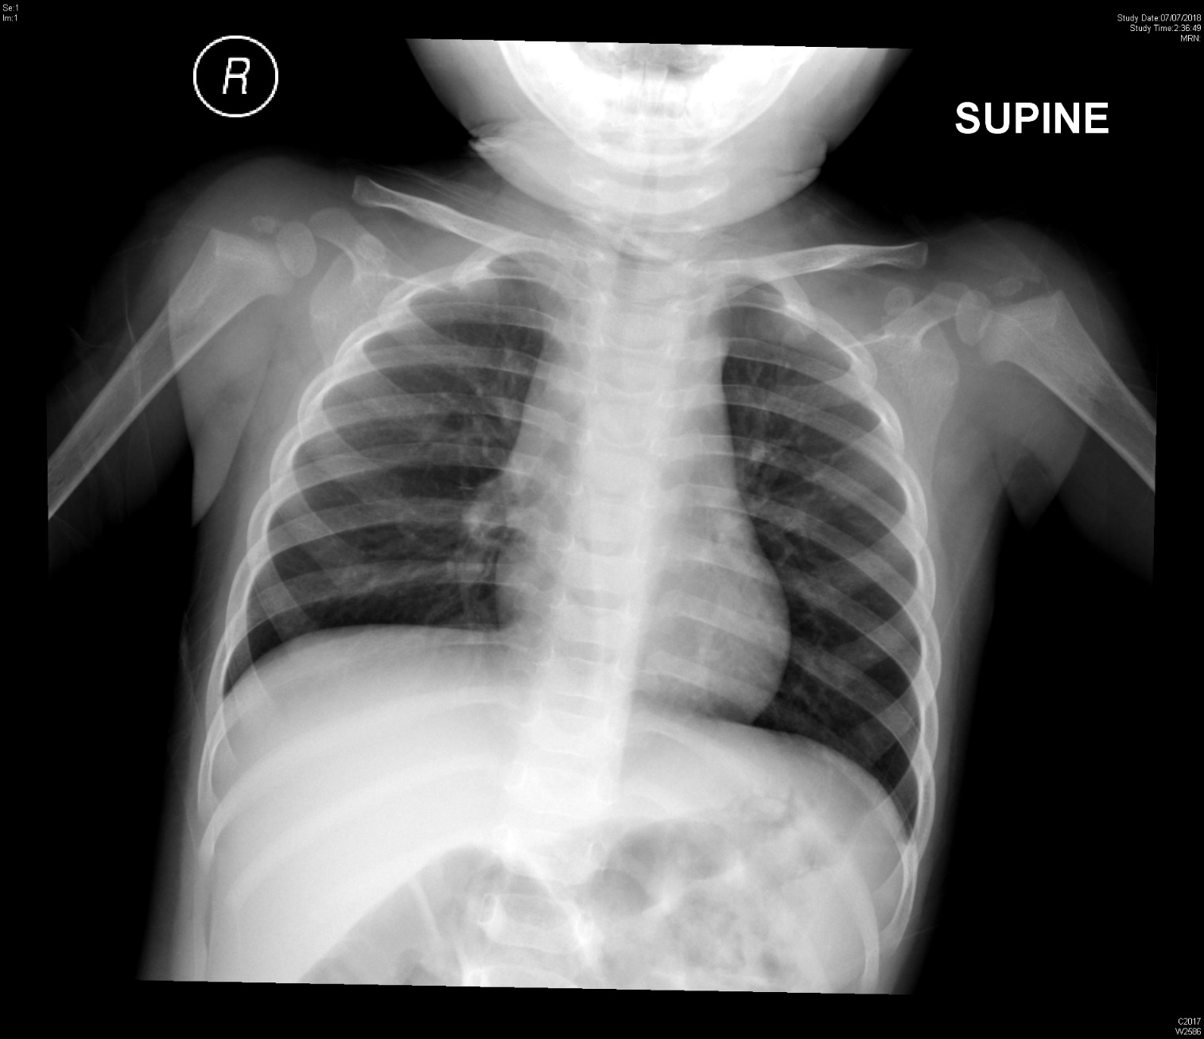
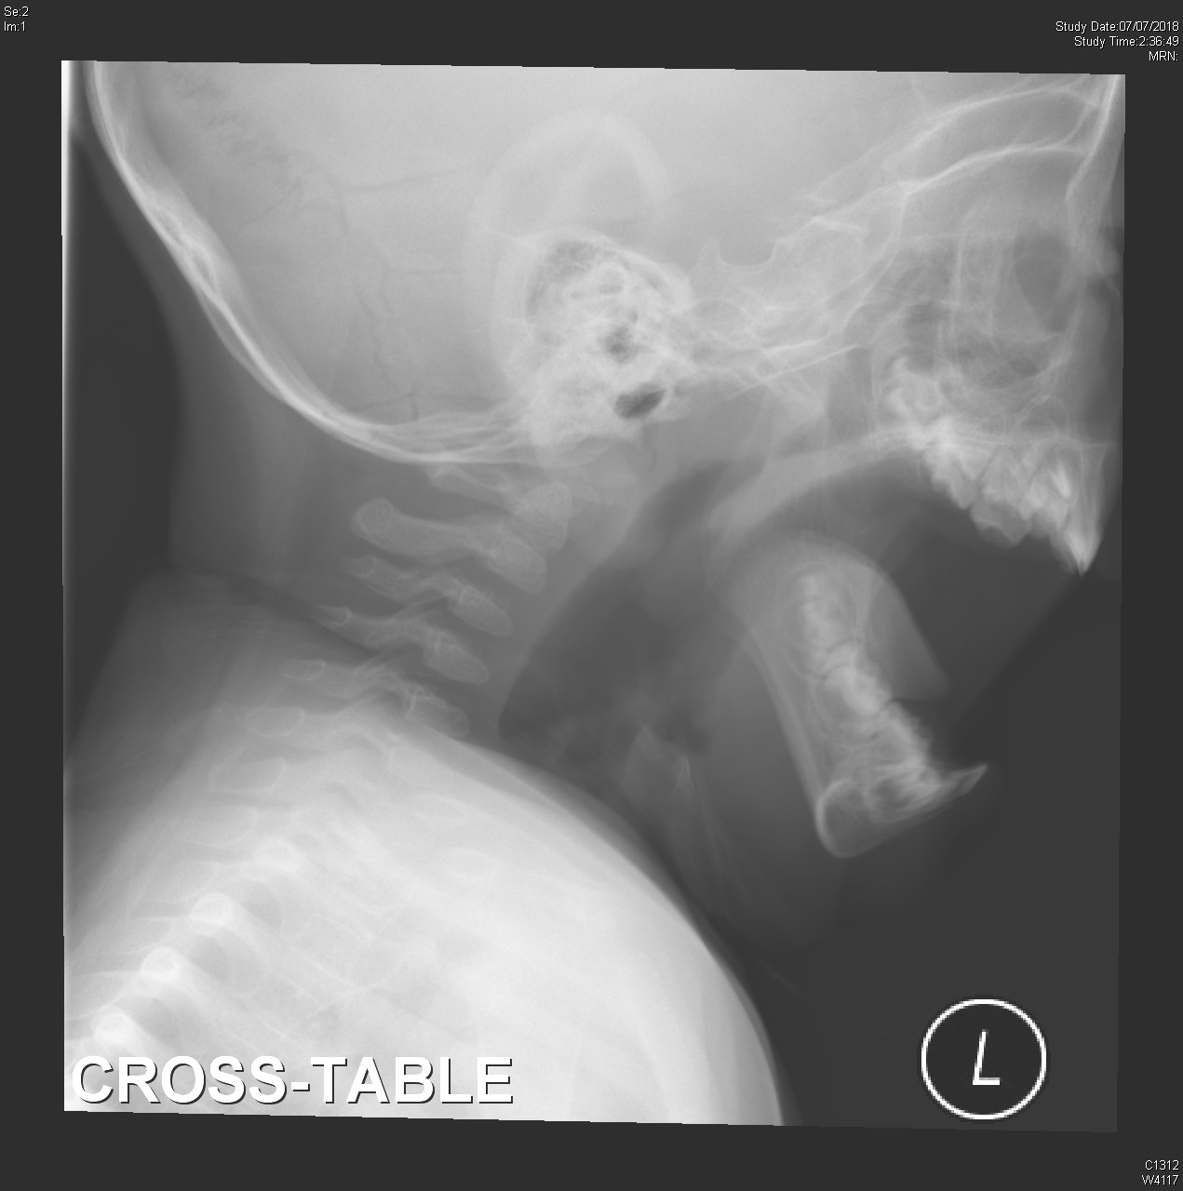

- What are the x ray findings?

- What is the diagnosis?

3. How would you assess the severity?

- What treatment would you give?

- 30mins after the treatment, the patient improved. Her mother asked whether the patient can be discharged. How would you advise?

Case 2.

11/F good past health
no urine output and suprapubic distension for 12 hrs.
bowel opening
P/E: suprapubic mass +
Bedside USG was preformed
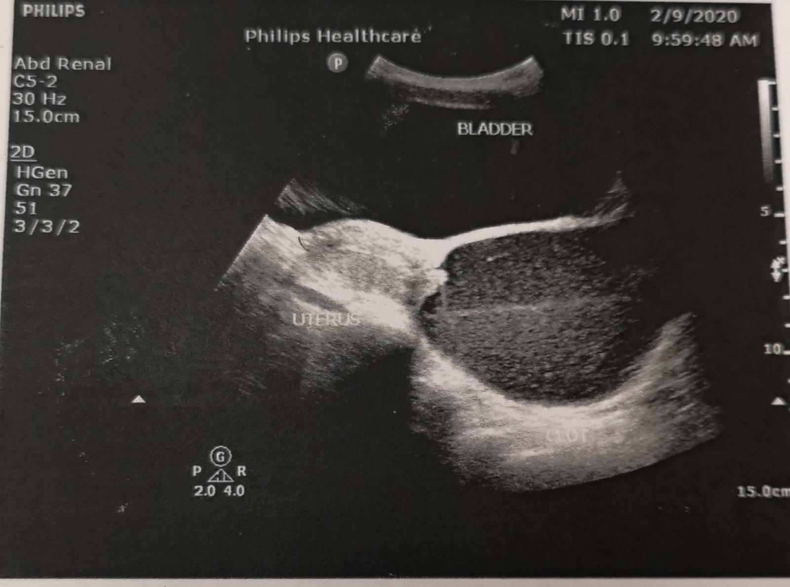
- What is the USG finding?

- What history would you like to ask?

- What is the diagnosis?

- What is the treatment?

Case3.

63/F
Left hand was stung by fish at market (with photo)
Sever pain and numbness
BP 190/107 P 92
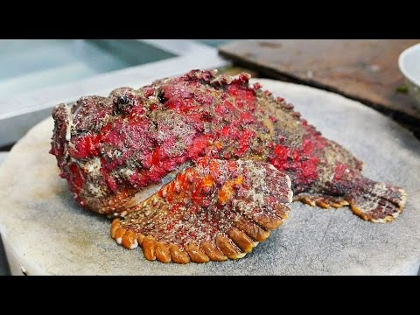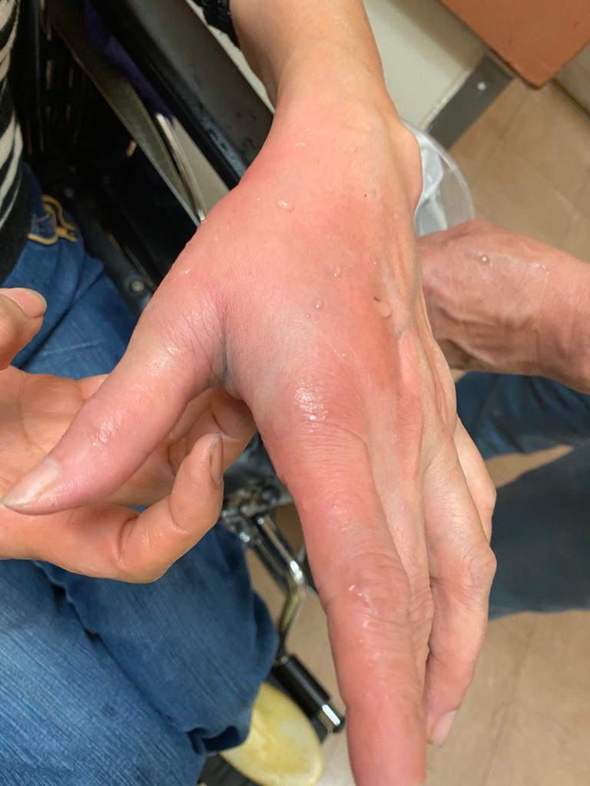
- What is the diagnosis and what initial treatment would you give?

- After the initial treatment, patient develop progressive swelling, pain and blister. What specific treatment would you give?
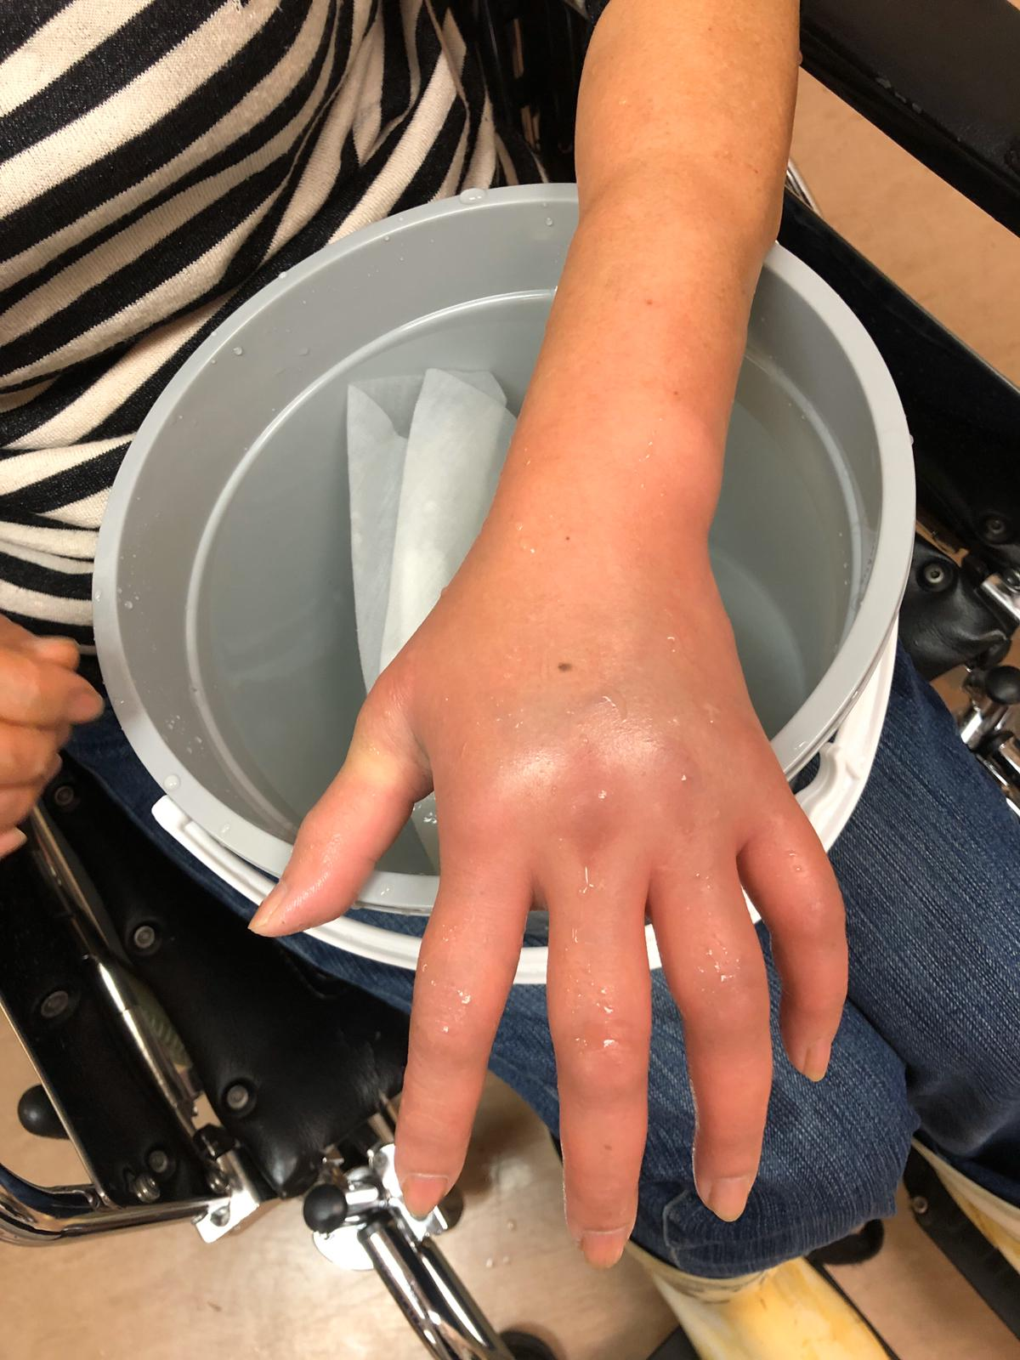
- what are the complications of the injury?

Case4

42/F
S/F while chasing bus
Left shoulder injury
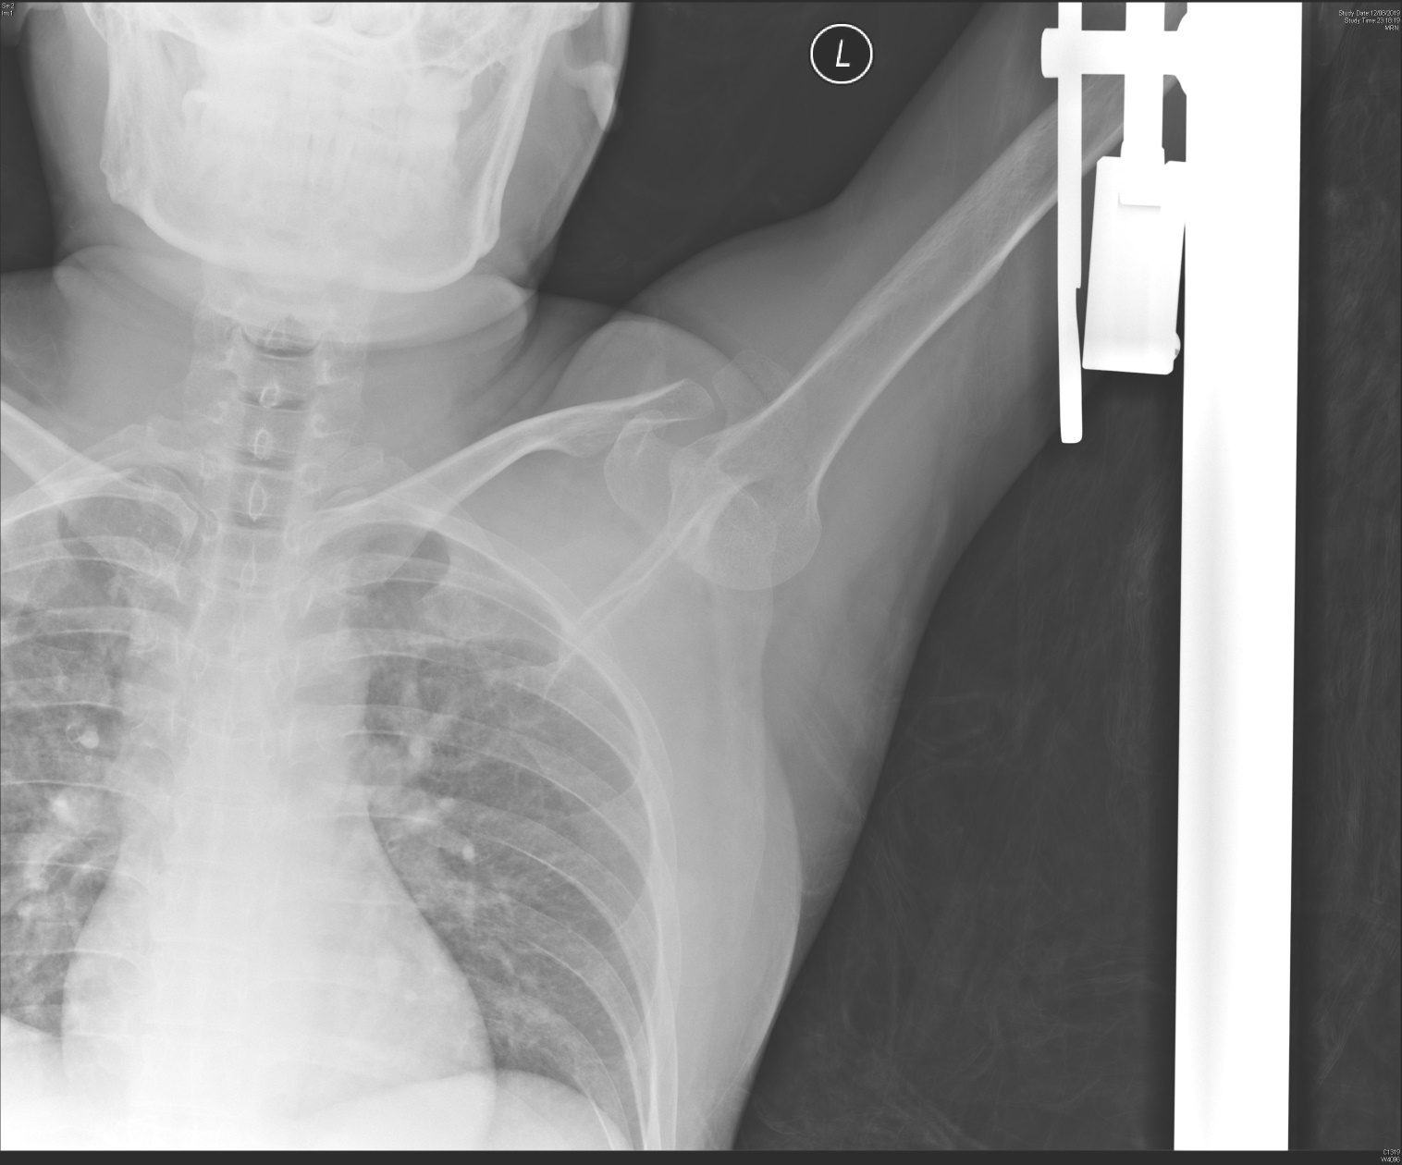
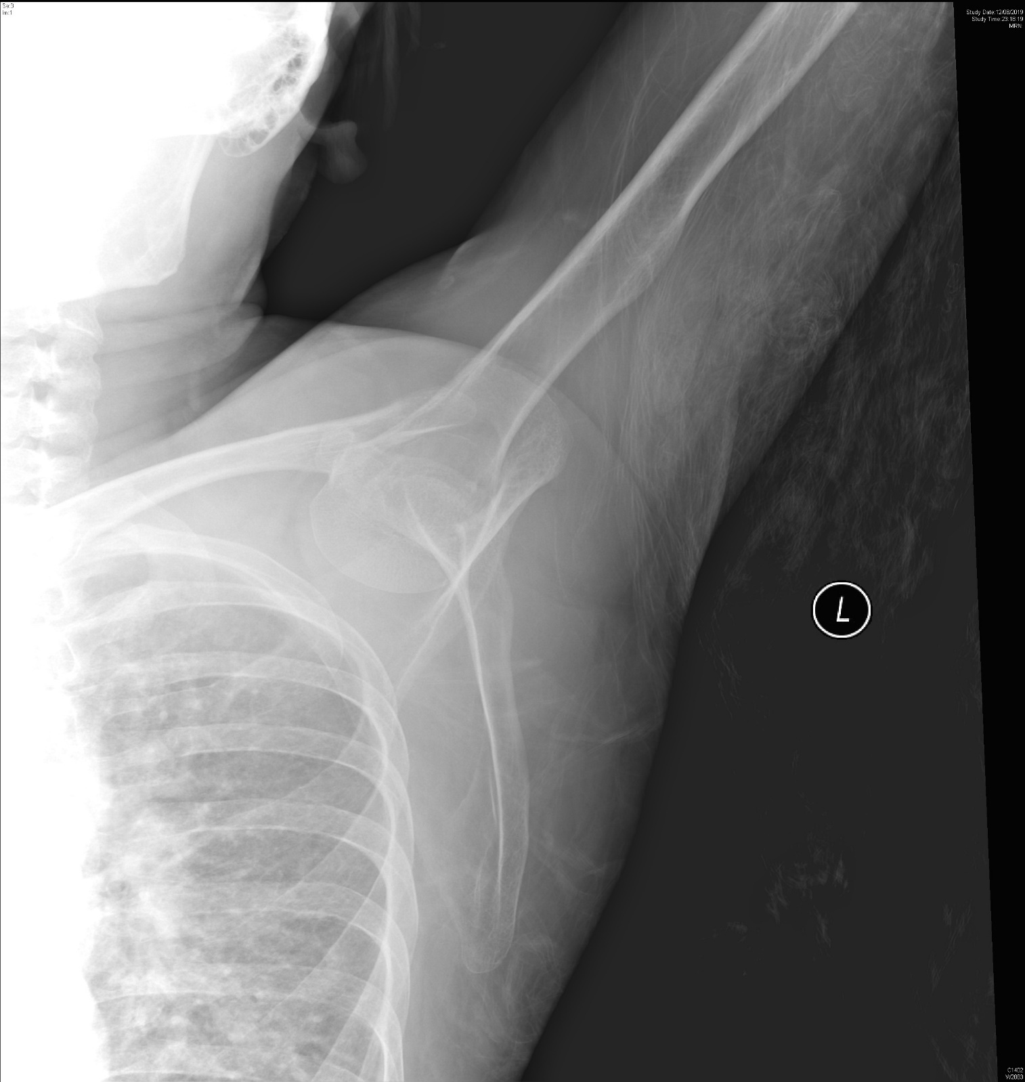

- What are the x ray finding and diagnosis?

- what are the 2 possible treatment method in ED?

- What are the complications of the injury?

