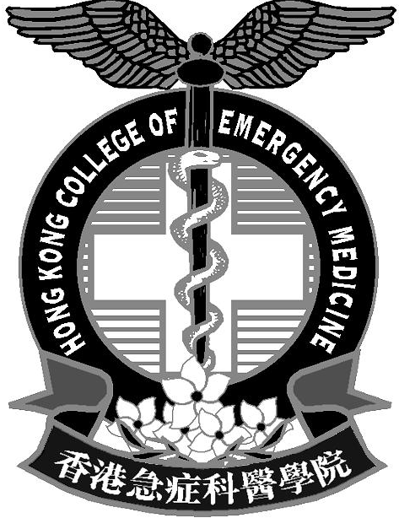 | 香港急症科醫學院  HONG KONG COLLEGE OF  EMERGENCY MEDICINE
SPONSORSHIP TO:
21st International Conference on Emergency Medicine (ICEM 2022)
Virtual Edition

The College invites application for the above sponsorship from Fellows and Ordinary Members. You can refer to the website: https://www.icem2022.com/ for details.

Details of the Sponsorship:
- Quota: 30 Fellows/ Ordinary Members
- Sponsorship amount: AUD800 for Fellows/ AUD400 for Ordinary Members (equivalent to 100% Early Bird Virtual Full Package Registration Fee of their corresponding categories) (till 15 March 2022)
- CMECPE and Training Points: - Pending
- Deadline for application: 4 March 2022
- Application method: by e-mail to Ms. Sonia HUEN at sonia@hkcem.org.hk or by fax at 2554-2913 with
personal particulars completed below.
- If the quota is exceeded, there will be a selection process by the College Council to confirm the list of successful applicants. The decision of the College Council will be final.
- Successful applicants will be notified through email no later than 11th March 2022.
- Successful applicants will be reimbursed AUD800/ AUD400, upon submission of a copy of official receipt (together with the proof of the corresponding exchange rate) and a copy of the attendance certificate to our Admin. Manager on, or before 22 July 2022.
- Documents for reimbursement will not be accepted after the deadline for reimbursement unless there is prior approval from the Council.
- Successful applicants who fail to attend will not be considered for any College sponsorship for 2 years from the closing date of the event.
- In case of cancellation, changes in date and/or format of the sponsored conference due to unforeseeable circumstances, the College WILL NOT be held responsible for the registration fee.

From: Dr Ben WAN, Hon. Secretary, HKCEM
18 Feb 2022
………………………………………………………………………………………………………………
To Dr Ben WAN Hon. Secretary, HKCEM Deadline for application: 4 March 2022
(c/o Ms Sonia HUEN) Email: sonia@hkcem.org.hk Fax: 2554-2913
International Conference on Emergency Medicine (ICEM 2022)
14-19 June 2022, Virtual Edition
I would like to apply for sponsorship of the above conference. I understand the conditions for application.
Name: | o Fellow o Ordinary Member
Post: | Hospital:
E-mail: | Contact No.:
Signature: | Date:

