Hong Kong College of Emergency Medicine (HKCEM)
Instructions to candidates sitting for online
Primary Examination on Emergency Medicine (PEEM)

Equipment for online examination

iPad (preferably bigger than 9.7 inch, with the minimum system requirement as specified on this link) with the Examplify application installed.

Smartphone for Zoom invigilation. Do not use Zoom background during the examination.

A mobile phone stand/tripod for mounting the Zoom invigilator phone (optional but recommended).

Another phone for instant communication during the online examination (optional but strongly recommended).

A private space with bright lighting and no disturbance from others. Joining the examination in a café, restaurant, or other public areas are not allowed and will lead to disqualification.

A clean working desk with no other electronic communication devices, papers, writings or books in the nearby area.

A reliable network connection.

Academic Integrity Statement for online Primary Examination on Emergency Medicine (PEEM)

I acknowledge that HKCEM examinations require all candidates to respect the highest standards of academic integrity. For the examination I am about to take, I make the following pledge:
- All the work will be my own, and I will not plagiarized from any source;
- I will not impersonate another candidate or being impersonated in the examination;
- I will not obtain or seek to obtain an unfair advantage by communicating or attempting to communicate with any other person during the examination; neither will I give or attempt to give assistance to another candidate in taking the examination;
- I will follow the instructions as announced by the Chief Examiner with regard to the running of the online examination.

I understand that candidates who are suspected of violating this pledge are liable to be disqualified from the examination.

____________________________
Signature

____________________________
Name of candidate

____________________________
Date

To facilitate administrative procedure, fax this pledge to 2554 2913 before 8th March 2022 even if you haven’t received any notification for a switch to online examination
Preparation for Online Examination

All candidates must take the online examination at the date and time specified by the College. For the March 2022 diet of PEEM, candidates are required to log in to the Zoom meeting with their ‘Zoom invigilator smartphone’ on the following date and time for invigilation:

Date: 10th March 2022 (Thursday)
Time: 8:15 a.m.
Meeting ID: To be announced to candidates individually
Password: To be announced to candidates individually

The examination would be conducted on the ExamSoft® platform with the Examplify App on an iPad. For candidates who don’t own an iPad, a limited number can be on loan from the College.

Before the date of examination, you should ensure that your iPad has installed the Examplify App. Instructions for installing the Examplify app, logging in the account and using the software is provided in the Appendix. A demonstration video on the basic operation of the app can be found here. A Demo examination will be available for candidates to try out after logging in the account. Log-in information and password of the Demo examination would be sent to candidates individually.

Candidates are strongly advised to view the demo video and complete the demo examination before the scheduled date of examination to make ensure that the application is working properly on the iPads and familiarise themselves with the application user interface.

Before the start of the examination

The candidate should join the examination in a brightly lit private space occupied by the candidate only. A clean working desk with no other electronic communication devices, papers, writings or books in the nearby area other than the iPad used for examination, the phones for Zoom invigilation and for instant communication with the invigilators. Joining the examination in a café, restaurant, or other public areas are not allowed and will lead to disqualification.

Candidates are required to join the Zoom meeting at the time specified. Prior to joining the Zoom meeting, you will be asked to consent to the recording of the Zoom meeting. You should display your name according to the following format:

Candidate number – Full name
For example:
PEEM/2022-03/01 – CHAN Tai Man

If you cannot join the Zoom meeting or if you have any technical difficulties, please contact the College by tel: 9588 9142 or 9188 0050. Candidates shall not leave the Zoom meeting throughout the examination.

At the start of the examination

Each candidate will be asked to show the surrounding of the room, according to the instruction of the invigilators. Afterwards, the video and speaker functions on the Zoom invigilator phone should be kept on all the time during the examination. The candidate should also mute the Zoom application on joining the meeting. The Zoom invigilator phone should be positioned such that it can capture the whole iPad screen and its immediate surrounding.

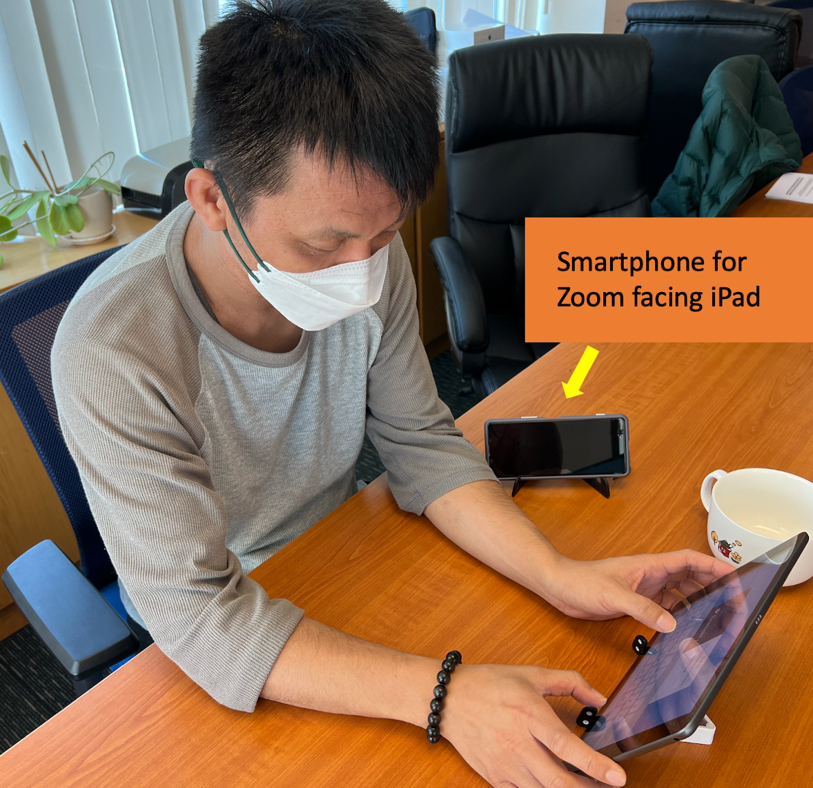

After all the candidates have shown their surroundings, candidates can log in to the Examplify app using the username and password for the actual examination (which will be provided to the candidates individually). The candidates will be asked to first download the Demo examination and complete it using the password broadcast via Zoom.

When all the candidates finish uploading the Demo examination, the actual examination can be downloaded. Candidates can start the examination using the password broadcast by Zoom.

During the examination

Candidates are not permitted to communicate with any other people nearby or by means of online chat rooms, mobile messengers etc.

On the Zoom invigilator phone, video and speaker functions should be enabled during the whole examination. Candidates are also required to mute the Zoom invigilator phone on joining. The use of headphones is not allowed.

Candidates are allowed to raise questions regarding the question paper via the Chat function on Zoom. All questions should be addressed only to the examination invigilator, not to everyone. Any special announcement by the invigilators would be made via Zoom verbally. It is therefore very important for all the candidates to have a good quality Zoom connection to avoid missing any important information.

The Zoom meeting will be recorded right from the start. Recorded material will be treated as strictly confidential and destroyed 60 calendar days after the announcement of the examination result or when any relevant investigation is completed or any relevant dispute resolved.

If you wish to go to the washroom, please obtain explicit permission from the invigilator by raising your request via Zoom Chat. The request should again only be addressed to the examination invigilator, not to everyone. You should not bring any mobile phone or communication device with you as this is regarded as breaching examination regulations.

Candidates should remain in the Zoom meeting and are not allowed to leave the meeting, even if they have answered all questions.

At the end of the examination

The invigilator will announce that time is up via Zoom verbally. Candidates should make sure they have submitted their answers to the ExamSoft platform according to the onscreen instructions. The invigilator will announce the end of examination after the upload status of all candidates are verified.

Candidates unable to fulfil online invigilation requirements

If any candidate anticipates that online invigilation is not feasible at his/her own place due to poor network connectivity or any other constraint, he/she shall contact the College for arrangement. Full refund will be considered if the candidate choose to withdraw from this examination due to technical difficulties sitting in the online examination.

Enquiries Contact

Non-technical issues
Ms. Joanne Lau Tel: 2871 8875; exam@hkcem.org.hk

Technical Issues
Mr. Jacky Wong Tel: 2871 8876; exam@hkcem.org.hk

Updated 25th February 2022

Appendix Instruction on installing the Examplify App on the iPad

Installing Examplify for iPad

Your iPad is preferably bigger than 9.7 inch, making sure that it meets the minimum system requirement as specified on this link.

Install the Examplify app from the App Store.
- The app is from ExamSoft Worldwide, Inc. and is free.
- If you already have Examplify installed, when you start it and there is an update you may be prompted to update. Please do this update unless otherwise indicated.

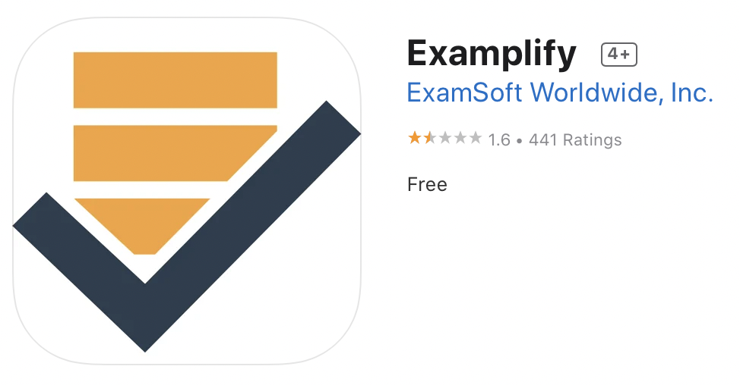

Start the Examplify app and Add a new account:
- The Software License License Agreement will be presented, you must scroll to the bottom and tap ‘I Agree’ to continue
- Type ‘HKCEM’ in the Institution ID box and tap ‘Hong Kong College of Emergency Medicine’ to select the institution. Tap Next.
- Enter the user ID and password provided to you.
- Open the Examplify app (you must be connected to the internet at this time).
- On the left side look under ‘READY FOR DOWNLOAD’ and tap the exam that you want to download.
- Tap the blue ‘Download Exam’ button to download the exam.

Further steps in using the Examplify app can be found in this video.

If you encounter any technical difficulties, please contact Mr. Jacky Wong at tel: 2871 8876; exam@hkcem.org.hk in the office hours for assistance.

