JCM OSCE Answers 2-8-2023

Q1 Ans.

1. H'stix 6.2mmol/L

2. CNS infection, sepsis, acute encephalopathy, chest infection, HI

3. a. Acute encephalopathy.

3. b. Urgent EEG

- Background is grossly symmetrical, intermittent burst of high amplitude polymorphic delta wave of up to 450uV wave was seen diffusedly with predominance over posterior region, lasting from few seconds up to 1-2 minutes. No epileptiform discharge were seen

- Overall suggestive of encephalopathy

4. Inform police or consult MSW for suspected child abuse.

Q2 Ans.

1. AKI with metabolic acidosis

2. Cardiac monitors, given Calcium gluconate and agents for lowering K, correction of severe metabolic acidosis and consult ICU

3. MALA, sepsis, hypoperfusion; Dx MALA

4. Vital function support, Treatment of underlying conditions, Alkalinization, Renal replacement therapy to rapidly eliminate metformin and correct acidosis

Q3 Ans.

1. Newly noted abnormal density over superior mediastinum with lobulated contour. Findings may represent mediastinal lymphadenopathy, ddx thoracic aorta aneurysm.

2. Multiple large lymph nodes are present on both sides of mediastinum. No pulmonary mass or other active lung lesions Lymphoproliferative disease has to be excluded. Tuberculosis is among the other possible diagnoses that need to be considered.

Q3. Most important diagnosis including lymphoma / TB which requires excision biopsy of LN. Patient was then referred to CTS for further work up for enlarged mediastinum LNs.

Q4. Noncaseating granulomas. The granulomas composed of nodular aggregates of epithelioid histiocytes and langhans type multinucleated giant cells. Ziehl-Neelsen stain and PAS stains do to reveal any acid fast bacilli or fungal organisms.

Q5. Sarcoidosis

Q4. Ans.

Q1. Fast AF

Q2. Synchronized cardioversion

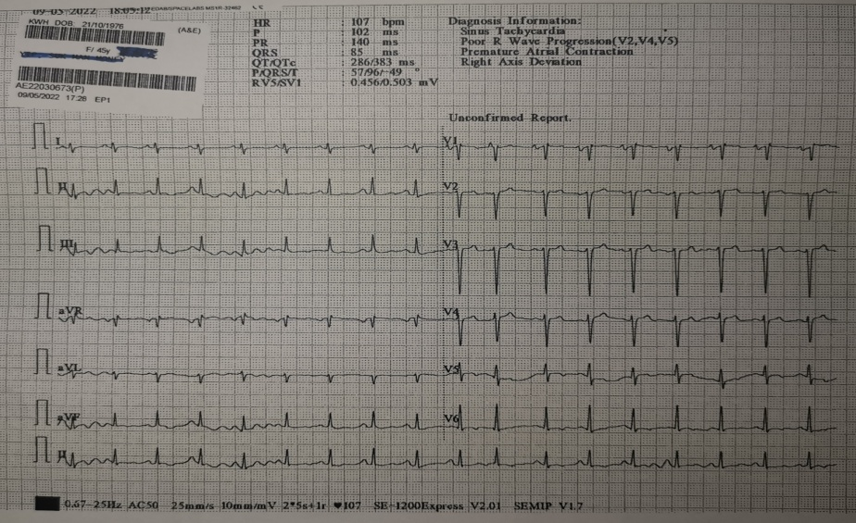

Q3. PTU, Lugol’s solution and Hydrocortisone.

Q4. Burch-Wartofsky Point Scale (BWPS) & The Japanese Thyroid Association (JTA) criteria