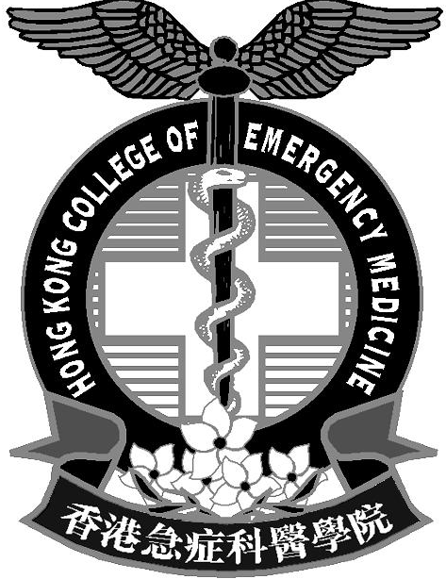 | 香港急症科醫學院  HONG KONG COLLEGE OF  EMERGENCY MEDICINE
SPONSORSHIP TO:
海峽兩岸醫藥衛生交流協會急診醫學分會學術年會
2024 年10月11-13日, 江西省吉安市

The College invites application for the above sponsorship from Fellows and Ordinary Members.

Details of the Sponsorship:
- Quota: 10 Fellows/ Ordinary Members
- Sponsorship amount: RMB800 (equivalent to 100% Registration Fee)
- CMECPE and Training Points: - Pending
- Deadline for application: 13 September 2024
- Application method: by e-mail to Ms Yvonne WONG at yvonne@hkcem.org.hk or by fax at 2554-2913 with
personal particulars completed below.
- If the quota is exceeded, there will be a selection process by the College Council to confirm the list of successful applicants. The decision of the College Council will be final.
- Successful applicants will be notified through email no later than 20 September 2024.
- Successful applicants will be reimbursed RMB800 upon submission of a copy of official receipt (together with the proof of the corresponding exchange rate) and a copy of the attendance certificate to our Admin. Manager on, or before 13 November 2024
- Documents for reimbursement will not be accepted after the deadline for reimbursement unless there is prior approval from the Council.
- Successful applicants who fail to attend will not be considered for any College sponsorship for 2 years from the closing date of the event.
- In case of cancellation, changes in date and/or format of the sponsored conference due to unforeseeable circumstances, the College WILL NOT be held responsible for the registration fee and traveling expenses (such as air ticket and hotel charges). You are strongly advised to purchase travel insurance upon sponsorship confirmation to cover the journey.

From: Dr Ben WAN, Hon. Secretary, HKCEM
29 August 2024
………………………………………………………………………………………………………………
To Dr Ben WAN Hon. Secretary, HKCEM Deadline for application: 13 September 2024
(c/o Ms Yvonne WONG) Email: yvonne@hkcem.org.hk Fax: 2554-2913

海峽兩岸醫藥衛生交流協會急診醫學分會學術年會
2024 年10月11-13日, 江西省吉安市
I would like to apply for sponsorship of the above conference. I understand the conditions for application.
Name: | o Fellow o Ordinary Member
Post: | Hospital:
E-mail: | Contact No.:
Signature: | Date:

